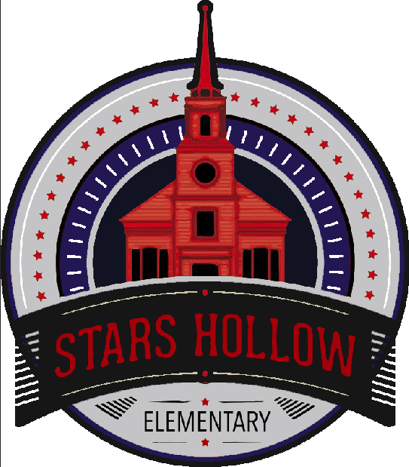

EDCP797: Program Planning

Capstone Project

May 17, 2019

Alexis Thompson

**Table of Contents**

**School Description/Data Profile 4**

**Foundation 13**

Stars Hollow Elementary School Mission and Vision Statements 14

Stars Hollow Elementary School Counseling Program Goals 18

ASCA Mindsets and Behaviors for Student Success 22

Mindset M-5 24

Behavior: B-LS 7 24

Behavior: B-SMS 6 25

Behavior: B-SS 2 25

**Management 27**

Annual Agreements 27

Advisory Council 37

Master Calendar 54

Monthly Calendars 58

**Delivery 77**

Core Curriculum Action Plan 77

Small Group Plan: 4th Grade Academic Achievement Group 100

Academic Achievement Group Results Graphs 131

**Accountability 140**Closing the Gap Action Plan and Results Report 140

Perception Data 140

Outcome Data 141

**References 144**

APPENDIX A: Perception Data Summary 148

APPENDIX B: Outcome Data Summary 154

**School Description/**

**Data Profile**

**School Name:** Stars Hollow Elementary School

**Level:** Elementary; Pre-K – 5

**Address:** 123 Peach Street, Stars Hollow, CT 06606

**Area:** Urban

**Number of students:** 587

**Number of counselors:** 2

# Stars Hollow Elementary School Enrollment, 1993 – Present

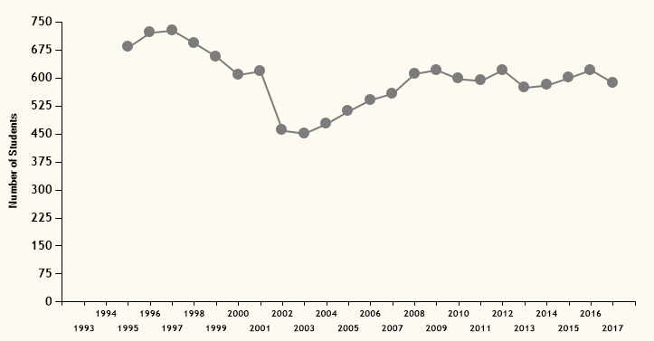

Over the past 25 years, enrollment at Stars Hollow Elementary School has consistently averaged around 600 students, with highest enrollment at 727 in 1997 and lowest enrollment at 451 in 2003. Enrollment is currently **587** students. Stars Hollow ES serves students in grades Pre-K – 5, with two half-day Pre-K classes and four classes of grades K – 5. Pre-K is not included in the total enrollment data or any further data.

Current enrollment by grade is:

* **Pre-Kindergarten:** 30 students
* **Kindergarten:** 85 students (~21 per class)
* **1st Grade:** 95 students (~24 per class)
* **2nd Grade:** 97 students (~24 per class)
* **3rd Grade:** 101 students (~25 per class)
* **4th Grade:** 105 students (~26 per class)
* **5th Grade:** 102 students (~26 per class)

# Special Services at Stars Hollow Elementary School, 2004 – Present

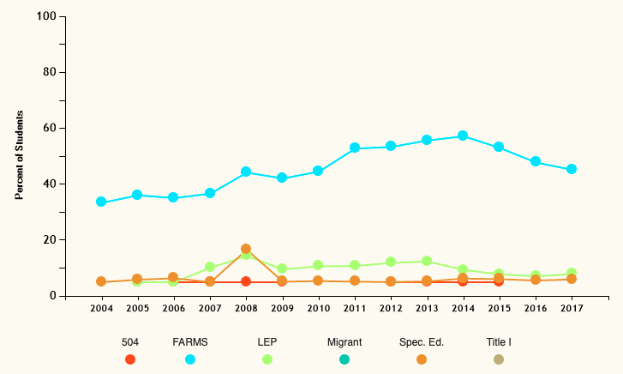

While Stars Hollow Elementary is not a Title I school, a sizeable portion of the students are economically disadvantaged. Currently, about half (270 students, or 46%) of the students in the school are eligible for free and reduced meals (FARMS). In addition to this, there are small but stable groups of students who have limited English proficiency (47 students, or 8%) or are eligible for special education (36 students, or 6.1%).

|  |  |  |  |  |  |
| --- | --- | --- | --- | --- | --- |
| **504** | **FARMS** | **LEP** | **Migrant** | **Special Ed.** | **Title 1** |
| * | 270 students (46%) | 47 students (8%) | * | 36 students (6.1%) | * |

# Stars Hollow Elementary Student Racial Demographics

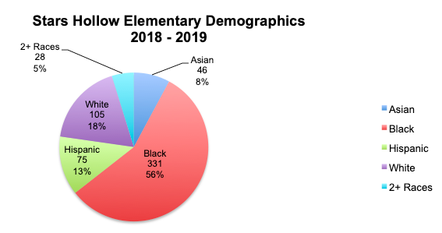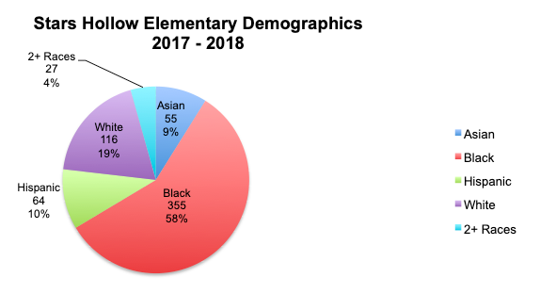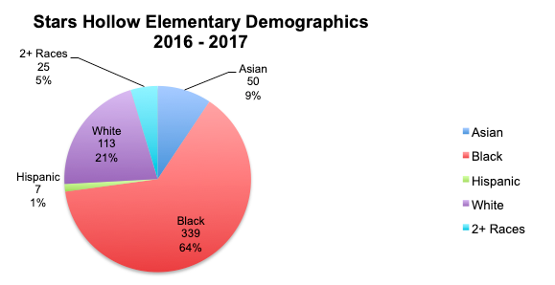

This year, over half of the students at Stars Hollow Elementary School are Black (331, 56%). Beyond this, the school is overall fairly diverse sizeable White (105, 18%) and Hispanic (75, 13%) populations and smaller groups of Asian (46, 8%) and multiracial (28, 5%) students. Over the past three years, Black students have been the consistent majority, making up slightly over half of the student population. White, Asian, and multiracial students have stayed consistent over the past three years. Our school’s Hispanic population has been rapidly growing, from 1% two years ago to 13% this year.

# Stars Hollow Elementary Gender Demographics

Stars Hollow Elementary has a fairly even number of male and female students, with roughly 50% of each for the past 3 years.

# Stars Hollow Elementary Attendance Rates

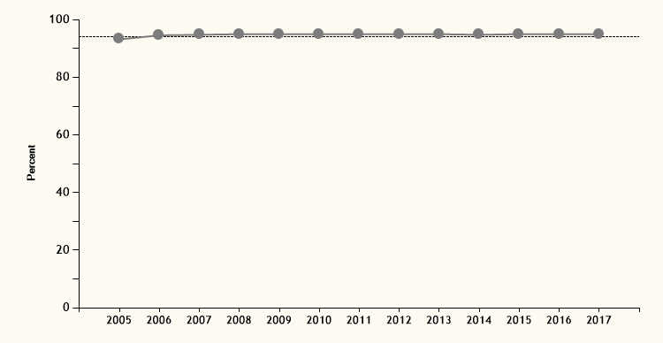

One of the strengths of Stars Hollow Elementary is its consistent attendance rate. The rate has met or passed the 94% threshold set for satisfactory attendance every year since 2006.

Sample Stars Hollow Elementary Achievement Data (PARCC)

## Stars Hollow Elementary 2016 – 2018 Math Achievement Summary

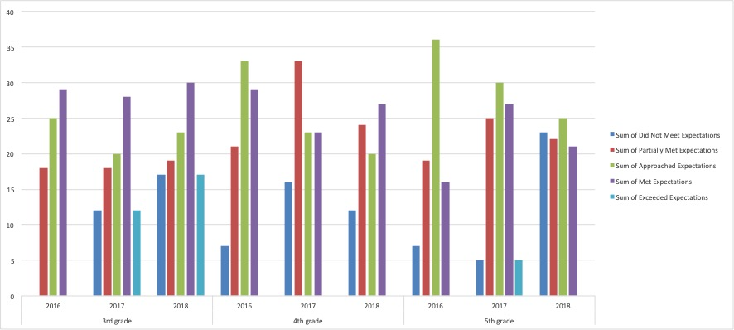

|  |  |  |  |  |  |  |
| --- | --- | --- | --- | --- | --- | --- |
|  | | Did Not Meet Expectations | Partially Met Expectations | Approached Expectations | Met Expectations | Exceeded Expectations |
| 3rd grade | 2016 | * | 18 | 25 | 29 | * |
| 2017 | 12 | 18 | 20 | 28 | 12 |
| 2018 | 17 | 19 | 23 | 30 | 17 |
| 4th grade | 2016 | 7 | 21 | 33 | 29 | * |
| 2017 | 16 | 33 | 23 | 23 | * |
| 2018 | 12 | 24 | 20 | 27 | * |
| 5th grade | 2016 | 7 | 19 | 36 | 16 | * |
| 2017 | 5 | 25 | 30 | 27 | 5 |
| 2018 | 23 | 22 | 25 | 21 | * |

Stars Hollow students fall primarily in the average to below average range in standardized testing. When students exceed expectations, it is most likely during their 3rd grade year, and performance declines as the students grow older and the tests more difficult, with most 4th grade students falling into the ‘approached expectations’ and ‘met expectations’ ranges and 5th grade students falling into the ‘approached expectations’ range and the two categories on either side.

## 2018 Math PARCC Achievement Results

During this past year specifically, less than half of the 3rd – 5th grade students at Stars Hollow Elementary are meeting expectations in math, while 10 – 20% are not meeting expectations at all.

## 2018 Math 3 PARCC Achievement Results (By Race and Score)

# 2018 ELA 3 PARCC Achievement Results (By Race and Score)

When disaggregated by race, Stars Hollow Elementary has differential outcomes for students of different races. While the majority of White students tend to meet expectations overall (as illustrated by the provided examples above and below), the majority of Black and Hispanic/Latino students are not meeting or are barely meeting expectations. This is illustrated, both above for 3rd grade scores, where the majority of White students are meeting or exceeding expectations while a third of Black and Hispanic students are not meeting or are partially meeting expectations, and below for 4th grade scores, where only White students are represented as exceeding expectations for both Math and English for all three years.

4th Grade Math and English PARCC Results By Race, 2016 - 2018

|  |  |  |  |  |  |
| --- | --- | --- | --- | --- | --- |
|  |  | Asian | African American | Hispanic/Latino | White |
| Did Not Meet Expectations | 2016 ELA 4 | * | * | * | 1 |
| 2017 ELA 4 | * | 5 | 2 | 2 |
| 2018 ELA 4 | * | * | * | * |
| 2016 Math 4 | * | 6 | * | * |
| 2017 Math 4 | * | 12 | 2 | 2 |
| 2018 Math 4 | * | 9 | * | * |
| Partially Met Expectations | 2016 ELA 4 | * | 16 | * | 2 |
| 2017 ELA 4 | * | 15 | 2 | 1 |
| 2018 ELA 4 | * | 15 | * | * |
| 2016 Math 4 | * | 16 | * | 1 |
| 2017 Math 4 | * | 24 | 3 | 2 |
| 2018 Math 4 | * | 20 | * | 1 |
| Approached Expectations | 2016 ELA 4 | * | 18 | * | * |
| 2017 ELA 4 | * | 25 | 4 | 2 |
| 2018 ELA 4 | * | 17 | * | * |
| 2016 Math 4 | * | 20 | * | 7 |
| 2017 Math 4 | * | 15 | 3 | 1 |
| 2018 Math 4 | * | 14 | * | 1 |
| Met Expectations | 2016 ELA 4 | * | 19 | * | 9 |
| 2017 ELA 4 | * | 13 | 4 | 7 |
| 2018 ELA 4 | * | 19 | * | 6 |
| 2016 Math 4 | * | 14 | * | 9 |
| 2017 Math 4 | * | 7 | 4 | 9 |
| 2018 Math 4 | * | 19 | * | 8 |
| Exceeded Expectations | 2016 ELA 4 | * | * | * | 6 |
| 2017 ELA 4 | * | * | * | 2 |
| 2018 ELA 4 | * | * | * | 4 |
| 2016 Math 4 | * | * | * | 1 |
| 2017 Math 4 | * | * | * | * |
| 2018 Math 4 | * | * | * | * |

*\*Please note that data was less than 5% cannot be disclosed*

**Foundation**

# Stars Hollow Elementary Vision Statement

## Stars Hollow Elementary School Counseling Vision Statement

After completion of the counseling program, the students of Stars Hollow Elementary School will have a passion for learning and a thirst for knowledge that spur them to push themselves to exceed expectations. Stars Hollow students will be empathetic and inclusive, always striving to make others feel welcome and accepted. Students who complete the counseling program are secure in expressing their true selves and are well-equipped with the skills, confidence, and resilience necessary to pursue their passions and embrace future challenges.

## School Counseling Program Beliefs

1. Every student is capable of success but some face more barriers than others
2. Students are capable of overcoming barriers when provided appropriate support and are advocated for
3. It is a school counselor’s responsibility to help students develop the skills to overcome personal barriers and to advocate on students’ behalf concerning systemic barriers
4. School counselors should advocate for equitable policies and outcomes for students and educate students on self-advocacy skills as well as encourage them to implement those skills
5. All students deserve equitable positive outcomes
6. Students should always be challenged and should be taught to see challenge and growth as positive processes
7. A comprehensive school counseling program must be rooted in data in order to provide appropriate services in the areas where students most urgently need support
8. A comprehensive school counseling program should be aligned with the ASCA National Model and be frequently assessed and adjusted for its alignment and effectiveness
9. A comprehensive school counseling program should be designed and catered to the student population’s demographics, background, and needs via culturally competent interventions and practice
10. Individual differences in aspects including race, culture, identity, and interests are positive and should be appreciated, respected, and celebrated
11. ASCA Ethical Standards guide important school counseling decisions and are intended to protect the best interests of students
12. Abiding by ASCA Ethical Standards is necessary for being an effective and competent school counselor
13. Every student deserves to be heard, respected, and valued as an individual and as an important part of the school community

## Stars Hollow Elementary School Vision Statement

Stars Hollow Elementary School’s vision is to inspire students to embrace challenges with a growth mindset so that they can thrive academically and exceed expectations as they pursue their passions and contribute to the world around them.

## Litchfield County Vision Statement

Litchfield County Public Schools will be a GREAT school system recognized for providing equitable education services which ensure that every student in our diverse district is resilient, has a passion for learning, and graduates ready for college and careers in a global society.

## Narrative

The Stars Hollow Elementary School Counseling Department came together during the 2018 – 2019 school year to discuss beliefs and craft a vision statement for the school counseling program. The department agreed that the school’s diverse student population faces a varying degree of barriers but that they are each equally capable of attaining success in their academic, social, emotional, and professional pursuits. As a result, the department believes that it is important for school counselors to intervene against these barriers when possible and advocate for policies that promote equity and the reduction of more systemic barriers. The department also saw the school’s diversity as a strength and an opportunity for students to learn about individual differences and celebrate those differences as something that makes each student unique. Stars Hollow Elementary should foster a welcoming and empathetic environment where students strive to include others regardless of differences.

Another agreed upon priority was the importance of designing a comprehensive school counseling program rooted in data that aligns with the ASCA National Model and serves the needs of the students. This program needs to abide by the ASCA Ethical Standard and be consistently evaluated for areas of improvement. As Stars Hollow Elementary serves a diverse student population, the department felt that it would be important to encourage differences and communicate to students the importance of respecting and valuing each person’s differences and individuality as well as their own.

The Stars Hollow Elementary School Counseling Program Vision Statement is rooted in the Stars Hollow Elementary School Vision Statement as well as the Litchfield County Vision Statement. As a county, Litchfield’s public schools place an emphasis on resilience and passion for learning. These values are also reflected in the program vision statement. The Stars Hollow Elementary School Counseling Program strives to provide students the tools and opportunities necessary to develop resilience and a lifelong love of learning. Much like the county’s emphasis on resiliency, Stars Hollow Elementary School as a whole values encouraging resiliency through fostering a growth mindset in students and encouraging them to embrace challenges as opportunities for growth. The department felt that this was important to include in the program vision statement because this mindset will prepare students for success when facing the academic, social, emotional, and professional challenges that arise during their time at Stars Hollow Elementary and beyond. Stars Hollow Elementary School holds students accountable and has a culture of encouragement and exceeding expectations. The School Counseling Department sees exceeding expectations as a value that can only arise after the development of a commitment to and love of learning.

# Mission Statement

## Litchfield County Mission Statement

To provide a great education that empowers all students and contributes to thriving communities of lifelong learners.

## Stars Hollow Elementary School Mission Statement

The mission of Stars Hollow Elementary School is to create an inclusive environment in which all students may develop the skills to make positive choices, realize their potential and view education as an enjoyable, valuable, and necessary lifelong endeavor.

## Stars Hollow Elementary Counseling Program Mission Statement

The mission of the school counseling program at Stars Hollow Elementary is to advocate, collaborate, and invest in order to provide all students with the equitable opportunities necessary for them to enjoy learning and realize their potential. The program empowers students to make positive choices and grow into empathetic and inclusive community members with the motivation to constantly improve their academic, social, emotional, and professional endeavors.

## Narrative

When creating the Stars Hollow Elementary School Counseling Program mission statement, the school counseling department discussed ways to use the foundation provided by the Litchfield County and Stars Hollow Elementary School mission statements to develop a program mission statement that also infuses equity, inclusivity, and advocacy. The department appreciated the county’s mission to empower students and felt that this was a necessary part of the department’s mission as well. When working with the Stars Hollow Elementary School administration team, the department believed that the school’s mission to create an inclusive environment and to provide opportunities to make positive choices, enjoy learning, and realize their potential was an important one that should be supported by the department. As counselors, the department saw it important to also include the roles of advocacy and collaboration on behalf of students as part of the mission. Looking back to the value of diversity and inclusion, it was important to include fostering a school community of inclusive students as part of the mission. Finally, the department chose to integrate the school’s value of constant growth and improvement and apply it to the three major domains (academic, social/emotional, and career and college readiness) of school counseling.

# School Counseling Program Goals

## Goal 1

By May 2019, 4th grade Hispanic students who pass (Meet or Exceed Expectations) the 2019 Math PARCC test will increase by 50% from 5 students (or 38.5%) to 10 students (or 76.92%)

* Possible systemic issues:
  + After school activities are announced via email and flyer and are only in English, making it more difficult for parents who do not speak English (or do not have an email address) to know about opportunities
  + The school cannot provide transportation (an additional bus) for after school activities, making it difficult for families with parents who work long hours or do not have a car
* Counselor response to systemic issues:
  + Offering materials and flyers in Spanish
  + Holding the workshops at accessible locations, like the community center, church, and library
* Current school programs/activities to address goal:
  + After school PARCC learning opportunity practice program (PLOPP)
  + Classroom test anxiety meditation between test sections
* School counselor interventions to address goal:
  + Parent workshops
  + Classroom lessons on growth mindset
  + Academic skills group

## Goal 2

By June 2019, the number of 5th grade referrals for bullying will decrease by 25% from 75 to 56

* Possible systemic issues:
  + Current approaches are short-term, one-time approaches
  + Bullying issues are currently addressed via mediation or punishment
* Counselor response to systemic issues
  + Initiating long-term, ongoing interventions
  + Teacher development on appropriate bullying interventions
* Current school programs/activities to address goal:
  + Yearly classroom lessons from counselor
  + Student-designed bulletin board competition
  + Yearly bullying assembly (the NED Show)
* School counselor interventions to address goal:
  + Literature-based anti-bullying small group
  + Partnering with librarian and classroom teacher to infuse bullying and friendship literature/lessons into curriculum
  + Peer advocate program
  + Advocating for PBIS program

## Goal 3

By June 2019, the number of 3rd grade African American students who are failing reading will decrease by 30% from 10 to 7

* Possible systemic issues:
  + 90% of students in this group report not reading with family at home
  + Students started first grade at lower reading level
* Counselor response to systemic issues
  + Mentoring program to provide invested adult to encourage reading outside of class
  + Specified attention outside of class for students to improve reading level
* Current school programs/activities to address goal:
  + Additional reading support from paraprofessional
  + RTI (Response-to-Intervention)
* School counselor interventions to address goal:
  + Loving to Read small group with mentoring opportunities
  + Mentorship program with university students
  + Class-Wide Peer Tutoring

## Narrative

The Counseling Department at Stars Hollow Elementary School noticed that the most evident disparities in the data were the academic achievement gaps between White students and students of color. As a result, we decided to dedicate two goals to supporting the academic achievement of students of color, championing our school’s mission of making learning enjoyable and valuable. Given an overrepresentation of the 5th grade in bullying-related referrals, the department also decided to address this issue throughout the year to cultivate a school community that promotes inclusion and acceptance. Because the bullying is often identity-based, it is currently an additional barrier for students holding non-privileged identities because those who are bullied have additional social stressors that can deter them from focusing on being successful in academic or professional realms. By addressing this issue, we are removing barriers to promote their success and the department’s belief that diverse backgrounds should be respected and appreciated.

Goal #1

One disparity that was evident for Stars Hollow Elementary was the gap in test performance between White students and students of color. Last year, 80% of White 3rd grade students met or exceeded expectations in English, while only 46.2% of Hispanic 3rd grade students achieved this same standard. In math, 75% of White 3rd grade students met or exceeded expectations, while only 38.5% of Hispanic 3rd grade students reached this standard. There is a comparable number of White and Hispanic students in the school and the class (13 of each) but a sizeable achievement gap concerning performance, particularly in math. This issue was addressed through an academic skills counseling group for 4 students, 4 family workshops on fostering academic excellence, and classroom lessons on perseverance and growth mindset.

Studies conducted by Blackwell, Trzesniewski, and Dweck (2007) have found that students who learn strategies to approach obstacles with a growth mindset are more likely to improve their grades over time when compared to students who view intelligence as a fixed entity. As a result, highlighting these ideas in the classroom and with parents was projected to provide students the necessary mindset to succeed academically. At the end of the 2018-2019 school year, 8 Hispanic students met or exceeded expectations. While the goal was not met, it was still important because it promoted the department’s vision of encouraging students to exceed expectations.

Goal #2

When reviewing the data from the 2017 – 2018 school year, there were 400 behavioral referrals. 195 of these referrals were for bullying or conflict-related issues. 75 of these referrals came from the 4th grade (rising 5th grade) class. This was the highest number for any grade and almost double of all the other grades, which averaged 24 bullying or conflict-related referrals. These referrals often involved exclusion or harassment based on differences, which goes against the school and department’s aspirations, mission, and vision. To address and decrease these issues, the counselors taught classroom lessons on individual differences, discrimination, and bullying.

Bullying research by school counselor Dr. Mary E. McCormac (2014) finds that classroom-based lessons lead to increased empathy and belief in ability to self-defend in students as well as a decrease in the behaviors that encourage bullying among peers. Similarly, it has been found that bystanders play a key role in determining whether bullying is considered acceptable in a given school setting, and classroom lessons provide opportunities to train students to be upstanders instead of bystanders (Midgett & Doumas, 2016). To supplement these lessons, literature-based group counseling was provided for a group of 5 students who were responsible for 30 of the referrals for the grade. Following McCormac’s (2014) research, the counseling department also partnered with the school librarian and classroom teachers to integrate bullying and friendship literature (including I Am Human, Strictly No Elephants, Just My Luck, and Restart) throughout the year. Finally, the department trained 20 peer advocates to de-escalate conflicts and act as upstanders to intervene with bullying attempts

Goal #3

For the 2nd grade during the 2017 – 2018 school year (now 3rd graders), 100% of the students failing reading class were African American (10 students). In second grade, on average, only 4 students typically fail reading in an average year. This difficulty has been rising for the class over the past 3 years, with 5 students struggling with reading in in Kindergarten in 2016 (3 Black, 2 Hispanic), 6 failing in 1st grade in 2017 (4 Black, 2 Hispanic), to 10 failing in 2nd grade in 2018 (all Black). It is important to address this issue on both the small group and classroom level because of this steady increase in failure over time. While making up the largest share of the student population, African American students at Stars Hollow Elementary School are consistently holding the lowest passing rate on standardized tests and the lowest grades in subjects. By addressing this issue in 3rd grade, the school counselors at Stars Hollow Elementary will also be able to shape more positive educational beliefs at an early age while seeing the interventions’ effectiveness in multiple domains (grades and standardized test scores).

The interventions included implementing a class-wide peer tutoring program (CWPT), an academic small group focused on enjoying reading and featured mentoring opportunities where members practiced reading to younger 1st grade students, and a partnership with a local university’s education department. By giving these students the opportunity both to be mentored by invested adults and to mentor younger students, the identified 3rd grade African American students can grow in their self-efficacy as readers and scholars.

# ASCA Mindsets and Behaviors for Student Success

|  |  |  |  |
| --- | --- | --- | --- |
| ASCA Mindsets & Behaviors: Program Planning Tool | | | |
| This form is a tool you can use in planning your overall school counseling curriculum. Indicate the grade level in which you plan to address any standard in the cells below as well as how the standard is addressed (core curriculum-CC, small group-SG, closing-the-gap-CTG). It isn’t necessary to address each standard each year. | **Grade Level/Delivery** | | |
| Academic | Career | Social/ Emotional |
| **Mindsets** | *Indicate grade level and how addressed (core curriculum-CC, small group-SG, closing the gap-CTG)* | | |
| M 1: Belief in development of whole self, including a healthy balance of mental, social/emotional and physical well-being |  |  | CC- K-5 |
| M 2: Self-confidence in ability to succeed | SG – 3,4 |  | CC-K-2 |
| M 3: Sense of belonging in the school environment | CC-K-5 |  | SG-3-5,  CC-K-5 |
| M 4: Understanding that postsecondary education and lifelong learning are necessary for long-term career success | CC-K-5 | CC-K-5 |  |
| M 5: Belief in using abilities to their fullest to achieve high-quality results and outcomes | CC-K-5,  CTG-1,3,4  SG-4 |  | CC-3-5 |
| M 6: Positive attitude toward work and learning | CC-K-5  CTG-3 | CC-K-5 |  |
| **Behavior: Learning Strategies** | | | |
| B-LS 1: Demonstrate critical-thinking skills to make informed decisions | CC-K-5 | CC-K-5 |  |
| B-LS 2: Demonstrate creativity |  |  | CTG-5 |
| B-LS 3: Use time-management, organizational and study skills | SG-4  SG-4 |  |  |
| B-LS 4: Apply self-motivation and self-direction to learning | CC-K-5  SG-3 |  |  |
| B-LS 5: Apply media and technology skills |  |  |  |
| B-LS 6: Set high standards of quality | CTG-4 |  |  |
| B-LS 7: Identify long- and short-term academic, career and social/emotional goals | CC-K-5  CTG-4 | CC-2-3 | SG-4-5 |
| B-LS 8: Actively engage in challenging coursework |  |  |  |
| B-LS 9: Gather evidence and consider multiple perspectives to make informed decisions | CC-K-5 | CC-K-5 |  |
| B-LS 10: Participate in enrichment and extracurricular activities |  |  |  |
| **Behavior: Self-Management Skills** | | | |
| B-SMS 1: Demonstrate ability to assume responsibility |  |  | SG-4-5 |
| B-SMS 2: Demonstrate self-discipline and self-control |  |  | SG-1,2 |
| B-SMS 3: Demonstrate ability to work independently |  |  |  |
| B-SMS 4: Demonstrate ability to delay immediate gratification for long-term rewards |  |  | SG-2 |
| B-SMS 5: Demonstrate perseverance to achieve long- and short-term goals | CC-33-5 | CC-K-5 | CC-3-5 |
| B-SMS 6: Demonstrate ability to overcome barriers to learning | CTG-3,4  CC-K-5 |  | CC-K-5 |
| B-SMS 7: Demonstrate effective coping skills when faced with a problem |  |  | CC-K-5  SG-1 |
| B-SMS 8: Demonstrate the ability to balance school, home and community activities |  |  |  |
| B-SMS 9: Demonstrate personal safety skills |  |  |  |
| B-SMS 10: Demonstrate ability to manage transitions and ability to adapt to changing situations and responsibilities | CC-3-5 |  |  |
| **Behavior: Social Skills** | | | |
| B-SS 1: Use effective oral and written communication skills and listening skills |  |  | CTG-5 |
| B-SS 2: Create positive and supportive relationships with other students | CTG-3 |  | CC-K-5  SG-3,5 |
| B-SS 3: Create relationships with adults that support success | CTG-3,4  CC-K-5 |  | CTG-3,4  CC-K-5 |
| B-SS 4: Demonstrate empathy |  |  | CC-K-5, SG-1,5 |
| B-SS 5: Demonstrate ethical decision-making and social responsibility |  |  | CTG-5 |
| B-SS 6: Use effective collaboration and cooperation skills | CTG-3 |  | CTG-5 |
| B-SS 7: Use leadership and teamwork skills to work effectively in diverse teams |  |  |  |
| B-SS 8: Demonstrate advocacy skills and ability to assert self, when necessary |  |  | CTG-5 |
| B-SS 9: Demonstrate social maturity and behaviors appropriate to the situation and environment |  |  | CTG-5  SG-2 |

# Narrative

While employing many of the ASCA Mindsets and Behaviors throughout the year, the Stars Hollow Elementary School Counseling Department chose to specifically focus on the following Mindset and Behaviors for the 2018 – 2019 school year:

M-5: Belief in using abilities to their fullest to achieve high-quality results and outcomes

B-LS 7: Identify long- and short-term academic, career, and social/emotional goals

B-SMS 6: Demonstrate ability to overcome barriers to learning

B-SS 2: Create positive and supportive relationships with other students

These were selected based on the department’s mission, vision, and goals as well as the ASCA Program Planning Tool and scheduled classroom guidance lessons for the year. Each quarter, the department met to revise the Mindsets and Behaviors as necessary according to the needs of the students at Stars Hollow Elementary.

## Mindset: M-5: Belief in using abilities to their fullest to achieve high-quality results and outcomes

This mindset best applies to goals 1 and 3, which target the academic success for Stars Hollow Elementary School’s Hispanic and African American students. Specifically, this mindset was applied during the December classroom guidance lesson on growth mindset and perseverance (grades K – 5), the 3rd grade small group and mentorship program (both being mentored and mentoring 1st grade students), and the parent workshops geared toward 4th grade Hispanic parent. This mindset also ties into the school’s emphasis on growth mindset and the department’s vision for students to embrace challenges.

## Behavior: B-LS 7: Identify long- and short-term academic, career, and social/emotional goals

This behavior applies in both the academic and social domains to address goals 1 and 2. Academically, it was applied during the May classroom guidance lesson about lifelong learning (grades K – 5) and the four parent workshops. During the workshops, parents were encouraged to talk to their children about their goals and ways the parents could support them or help their children to form goals. Similarly, in the classroom, students learned the importance of academic goal-setting and participated in an activity where they set personal goals for over the break. Socially, this behavior applied to the 5th grade social small group, where students discussed Wonder and set their own personal social goals for becoming more like Auggie or Jack and less like Julian.

## Behavior: B-SMS 6: Demonstrate ability to overcome barriers to learning

Goals 1 and 3 looked at two student populations (Hispanic and African American) who face barriers (past grades, lack of books at home, language, systemic barriers, etc.) to learning. As a result, we agreed as a department that this behavior would be beneficial to the program. This behavior applied in both the 4th grade Hispanic academic skills group and the 3rd grade African American love of learning group. Additionally, it applied to the 3rd grade mentorship program as students were paired with college students who likely faced barriers to get to where they are. Similarly, students in the love of learning small group mentored 1st grade students who were struggling to read as well. Finally, it was highlighted in December’s classroom guidance lesson on perseverance and growth mindset (grades K – 5).

## Behavior: B-SS 2: Create positive and supportive relationships with other students

The final behavior ties into the counseling department’s environmental aspect of its mission statement that students will be “empathetic and inclusive community members.” These positive peer relationships were supported by multiple interventions but most specifically tie into goals 2 and 3. Socially, this applied during the October classroom lesson on individual differences for all grades (K – 5). Similarly, it was an aspiration that this behavior would begin to be exhibited as a result of the 5th grade social small group. Academically, this behavior was also exhibited with the 3rd grade Class-Wide Peer Tutoring (CWPT) in support of goal 3. By building supportive relationships in the social and academic domains, students can contribute to a thriving community and encourage each other to make positive choices.

## What students will learn

Based on the counseling program’s goals, needs, and selected Mindsets & Behaviors, students will learn the importance of empathy, perseverance, and lifelong learning, and will be able to apply these concepts behaviorally and academically. Specifically, students identified in goal #1 (Hispanic 4th grade students failing PARCC) will grow in persistence fueled by a belief that anything can be accomplished with continued attempts. They will know the necessary study skills for success and will be able to identify school community members who are able to support them and connect them to necessary resources. This group of students will develop a growth mindset and be able to reframe any fixed mindset thought patterns. Finally, they will believe in setting high expectations for themselves regardless of the messages others communicate to them.

Fifth graders (particularly those perpetuating bullying behaviors) will cease any bullying, ridiculing, or exclusionary behavior following their participation in the counseling program. They will know the historical roots of exclusion and value the diversity of backgrounds and experiences that other students bring to the school community. They will invite and include other students to join in on games and activities. They will know what it means to be an upstander and be able to hold themselves and others accountable for any bullying behaviors.

Finally, third grade African American students who are failing reading will believe in the importance of lifelong learning. They will know the important role that reading holds in being successful and will have confidence in their ability to be strong readers. They will be able to identify at least one adult who is invested in their success. They will develop an interest in reading and will begin to read at home, seeking out reading materials related to their own personal topics of interest. Finally, they will be able to apply these beliefs, knowledge, and skills by working with younger students and modeling persistence and enjoyment of lifelong learning.

By believing in, knowing, and acting on the importance of growth mindset, empathy and inclusion, and lifelong learning, all three of these groups will grow closer toward embodying the counseling program’s vision and mission.

**Management**

## Annual Agreements

School Counselor Alexis Thompson Year 2018 - 2019

# School Counseling Program Mission Statement

The mission of the school counseling program at Stars Hollow Elementary is to advocate, collaborate, and invest in order to provide all students with the equitable opportunities necessary for them to enjoy learning and realize their potential. The program empowers students to make positive choices and grow into empathetic and inclusive community members with the motivation to constantly improve their academic, social, emotional, and professional endeavors.

**School Counseling Program Goals**

The school counseling program will focus on the following achievement, attendance and/or behavior goals this year. Details of activities promoting these goals are found in the curriculum, small-group and closing-the-gap action plans.

|  |  |
| --- | --- |
| **Program Goal Statements** | |
| **1** | By May 2019, 4th grade Hispanic students who pass (Meet or Exceed Expectations) the 2019 Math PARCC test will increase by 50% from 5 students (or 38.5%) to 10 students (or 76.92%) |
| **2** | By June 2019, the number of 5th grade referrals for bullying will decrease by 25% from 75 to 56 |
| **3** | By June 2019, the number of 3rd grade African American students who are failing reading will decrease by 30% from 10 to 7 |

# Use of Time

I plan to spend the following percentage of my time delivering the components of the school counseling program. All components are required for a comprehensive school counseling program.

|  |  |  |  |  |
| --- | --- | --- | --- | --- |
|  | **Planned Use** | | | **Recommended** |
| Direct Services to Students | 5 percent | School counseling core curriculum | Provides developmental curriculum content in a systematic way to all students | 80 percent or more |
| 10  percent | Individual student planning | Assists students in the development of educational, career and personal plans |
| 35  percent | Responsive services | Addresses the immediate concerns of students |
| Indirect Services for Students | 35 percent | Referrals, consultation and collaboration | Interacts with others to provide support for student achievement |
| Program |  | Foundation, management | Includes planning and |  |
| Planning and |  | and accountability and | evaluating the school |  |
| School Support | 15 percent | school support | counseling program and school support activities | 20 percent or less |

# Advisory Council

The school counseling advisory council will meet on the following dates.

**Friday, September 14, 2018**

**Friday, May 3, 2019**

**Friday, July 12, 2019**

# Planning and Results Documents

# The following documents have been developed for the school counseling program.

☒Annual calendar ☒ Closing-the-gap action plans

☒ Curriculum action plan ☒ Results reports (from last year’s action plans)

☒ Small-group action plan

# Professional Development

I plan to participate in the following professional development based on school counseling program goals and my school counselor competencies self-assessment.

**Caseload and School Counselor’s Responsibilities**

Indicate how students are assigned to the school counselor’s caseload and the specific responsibilities assumed by the school counselor.

Bullying

Achievement Gap

Peer Interventions and Trainings

PBIS

|  |  |  |
| --- | --- | --- |
| Caseload Defined by: |  | Alpha: last names beginning with to |
|  | Grade level: students in grades: |
| **X** | All students in building |
|  | Other: |
| School Counselor Responsibilities | **Direct Student Services** | |
| **X** | School Counseling Core Curriculum |
|  | Academic Advisement |
|  | Individual Student Planning |
|  |  |
| **Responsive Services** | |
| **X** | Individual Counseling |
| **X** | Small Groups |
| **X** | Crisis Response |
|  |  |
| **Indirect Student Services** | |
|  | Referrals to Community Agencies |
|  |  |
| **Special Programs** | |
| **X** | Career Day |
|  |  |
| **Other** | |
|  |  |
|  |  |

# Professional Collaboration and Responsibilities

Choose all that apply.

|  |  |  |
| --- | --- | --- |
| **Group** | **Weekly/Monthly** | **Coordinator** |
| School Counseling Team Meetings | Weekly | Ms. Alexis Thompson |
| Administration/School Counseling Meetings | Monthly | Dr. Hanlin Charleston |
| Student Support Team Meetings | Monthly | Ms. Lorelei Gilmore |
| Department Chair Meetings |  |  |
| School Improvement Team Meetings | Bi-Weekly | Mr. Jackson Belleville |
| District School Counseling Meetings | Monthly | Mr. Dave Rygalski |
| Other |  |  |

**Budget Materials and Supplies** Annual budget: $1600 Materials and supplies needed:

Refreshments (Career Day/Post-High School Options Day); Paper; office supplies; reference books (libraries, classrooms, group members); professional development attendance costs; Classroom and group curriculum

# School Counselor Availability/Office Organization

The school counseling office will be open for students/parents/teachers from 8:30 AM to 2:30 PM. My hours will be from 8:00 AM to 3:30 PM (if flexible scheduling is used).

The career center will be open from (N/A)

# Role and Responsibilities of Other Staff and Volunteers

School counseling department assistant N/A Attendance assistant clerk N/A Data manager/registrar N/A Career and college center assistant N/A Other staff Jess Mariano – School Social Worker: Home visits, specializing in truant students Volunteers Career Day/Post-High School Options Day speakers: Share job experiences and lead activities with assigned classes; Mentors: Meet with mentored students every other week to do rapport-building educational activities and check in on them.

School Counselor Signature Alexis Thompson

Principal Signature Dr. Hanlin Charleston

Date 8/28/18

School Counselor Lorelei L. Gilmore Year 2018 - 2019

# School Counseling Program Mission Statement

The mission of the school counseling program at Stars Hollow Elementary is to advocate, collaborate, and invest in order to provide all students with the equitable opportunities necessary for them to enjoy learning and realize their potential. The program empowers students to make positive choices and grow into empathetic and inclusive community members with the motivation to constantly improve their academic, social, emotional, and professional endeavors.

**School Counseling Program Goals**

The school counseling program will focus on the following achievement, attendance and/or behavior goals this year. Details of activities promoting these goals are found in the curriculum, small-group and closing-the-gap action plans.

|  |  |
| --- | --- |
| **Program Goal Statements** | |
| **1** | By May 2019, 4th grade Hispanic students who pass (Meet or Exceed Expectations) the 2019 Math PARCC test will increase by 50% from 5 students (or 38.5%) to 10 students (or 76.92%) |
| **2** | By June 2019, the number of 5th grade referrals for bullying will decrease by 25% from 75 to 56 |
| **3** | By June 2019, the number of 3rd grade African American students who are failing reading will decrease by 30% from 10 to 7 |

# Use of Time

I plan to spend the following percentage of my time delivering the components of the school counseling program. All components are required for a comprehensive school counseling program.

|  |  |  |  |  |
| --- | --- | --- | --- | --- |
|  | **Planned Use** | | | **Recommended** |
| Direct Services to Students | 5 percent | School counseling core curriculum | Provides developmental curriculum content in a systematic way to all students | 80 percent or more |
| 20 percent | Individual student planning | Assists students in the development of educational, career and personal plans |
| 25 percent | Responsive services | Addresses the immediate concerns of students |
| Indirect Services for Students | 35 percent | Referrals, consultation and collaboration | Interacts with others to provide support for student achievement |
| Program |  | Foundation, management | Includes planning and |  |
| Planning and |  | and accountability and | evaluating the school |  |
| School Support | 15 percent | school support | counseling program and school support activities | 20 percent or less |

# Advisory Council

The school counseling advisory council will meet on the following dates.

**Friday, September 14, 2018**

**Friday, May 3, 2019**

**Friday, July 12, 2019**

# Planning and Results Documents

# The following documents have been developed for the school counseling program.

☒Annual calendar ☒ Closing-the-gap action plans

☒ Curriculum action plan ☒ Results reports (from last year’s action plans)

☒ Small-group action plan

# Professional Development

I plan to participate in the following professional development based on school counseling program goals and my school counselor competencies self-assessment.

**Caseload and School Counselor’s Responsibilities**

Indicate how students are assigned to the school counselor’s caseload and the specific responsibilities assumed by the school counselor.

Relational Aggression

Cyberbullying

Connecting with families-of-color (Hispanic)

Growth Mindset

|  |  |  |
| --- | --- | --- |
| Caseload Defined by: |  | Alpha: last names beginning with to |
|  | Grade level: students in grades: |
| **X** | All students in building |
|  | Other: |
| School Counselor Responsibilities | **Direct Student Services** | |
| **X** | School Counseling Core Curriculum |
| **X** | Academic Advisement |
| **X** | Individual Student Planning |
|  |  |
| **Responsive Services** | |
| **X** | Individual Counseling |
| **X** | Small Groups |
| **\** | Crisis Response |
|  |  |
| **Indirect Student Services** | |
| **X** | Referrals to Community Agencies |
|  |  |
| **Special Programs** | |
| **X** | Post-High School Options Day |
|  |  |
| **Other** | |
|  |  |
|  |  |

# Professional Collaboration and Responsibilities

Choose all that apply.

|  |  |  |
| --- | --- | --- |
| **Group** | **Weekly/Monthly** | **Coordinator** |
| School Counseling Team Meetings | Weekly | Ms. Alexis Thompson |
| Administration/School Counseling Meetings | Monthly | Dr. Hanlin Charleston |
| Student Support Team Meetings | Monthly | Ms. Lorelei Gilmore |
| Department Chair Meetings |  |  |
| School Improvement Team Meetings | Bi-Weekly | Mr. Jackson Belleville |
| District School Counseling Meetings | Monthly | Mr. Dave Rygalski |
| Other |  |  |

**Budget Materials and Supplies** Annual budget: $1600 Materials and supplies needed:

Refreshments (Career Day/Post-High School Options Day); Paper; office supplies; reference books; professional development cost; Classroom and Group Curriculum

# School Counselor Availability/Office Organization

The school counseling office will be open for students/parents/teachers from 8:30 AM to 2:30 PM. My hours will be from 8:30 AM to 4:00 PM (if flexible scheduling is used).

The career center will be open from (N/A)

# Role and Responsibilities of Other Staff and Volunteers

School counseling department assistant N/A Attendance assistant clerk N/A Data manager/registrar N/A Career and college center assistant N/A Other staff Jess Mariano – School Social Worker: Home visits, specializing in truant students Volunteers Career Day/Post-High School Options Day speakers; Mentors: Meet with students every other week to do rapport-building activities and check in on them.

School Counselor Signature Lorelei L. Gilmore

Principal Signature Dr. Hanlin Charleston

Date 8/28/18

## Narrative:

When creating the Annual Agreement, first the counselors discussed whether the department’s mission statement needed to be revised. They we discussed current data from the past year and agreed on program goals. We also use this data to develop the results report. The counselors discussed possible advisory council members and scheduled possible dates for advisory council meetings. Based on our goals, we collaborated to decide which general actions needed to be taken for the year in terms of curriculum, small group, and closing-the-gap action plans. After collaborating on the annual calendar and monthly requirements (process detailed below), the counselors worked independently to develop our own small group and curriculum plans as well as our personal monthly calendars. Each counselor determined our own personal development needs based off the agreed upon goals.

Dr. Charleston, the principal, stated that he prefer that both counselors share the caseload of all students in the building rather than dividing it. From here, the two counselors discussed how to divide the remaining responsibilities. We agreed that one counselor would be responsible for organizing Career Day (Ms. Thompson) and the other Post-High School Options Day (Ms. Gilmore). We determined that Ms. Thompson would spend more time in crisis response (which Ms. Gilmore would still assist with when needed) and that Ms. Gilmore would focus more on individual student planning and PEPs. When presented to the principal, he agreed that this was an acceptable way to divide the workload.

With the establishment of the advisory council, Dr. Charleston requested that Administration/School Counseling Meetings be reduced from a Bi-Weekly to Monthly basis. Each counselor submitted her proposed agreement to Dr. Charleston for approval on August 28, 2018.

## Advisory Council

## Advisory Council Members and Stakeholder Positions:

Alexis Thompson – School Counselor

Lorelei L. Gilmore – School Counselor

Dr. Hanlin Charleston – Principal

Paris Geller – School Board Member

Jess Mariano – School Social Worker

Max Medina – Teacher, 5th grade; Soccer Coach

Kirk Gleason – Teacher, 2nd grade

Brian Fuller – Music Teacher (K – 5)

April Nardini – Student (5th grade)

Jennifer Kim – Parent

Taylor Doose – Community Partner/Town Selectman/Business Owner/Scout Leader

Patricia LaCosta – Community Partner/Owner of Miss Patty’s Dance Studio

## Narrative

This year was the first year for the Stars Hollow Elementary School Counseling Advisory Council. When forming the council, the counseling department strove to include representatives from as many different perspectives and stakeholders as possible. Each member brings a unique expertise to the council in an effort to develop a program that benefits all students across the school community. This council included two counselors, the principal, a school board member, the school social worker, two teachers (upper and lower grade), one teacher specialist (Music), a student, a parent, and two community partners. The background and role of each member is detailed below:

* Alexis Thompson and Lorelei Gilmore – School Counselors: As Professional School Counselors, Ms. Thompson and Ms. Gilmore develop a comprehensive school counseling program addressing students academic, social, and career/college needs.

* Dr. Hanlin Charleston – Principal: Dr. Charleston represents the school administration and its hopes for the school counseling program. He shares what is tenable given the school’s resources

* Paris Geller – School Board Member: Ms. Gellar represents the perspective and input of the school board. Former classmate of Ms. Gilmore and SHES alumni, Ms. Gellar is intensely committed to the current activities at the school.

* Jess Mariano – School Social Worker: Mr. Mariano collaborates with the School Counselors to develop programs to serve Stars Hollow Elementary students’ needs. In particular, he has a passion for students who are truant and often misunderstood.

* Max Medina – Teacher, Soccer Coach: Mr. Medina is a veteran teacher at Stars Hollow Elementary School. His 5th grade class has a large proportion of ESOL students, and he advocates for them. Mr. Medina also coaches soccer in the spring.

* Kirk Gleason – Teacher: Mr. Gleason is a new teacher but is eager to get involved. As a 2nd grade teacher, he represents the needs of the younger students. An open collaborator and proponent of the counseling program, Mr. Gleason is often among the first to attempt new initiatives in class, like PBIS.

* Brian Fuller – Music Teacher: Mr. Fuller sees all students weekly through his music classes. He has developed a positive rapport with his students, allowing him to recognize when students are undergoing new difficulties. He also collaborates with the counseling department for various interventions throughout the school year.

* April Nardini – Student: April Nardini is a 5th grade student in Mr. Heyden’s class. She is a member of both the swim team and science club and has positive relationships with most of her peers. A well-spoken self-advocate, April speaks on behalf of the students by pulling from the personal experiences of both herself and her classmates.

* Jennifer Kim – Parent: Mrs. Kim represents the parents of Stars Hollow Elementary and shares their concerns with the council. She is also an active member of the local church. While a practicing Seventh Day Adventist, she was raised Buddhist and knows about a variety of faiths. In addition to providing a parental perspective, Mrs. Kim ensure that events and programs are sensitive to the students who come from a variety of faith backgrounds and has clout within her faith community.

* Taylor Doose – Community Partner: Mr. Doose is an invested member of the community, acting as Town Selectman as well as owning two businesses (Doose’s Market and Taylor’s Olde Fashioned Soda Shoppe) and is a Scout Leader. Many of the Stars Hollow Elementary students are patrons of his businesses. Mr. Doose connects the council with different businesses as potential sponsors. As Town Selectman, he also knows all the relevant policies, procedures, paperwork, and licenses needed for holding community events.

* Patricia LaCosta – Community Partner: Ms. LaCosta owns Miss Patty’s Dance Studio, which serves many of the students of Stars Hollow Elementary. She is well known throughout the town, and many of the parents trust her, allowing her to promote the work of the advisory council and gain buy-in.

The team meets three times a year (summer, fall, and spring) to suggest possible programs for the school year (summer and fall) and review successes and growth edges from the school year (spring). Additionally, team members brainstorm possible ways their network can contribute to the success of the counseling program. During each fall meeting, members fill out a needs assessment to provide data on the program’s potential goals. Advisory council members also attend the school counseling events throughout the year like Career Day and Post-High School Options Day. The council guides the school counseling program by providing input on the proposed goals in the fall, providing feedback and clarification for data and results presented in the spring, and proposing ideas for the following school year’s counseling program in the summer. During meetings, they brainstorm possible interventions, obstacles, and solutions to issues, and outside of meetings, they advocate for the program by encouraging people in their network to support the department’s activities.

**School Counseling Advisory Council Agenda**

**Date**: Friday, September 14, 2018

**Time**: 5:00 PM

**Topics**:

1. Welcome and Introductions
2. Overview – role of advisory council
3. Needs Assessments and discussion
4. Proposed Goals 2018 – 2019 School Year
5. Discussion and Feedback
6. Program Feedback
7. Closing and Next Steps

Spring proposed meeting date: *Friday, May 3, 2019*

**School Counseling Advisory Council Minutes**

**Date**: Friday, September 14, 2018

**Time**: 5:00 PM

**Attendees:**

Alexis Thompson

Lorelei L. Gilmore

Kirk Gleason

Brian Fuller

Taylor Doose

Patricia LaCosta

Dr. Hanlin Charleston

Jennifer Kim

**Topics**:

1. Welcome and Introductions

Ms. Thompson and Ms. Gilmore introduced themselves and thanked advisory members for agreeing to participate on the committee in support of the counseling department. Each member introduced themselves and their connection to the school and department.

1. Overview – role of advisory council

Ms. Gilmore reviewed the role of the advisory council. The council will meet at least twice a year, with a possible third meeting in the summer. The role of the council is to support the program by: 1. Providing input on program goals, 2. Discuss program results, 3. Make recommendations for the program, 4. Advocate for the program, and 5. Work as a team to support the success of the program.

These roles can be remembered by keeping in mind that each member’s contribution is important and GREAT:

**G**oals

**R**ecommendations

**E**valuating program results

**A**dvocating for the program

**T**eaming up with other members

Ms. Thompson and Ms. Gilmore then opened the floor for questions about the role of the council.

*Mrs. Kim:* Will any required council events take place on Saturday? Saturday is a sacred day and I do not do any work on Saturday

*Ms. Thompson:* We appreciate you letting us know and will do everything in our power to ensure that council events do not interfere with your religious observances.

*Mr. Doose:* Are there any tax breaks associated with being a member of the advisory council?

*Ms. Gilmore:* No, there are no tax benefits associated with being part of the council, but if your business were to make a donation to one of our department’s events, we would send you a thank you note on school letterhead, which you could use for tax purposes. Because there is nothing monetary associated with being part of the council, there are no tax benefits.

*Ms. LaCosta:* What type of input are you looking for from council members?

*Ms. Thompson:* Wonderful question! As members of our advisory council, we value your perspectives. Each of you works with various sets of students in the Stars Hollow community. If you recognize a need with your students that we can serve as their school counselors, let us know, and we can discuss how we can address that need in our program. In terms of feedback, we try to root our program goals in data, but if you are noticing a more pressing need than the ones we are proposing, let us know so we can consider that need and see if it is supported by data. We can determine how to address it then or during a following meeting

*Mr. Gleason:* Will there be T-shirts? I recently started a T-shirt business and could provide them for a 5% discount

*Ms. Gilmore:* There are no T-shirts needed at this time, but we appreciate you enthusiasm and will let you know if that need arises.

*Mr. Fuller:* How will we keep track of the progress we are making as a council?

*Ms. Thompson:* Another great question. For each meeting, we will be taking minutes (Patty LaCosta is taking them now). Following each meeting, we will send them out via email. At the beginning of each meeting, we will present current school data related to our previous discussion topics, and at the end of each meeting, we will discuss next steps.

1. Needs Assessments and discussion

Ms. Gilmore distributed a needs assessment while Ms. Thompson explained what it was and its purpose. The needs assessment is a survey for school community members to indicate what they believe the most pressing issues facing students are. Members were encouraged to write any additional comments or concerns not addressed in the survey on the back.

Following the distribution of needs assessments, the council discussed what they saw the most pressing needs were:

Bullying, particularly in the upper grades (Mr. Fuller and Ms. LaCosta)

*Mr. Fuller noted the increased teasing some students have been facing during his music class. He has also observed bullying happening after school. He stops it when he sees it but also recognizes that this is likely happening at other times when he is not present. Ms. LaCosta echoed his concern, noting that some of her dance students have been isolated from classmates. She has caught a few instances of teasing before rehearsals but has trouble determining when it is bullying and when it is joking. Ms. Gilmore and Ms. Thompson agreed with these concerns, noting that it is reflected in school data that the 5th grade class has had greater instances of bullying than most other grades and that one hope is that we can address this issue this year.*

Students skipping school to go to the Soda Shoppe (Mr. Doose)

*Mr. Doose reported seeing two students who should be in school entering his Soda Shoppe last Friday. Ms. Gilmore and Ms. Thompson affirmed his concerns, but assured him that overall, Stars Hollow Elementary School has a solid attendance rate. At the same time, they offered to speak with him after the meeting about this incident so they could speak with the students who skipped school.*

Difficulties concentrating in class (Mr. Gleason, Ms. Kim)

*Mr. Gleason reported that many of his second grade students have difficulty concentrating considering that it is only the third week of school. Many stand up in their seat without asking or talk out of turn. Ms. Kim agreed with this attention concern, reporting that her daughter has mentioned students not paying attention during class and being distracting. She is concerned because she does not want this to impact her daughter’s academic performance.*

Grades across the school, particularly in standardized tests (Dr. Charleston)

*Dr. Charleston noted his concern of students’ academic performance. As students progress in each grade, their standardized test performance declines over time. He acknowledged the role of increased difficulty, but hopes the department can address this school-wide need. Ms. Thompson agreed with his concern and explained that it ties in perfectly with the next part of the agenda.*

1. Proposed Goals 2018 – 2019 School Year

Ms. Thompson and Ms. Gilmore introduced and proposed the three primary goals that they hope to address during the school year.

**Goal 1:** “By May 17, 2019, 4th grade Hispanic students who pass (Meet or Exceed Expectations) the 2019 Math PARCC test will increase by 200% from 5 students (or 38.5%) to 10 students (or 76.92%)”

Hispanic students make up about 13% of the Stars Hollow Elementary population, which is approximately similar to (but a bit less than) the number of White students at the school. At the same time, they are consistently scoring lower across grades and test subject. Last year for 3rd grade, there were the same number of each race but very different PARCC results. 80% of White 3rd grade students met or exceeded expectations for English on the PARCC. Only 46.2% of their Hispanic classmates met the same standard. For math, 75% of White 3rd grade students met or exceeded expectations, while only 38.5% of their Hispanic classmates – about half – performed the same. So we’re seeing an achievement gap forming at a very early age. As a result, we’re hoping to work with these students, who are now in 4th grade, to start to close this standardized test performance gap.

We plan to address this through an academic skills small groups and classroom lessons on perseverance and growth mindset. We are hoping to do one more school-wide intervention about growth mindset and are open to suggestions on what that might look like.

**Goal 2:** “By June 2019, the number of 5th grade referrals for bullying will decrease by 25% from 75 to 56”

For our second goal, we also noticed the increase in bullying in the school, especially in the upper grades. When we looked at the behavior referrals from last year, the number of bullying or conflict-related issues for this current 5th grade class was almost double of every other grade in the school. The class represented 75 of the 195 bullying referrals, or about 38% on their own. The other classes each made up about 12 – 15% of the bullying referrals on average.

Because the current 5th grade class is having a bullying issue, and because this behavior goes against our mission and vision, we are hoping to address this issue this year. We plan to start addressing this through classroom lessons and a small group, but are open to other additional suggestions. We are also hoping to address this school-wide by training ‘upstanders’ or peer advocates – students who are trained to call out bullying when they see it and de-escalate the issue.

**Goal 3:** “By June 2019, the number of 3rd grade African American students who are failing reading will decrease by 50% from 10 to 5”

Finally, we noticed report card performance issues last year for our African American students in 2nd grade. All 10 of the students who were failing reading in that class were Black. This is also a much higher number than usual in terms of how many students struggle with reading – usually about 4 students fair reading in an average year in second grade. When we look further at the grade data, a trend starts to emerge for this particular cohort – 5 students were struggling when they were in Kindergarten (3 Black, 2 Hispanic), 6 in 1st grade (4 Black, 2 Hispanic), and now 10 this year, all Black.

We plan to address this issue in the classroom and with a small group of students so we can encourage in them a love for reading. We also want to work on the class-wide level by trying out an intervention called CWPT – class-wide peer tutoring.

1. Discussion and Feedback

**Goal 1:**

*Mr. Fuller:* You may want to verify the percentage increase you’re hoping for. Going from 5 students to 10 students is a 50% increase, not 200%

*Ms. Gilmore*: Oh, you’re absolutely right. We’ll adjust that. Thank you for pointing it out!

*Ms. LaCosta:* Did you say you were looking for suggestions about more ways to include growth mindset ideas?

*Ms. Thompson* – Yes, we currently have some classroom lessons planned, but we’re hoping for another intervention to drive the point home.

*Ms. LaCosta:* What if you did something with the families? The families I know from my dance classes are very involved.

*Ms. Gilmore:* That’s a great idea. Does anyone have ideas on what we could do with families?

*Mr. Doose:* What about a family fun night? We could do games related to growth mindset.

*Dr. Charleston:* What if we did a series of workshops? Each one could have a different topic on how parents can contribute to their child’s success.

*Ms. Thompson:* I think those are both great ideas that we could consider further and discuss their progress in the spring.

**Goal 2:**

*Mr. Gleason:* I think the classroom lessons are a great idea, but I wonder if there are ways to hammer the lessons home in the classroom. Mr. Medina and I were talking about it last week and he mentioned how it’s great to have the counselors come into the classroom, but because that’s only once a month, he fears students might forget what was discussed during those 45 minutes.

*Ms. Gilmore:* That’s a great point. Is there something we can do to make those lessons last in the classroom?

*Mr. Fuller:* What if you partnered with teachers to do something?

*Mr. Gleason:* We could be more strategic in the books we read during class, at least for the younger grades. We could try to choose books that line up better with the lessons to reinforce them.

*Ms. Thompson:* That’s a great idea. Maybe we can talk to Mr. Andrew the librarian about the books read to the upper grades in library classes too.

*Ms. Gilmore:* And maybe our small group could be a type of book club.

*Mr. Gleason:* I could talk to Mr. Medina and Mr. Heydon and try to drum up some support from other teachers.

**Goal 3:**

*Mr. Doose*: Is a 50% decrease a bit too ambitious? Do we think that is attainable?

*Ms. Gilmore:* That is a good point… When we made the goal, we were hoping for the best possible outcome, but maybe we should scale back the goal a bit. If we pass the new goal, great.

*Ms. LaCosta:* I agree – maybe 7 would be more attainable?

*Ms. Thompson:* A 30% decrease sounds like a safer bet. While we’ll try to target 5 students, all 5 may not respond to the intervention in the way that we hope.

*Mrs. Kim:* You also mentioned you were looking for ways to get students interested in reading? What if you tried a mentorship program? I’m sure there would be high school or college students interested in spending time with the students and encouraging their success.

*Ms. Thompson:* That’s a great idea. We could try a mentorship program with older students.

*Ms. Gilmore:* Maybe we could even give the 3rd grade students a chance to be a mentor too. They could practice reading to younger students to gain confidence in reading.

**Revised Goals:**

**Goal 1:** “By May 2019, 4th grade Hispanic students who pass (Meet or Exceed Expectations) the 2019 Math PARCC test will increase by 50% from 5 students (or 38.5%) to 10 students (or 76.92%)”

**Goal 2:** “By June 2019, the number of 5th grade referrals for bullying will decrease by 25% from 75 to 56”

**Goal 3:** “By June 2019, the number of 3rd grade African American students who are failing reading will decrease by 30% from 10 to 7”

1. Program Feedback

*Ms. Gilmore:* Does anyone have any feedback for the program so far or additional concerns they would like to bring to the council?

*Mr. Doose:* I still want to talk after the meeting concludes about those students playing hooky at my store.

*Ms. Thompson*: We will be sure to speak with you Mr. Doose. If there are no other concerns, let’s move toward recapping and next steps.

1. Closing and Next Steps

*Next Steps:*

Ms. Gilmore and Ms. Thompson: discuss possible family fun night and family workshops and determine whether they would fit into the program’s capabilities.

Ms. Thompson: talk to Mr. Andrew the librarian about integrating social/emotional books into some classes

Mr. Gleason: drum up support of other teachers for integrating social/emotional books

Ms. Gilmore: contact the local high school and university for potential mentors

Spring proposed meeting date: *Friday, May 3, 2019*

**School Counseling Advisory Council Agenda**

**Date**: Friday, May 3, 2019

**Time**: 5:00 PM

**Topics**:

1. Welcome and Recap of last meeting
2. Data and Progress on Counseling Goals
3. Discussion and Feedback
4. Closing and Next Steps

Summer proposed meeting date: *Friday, July 12, 2019*

**School Counseling Advisory Council Minutes**

**Date**: Friday, May 3, 2019

**Time**: 5:00 PM

**Attendees:**

Alexis Thompson

Lorelei Gilmore

April Nardini

Paris Geller

Max Medina

Kirk Gleason

Jennifer Kim

Patricia LaCosta

Brian Fuller

Jess Mariano

**Topics**:

1. Welcome and Recap of last meeting

Ms. Thompson and Ms. Gilmore began the advisory council meeting by encouraging everyone to introduce themselves again. The two counselors reviewed the role of the advisory council (meet twice a year and contribute through **G**oals, **R**ecommendations, **E**valuating program results, **A**dvocating for the program, and **T**eaming up with other members). They reviewed the three program goals and went over the agenda for this meeting (discussing the goals and their progress and providing feedback for next year).

**Goal 1:** “By May 2019, 4th grade Hispanic students who pass (Meet or Exceed Expectations) the 2019 Math PARCC test will increase by 50% from 5 students (or 38.5%) to 10 students (or 76.92%)”

**Goal 2:** “By June 2019, the number of 5th grade referrals for bullying will decrease by 25% from 75 to 56”

**Goal 3:** “By June 2019, the number of 3rd grade African American students who are failing reading will decrease by 30% from 10 to 7”

1. Data and Progress on Counseling Goals

The counselors provided data and updates on each counseling goal.

**Goal 1:** “By May 2019, 4th grade Hispanic students who pass (Meet or Exceed Expectations) the 2019 Math PARCC test will increase by 50% from 5 students (or 38.5%) to 10 students (or 76.92%)”

*Activities done to address goal:*

* Academic counseling skills group (4 students),
* Class-wide peer tutoring (CWPT)
* 4 family workshops,
  + The counseling department decided to do family workshops to potentially reach more families by posting recordings online.
* Classroom lessons (perseverance, embracing challenges)

*Data:*

* PARCC test scores will not be released until late in the summer, but we will publish those outcomes as soon as possible and discuss them during next year’s fall meeting.
* 4 students participated in a small academic skills group
* Following the group, 2 students reported increased self-efficacy in terms of their self-evaluation of their study skills. These two students each saw an increase of one letter grade in at least one of their classes.
* 34 families participated in at least one session of the family workshops. 2 families attended every workshop. Workshops averaged about 10 families per session.
* Perception data indicated that following the workshops, families felt more prepared to facilitate their child’s academic success from home, were more mindful of the messages they communicate to their child, and had higher interest in helping their student with schoolwork.
* Following the classroom lesson on growth mindset, there was a 15% increase in student preference for challenging activities. Teachers also reported an increase in persistence among students with respect to completing difficult tasks.

**Goal 2:** “By June 2019, the number of 5th grade referrals for bullying will decrease by 25% from 75 to 56”

*Activities done to address goal:*

* Classroom lessons (individual differences, discrimination, and bullying)
* Small group (read “Wonder”)
* Peer advocates/upstanders training
* Partnerships with teachers and librarian to integrate bullying and friendship literature into class.

*Data:*

* As of today, there are 49 bullying-related referrals for 5th grade students. While we will not know until June whether the goal was met, we can share the following information:
* The rate of referrals has increased over the course of the school year. 25 of the referrals were from September and October alone, 10 were from November through January, 9 were from February and March, and 5 have been from April and May so far.
* For members who participated in the small group counseling, referrals have decreased from 30 to 18, which is currently a 40% decrease. We will re-evaluate in June to determine whether the goal was officially met, but we’re headed in the right direction

**Goal 3:** “By June 2019, the number of 3rd grade African American students who are failing reading will decrease by 30% from 10 to 7”

*Activities done to address goal:*

* Class-wide peer tutoring (CWPT)
* Academic small group to foster reading enjoyment (5 students)
* Mentorship with local university (10 students).

*Data:*

* 5 of the students targeted are currently passing reading. All students have C’s, but one is a high C that could be pulled up to a B.
* 3 of the remaining 5 students have seen increases in their grades but are not passing yet. We are advocating that these students receive resources to continue building on their progress over the summer.
* Following participation in the small group, 4 out of the 5 students (80%) report increased interest in and enjoyment of reading.
* The two classes that implemented class-wide peer tutoring have seen class-wide improvements in grades, with an average of 8 students improving by one letter grade for third quarter. They plan to continue using this approach with future classes.

1. Discussion and Feedback

*Ms. Geller:* With respect to Goal #1, since PARCC scores will not be released until late in the summer, what will you do if you goal is not met?

*Ms. Gilmore*: Very good point. We will look at the data and celebrate any successes, but also look to see where there is room for more growth. If this is a continued issue into next year, we will work to address it with our program via new interventions.

*Mr. Mariano:* What do you think explained the decline in bullying referrals over the year for 5th grade? Were the students actually bullying less, or did the teachers just get sick of writing referrals?

*Ms. Thompson:* Good observation. While we can never know for certain what the exact explanation for the decline was, we have observed that the decreases have occurred soon after the classroom lessons we conducted. While that’s just a correlation, that would be my guess.

*April Nardini:* I think the lessons helped. For the weeks afterwards, Mr. Heydon would cover books in reading class that were similar to what we talked about. Whenever he got the chance, he would have us draw connections to the activities we did with the counselors. Sometimes even at recess, kids would make references to the books (or if they’re like me, read them during recess).

*Mr. Medina:* What are your next steps for the rest of the school year?

*Ms.* *Gilmore*: Things are definitely starting to wrap up for the year. As always, we are working with students as day-to-day issues arise. We will be going into the classrooms two more times (once this month and once in June) for some lessons on self-confidence, embracing challenges, lifelong learning, and transitions. We’re going over the data as we receive it and are taking notes on where we can make a difference and improve the program for next year. We will share these ideas over the summer and look forward to hearing all of yours.

1. Closing and Next Steps

All advisory council members: Consider the concerns you would like to address during the summer meeting and email two ideas or topics to Ms. Gilmore: [LGilmore@StarsHollowES.org](mailto:LGilmore@StarsHollowES.org)

Summer proposed meeting date: *Friday, July 12, 2019*

|  |  |  |  |  |  |
| --- | --- | --- | --- | --- | --- |
|  | **September** | **October** | **November** | **December** | **January** |
| **Classroom** | Counselor Introduction  (Needs Assessment) | Individual Differences | K – 1st  A – Z Jobs | K – 1st  Growth Mindset | K – 1st  Friendship |
| 2nd – 3rd  Types of Jobs (Careers on Wheels) | 2nd – 3rd  Growth Mindset | 2nd – 3rd  Inclusion |
| 4th – 5th Career Exploration | 4th – 5th  Perseverance | 4th – 5th  Discrimination |
|  |  | ClassWide Peer Tutoring Starts |
| **Small Group** | 4th grade Hispanic academic | 4th grade Hispanic academic  2nd grade group based on needs assessment data (social skills)  1st grade group based on needs assessment data (Gilmore)  (Anger management)  3rd grade group based on needs assessment data (friendship)  (Gilmore)  Lunch Bunch: 4th grade girls (Gilmore)  2nd grade (Gilmore), 3rd grade AA (Thompson  4th grade Hispanic (Thompson)  5th grade (Thompson) | 2nd grade group based on needs assessment data |  | 3rd grade love to read |
| **Individual Counseling** |  | 3rd – 5th based on the following referral: self, parent and teacher  (6 students – 3 T, 3 G) | 3rd – 5th based on the following referral: self, parent and teacher | 3rd – 5th based on the following referral: self, parent and teacher | 3rd – 5th based on the following referral: self, parent and teacher |
| **Parent Education** |  | Parent Workshop: Investing in Child’s Academic Success |  | Parent Workshop: Growth Mindset |  |
| **Teacher Consultation** | Teacher Dev.  -Child Abuse Reporting  -PBIS  -SIT Referral  -Speech & Language Screening | Teacher Dev.  Bullying  Integrating friendship literature | Integrating friendship literature | Integrating friendship literature | Teacher Professional Development: Mental Health  Integrating friendship literature |
| **Counselor Professional Development (Attending)** | Connecting with Hispanic Families (Gilmore) | Achievement Gap (Thompson) | Growth Mindset (Gilmore) | Peer Interventions and Trainings (Thompson) | Bullying (Thompson) |
| **Community Connection** |  | Red Ribbon Week | Career Day | Academic African American Mentoring |  |
| **Leadership** |  | Peer advocate training | Peer advocates | Peer advocates | Peer advocates |
| **Student Intervention Team** | Data Collection  Team Meetings | Data Collection  Team Meetings | Data Collection  Team Meetings | Data Collection  Team Meetings | Data Collection  Team Meetings |

|  |  |  |  |  |  |
| --- | --- | --- | --- | --- | --- |
|  | **February** | **March** | **April** | **May** | **June** |
| **Classroom** | Bullying | College | K – 2nd  Emotions (Inside Out) | K – 2nd  Self-confidence | K – 2nd  Lifelong Learning |
| ClassWide Peer Tutoring Continues | ClassWide Peer Tutoring Data Analysis | 3rd – 5th  Stress/Coping skills | 3rd – 5th  Embracing challenges | 3rd – 5th  Lifelong learning and Transition |
| **Small Group** | 5th grade bullying  3rd grade AA love to read | 5th grade bullying (Thompson)  4th grade friendship (Gilmore)  Lunch bunch: 4th grade boys (Gilmore), Friendship (Thompson), 1st grade AA (Thompson), 3rd grade struggling students (Thompson) | Group based on needs assessment data | Group based on needs assessment data | Group based on needs assessment |
| **Individual Counseling** | 3rd – 5th based on the following referral: self, parent and teacher | 3rd – 5th based on the following referral: self, parent and teacher  (8 students – 4 T, 4 G) | 3rd – 5th based on the following referral: self, parent and teacher | 3rd – 5th based on the following referral: self, parent and teacher | 3rd – 5th based on the following referral: self, parent and teacher |
| **Parent Education** | Parent Workshop:  Resources to support your student’s academic growth |  | Parent Workshop:  Funding your child’s future and cultivating positive post-secondary goals |  |  |
| **Teacher Consultation** | When requested  Integrating friendship literature | When requested  Integrating friendship literature | When requested  Integrating friendship literature | When requested  Integrating friendship literature | When requested  Integrating friendship literature |
| **Counselor Professional Development** | Relational Aggression (Gilmore) |  | Cyberbullying (Gilmore) | PBIS (Thompson) |  |
| **Community Connection** | Academic African American Mentoring | Academic African American Mentoring  Post High-School Options Day | Academic African American Mentoring |  |  |
| **Leadership** | Peer advocates | Peer advocates  Articulation meetings | Peer advocates  Articulation meetings | Peer advocates | Peer advocates |
| **Student Intervention Team** | Data Collection | Data Collection  Team Meetings | Data Collection  Team Meetings | Data Collection  Team Meetings | Data Collection  Team Meetings |

|  |  |  |  |  |  |
| --- | --- | --- | --- | --- | --- |
|  | **Monday**  **(Oct. 1, 8, 15, 22, 29)** | **Tuesday**  **(Oct. 2, 9, 16, 23, 30)** | **Wednesday**  **(Oct. 3, 10, 17, 24, 31)** | **Thursday**  **(Oct. 4, 11, 18, 25)** | **Friday**  **(Oct. 5, 12, 19, 26)** |
| **8:00-9:00** | Prep for the Day Consultation/Meetings  E Week: Red Ribbon Week | Prep for the Day  Consultation/Meetings  D & E Weeks: Red Ribbon Week | Prep for the Day  Consultation/Meetings  D Week: Red Ribbon Week | Prep for the Day  Consultation/Meetings  D Week: Red Ribbon Week | Prep for the Day  Consultation/Meetings  B Week: First Quarter Progress Reports Released  D Week: RRW |
| **9:00- 10:00** | Office/Follow-ups (emails, phone calls, parent meetings) | A Week: SIT Meetings  B Week: Admin/Counselor Meeting  C Week: SIT Meetings  D Week: SST Meeting  E Week: District Counselor Meeting | Office/Follow-ups (emails, phone calls, parent meetings) | Office/Follow-ups (emails, phone calls, parent meetings) | Office/Follow-ups (emails, phone calls, parent meetings) |
| **9:30 - 10:00 AM**  Classroom Lesson: Individual Differences  A Week: Grade 3, Class A  B Week: Grade 3, Class B  C Week: Grade 3, Class C  D Week: Grade 3, Class D  E Week: Makeups | **9:30 - 10:00 AM**  4th grade Hispanic Academic Group (All Weeks, During Library) | **9:30 - 10:00 AM**  B Week: Teacher Development – Bullying  C Week: Counselor Professional Development – Achievement Gap  Individual Counseling Referral Follow-Up | **9:30 - 10:00 AM**  Classroom Lesson: Individual Differences  A Week: Grade 5, Class A  B Week: Grade 5, Class B  C Week: Grade 5, Class C  D Week: Grade 5, Class D |
| **10: 00 11:00** | Individual Counseling Referral Follow-Up | *Counseling Team Meeting (All Weeks)* | Observations/ BIP/FBA Follow-Ups - Kindergarten | School-wide  Programs Planning / Career Day Outreach | Observations/ BIP/FBA Follow-Ups |
| **10:40 - 11:00 AM**  Individual Counseling Referral Follow-Up | **10:40 - 11:00 AM**  Individual Counseling Referral Follow-Up | **10:40 - 11:00 AM**  Individual Counseling Referral Follow-Up |
| **11:00-**  **12:00** | **11:00 - 11:30 AM**  Teacher Consultation Office Hours | IEP/504/Parent Meetings | **11:00 - 11:30 AM** Classroom Lesson: Individual Differences  A Week: Grade 4, Class A  B Week: Grade 4, Class B  C Week: Grade 4, Class C  D Week: Grade 4, Class D  E Week: Makeups | **11:00 - 11:30 AM**  2nd grade social skills group based on Needs Assessment Data (Weeks A, B, and D) | **11:00 - 11:30 AM**  School-wide  Programs Planning  Responsive Services  2nd grade social skills group make-up session (Week C) |
| **11:30 AM - 12:00 PM** Individual Counseling Follow-Up | **11:30 AM - 12:00 PM** Individual Counseling Referral Follow-Up | **11:30 AM - 12:00 PM**  Individual Counseling Referral Follow-Up | **11:30 AM - 12:00 PM**  Individual Counseling – Student D |

|  |  |  |  |  |  |
| --- | --- | --- | --- | --- | --- |
|  | **Monday**  **(Oct. 1, 8, 15, 22, 29)** | **Tuesday**  **(Oct. 2, 9, 16, 23, 30)** | **Wednesday**  **(Oct. 3, 10, 17, 24, 31)** | **Thursday**  **(Oct. 4, 11, 18, 25)** | **Friday**  **(Oct. 5, 12, 19, 26)** |
| **12:00-1:00** | **12:00 - 12:30 PM**  Individual Counseling – Student A | Lunch  Teacher Consultation Office Hours | **12:00 - 12:35 PM**  Individual Counseling – Student B | Lunch  Individual Counseling – Student C | **12:00 - 12:35 PM**  A Week: Lunch Bunch – 3rd Grade AA  B Week: Lunch Bunch - 4th Grade Hispanic  C Week: Lunch Bunch – 3rd Grade AA  D Week: Lunch Bunch - 4th Grade Hispanic |
| Lunch | Lunch | **12:30 - 1:00 PM**  5th Grade Lunch Bunch | Lunch |
| **1:00-2:00** | School-wide  Program Planning | IEP/504/Parent Meetings | **1:00 - 1:30 PM**  PEPs  E Week: Costume Parade and Quarter 1 Celebrations | Individual Counseling Referral Follow-Up  Responsive Services | Prep for classroom guidance and Group |
| **1:35 - 1:50 PM**  Parent Workshop Planning |
| **1:35 - 1:50 PM**  Observations/ BIP/FBA Follow-Ups | **1:35 - 1:50 PM**  E Week: Costume Parade and Quarter 1 Celebrations |
| **2:00-3:00** | Individual Counseling Referral Follow-Up/Responsive Services | IEP/504/Parent Meetings | Individual Counseling Referral Follow-Up-  E Week: Costume Parade and Quarter 1 Celebrations | Observations/ BIP/FBA Follow-Ups | **2:35 - 3:00 PM**  Individual Counseling Follow-Up |
| **2:35 - 3:00 PM**  Individual Counseling Referral Follow-Up/Responsive Services |
| **3:00**  **3:30** | Office/Follow-ups (emails, phone calls, parent meetings)  Career Day Preparation | Meetings | Office/Follow-ups (emails, phone calls, parent meetings)  E Week: Costume Parade and Quarter 1 Celebrations | Prep for classroom guidance and Group | Office/Follow-ups (emails, phone calls, parent meetings) |

|  |  |  |  |  |  |
| --- | --- | --- | --- | --- | --- |
|  | **Monday**  **(Oct. 1, 8, 15, 22, 29)** | **Tuesday**  **(Oct. 2, 9, 16, 23, 30)** | **Wednesday**  **(Oct. 3, 10, 17, 24, 31)** | **Thursday**  **(Oct. 4, 11, 18, 25)** | **Friday**  **(Oct. 5, 12, 19, 26)** |
| **8:30-9:00** | Prep for the Day Consultation/Meetings  E Week: Red Ribbon Week | Prep for the Day  Consultation/Meetings  D & E Weeks: Red Ribbon Week | Prep for the Day  Consultation/Meetings  D Week: Red Ribbon Week | Prep for the Day  Consultation/Meetings  D Week: Red Ribbon Week | Prep for the Day  Consultation/Meetings  B Week: First Quarter Progress Reports Released  D Week: RRW |
| **9:00- 10:00** | Office/Follow-ups (emails, phone calls, parent meetings) | A Week: SIT Meetings  B Week: Admin/Counselor Meeting  C Week: SIT Meetings  D Week: SST Meeting  E Week: District Counselor Meeting | Office/Follow-ups (emails, phone calls, parent meetings) | Office/Follow-ups (emails, phone calls, parent meetings) | Office/Follow-ups (emails, phone calls, parent meetings) |
| **9:30 - 10:00 AM**  3rd grade friendship Needs assessment-based group | **9:30 - 10:00 AM**  Classroom Lesson: Individual Differences  A Week: Kinder, Class A  B Week: Kinder, Class B  C Week: Kinder, Class C  D Week: Kinder, Class D  E Week: Makeups | **9:30 - 10:00 AM**  B Week: Teacher Development – Bullying  C Week: Responsive Services  Observations/ BIP/FBA Follow-Ups | **9:30 - 10:00 AM**  Individual Counseling Referral Follow-Up |
| **10: 00 11:00** | Observations/ BIP/FBA Follow-Ups – Kindergarten | *Counseling Team Meeting (All Weeks)* | Individual Counseling Referral Follow-Up | Individual Counseling Referral Follow-Up | PEPs |
| **10:30 - 11:00 AM**  PEPs | **10:40 - 11:00 AM**  Observations/ BIP/FBA Follow-Ups – 2nd grade | **10:40 - 11:00 AM**  School-wide  Programs Planning |
| **11:00-**  **12:00** | **11:00 - 11:30 AM**  PEPs | IEP/504/Parent Meetings | **11:00 - 11:30 AM**  Individual Student Planning | **11:00 - 11:30 AM**  Classroom Lesson: Individual Differences  A Week: Grade 1, Class A  B Week: Grade 1, Class B  C Week: Grade 1, Class C  D Week: Grade 1, Class D | **11:00 - 11:30 AM**  Individual Counseling – Student C (Weeks A, B, D)  C Week: PEPs |
| **11:30 AM - 12:00 PM** Individual Counseling Check-ins (Hallway) | **11:30 AM - 12:00 PM**  PEPs | **11:30 AM - 12:00 PM**  Lunch Bunch – 2nd Grade | **11:30 AM - 12:00 PM**  Individual Student Planning |

|  |  |  |  |  |  |
| --- | --- | --- | --- | --- | --- |
|  | **Monday**  **(Oct. 1, 8, 15, 22, 29)** | **Tuesday**  **(Oct. 2, 9, 16, 23, 30)** | **Wednesday**  **(Oct. 3, 10, 17, 24, 31)** | **Thursday**  **(Oct. 4, 11, 18, 25)** | **Friday**  **(Oct. 5, 12, 19, 26)** |
| **12:00-1:00** | **12:00 - 12:30 PM**  Lunch | Lunch  Teacher Consultation Office Hours | **12:00 - 12:35 PM**  Lunch | **12:00 - 12:30 PM**  Lunch  Student check-ins | **12:00 - 12:35 PM**  Classroom Lesson: Individual Differences  A Week: Grade 2, Class A  B Week: Grade 2, Class B  C Week: Grade 2, Class C  D Week: Grade 2, Class D |
| Individual Counseling – Student A | Individual Counseling – Student B | **12:30 - 1:00 PM**  Individual Student Planning | Lunch |
| **1:00-2:00** | School-wide  Program Planning | IEP/504/Parent Meetings | **1:00 - 1:30 PM**  Grade 4 girl Lunch Bunch  E Week: Costume Parade and Quarter 1 Celebrations | Individual Student Planning | Prep for classroom guidance and Group |
| **1:35 - 1:50 PM**  1st grade anger management group based on Needs Assessment Data (All Weeks) |
| **1:35 - 1:50 PM**  Individual Counseling Referral Follow-Up/Academic Planning | **1:35 - 1:50 PM**  E Week: Costume Parade and Quarter 1 Celebrations |
| **2:00-3:00** | Observations/ BIP/FBA Follow-Ups – 1st grade | IEP/504/Parent Meetings | Individual Counseling Referral Follow-Up (Hallway minute meetings)  E Week: Costume Parade and Quarter 1 Celebrations | Individual Counseling Referral Follow-Up | Individual Counseling Follow-Up |
| **2:30 - 3:00 PM**  PEPs | **2:35 - 3:00 PM**  PEPs |
| **3:00**  **4:00** | Office/Follow-ups (emails, phone calls, parent meetings)  Career Day Preparation | Meetings | Office/Follow-ups (emails, phone calls, parent meetings)  E Week: Costume Parade and Quarter 1 Celebrations | Prep for classroom guidance and Group | Office/Follow-ups (emails, phone calls, parent meetings) |

|  |  |  |  |  |  |
| --- | --- | --- | --- | --- | --- |
|  | **Monday**  **(March 4, 11, 18, 25)** | **Tuesday**  **(March 5, 12, 19, 26)** | **Wednesday**  **(March 6, 13, 20, 27)** | **Thursday**  **(March 7, 14, 21, 28)** | **Friday**  **(March 1, 8, 15, 22, 29)** |
| **8:00-9:00** | Prep for the Day Consultation/Meetings | Prep for the Day  Consultation/Meetings | Prep for the Day  Consultation/Meetings | Prep for the Day  Consultation/Meetings | Prep for the Day  Consultation/Meetings  B Week: Third Quarter Progress Reports Released |
| **9:00- 10:00** | Office/Follow-ups (emails, phone calls, parent meetings) | A Week: SIT Meetings  B Week: Admin/Counselor Meeting  C Week: SIT Meetings  D Week: SST Meeting | Office/Follow-ups (emails, phone calls, parent meetings) | Office/Follow-ups (emails, phone calls, parent meetings) | Office/Follow-ups (emails, phone calls, parent meetings) |
| **9:30 - 10:00 AM**  Individual Counseling Referral Follow-Up | **9:30 - 10:00 AM**  D Week: Post-High School Options Day | **9:30 - 10:00 AM**  C Week: District Counselor Meeting  Individual Counseling Referral Follow-Up | **9:30 - 10:00 AM**  Individual Counseling Follow-Up |
| **10: 00 11:00** | Individual Counseling Referral Follow-Up | *Counseling Team Meeting (All Weeks)* | Observations/ BIP/FBA Follow-Ups – Kindergarten  D Week: Post-High School Options Day | School-wide  Programs Planning / CWPT Data Analysis | Observations/ BIP/FBA Follow-Ups |
| **10:30 - 11:00 AM**  Classroom Lesson: College  A Week: Kinder, Class A  B Week: Kinder, Class B  C Week: Kinder, Class C  D Week: Kinder, Class D | **10:40 - 11:00 AM**  Individual Counseling Referral Follow-Up  D Week: Post-High School Options Day | **10:40 - 11:00 AM**  Individual Counseling Referral Follow-Up | **10:40 - 11:00 AM**  Individual Counseling Referral Follow-Up |
| **11:00-**  **12:00** | **11:00 - 11:30 AM**  5th grade Bullying Group (All Weeks, During Library) | IEP/504/Parent Meetings | **9:30 - 10:00 AM** Classroom Lesson: College  A Week: Grade 1, Class A  B Week: Grade 1, Class B  C Week: Grade 1, Class C | **11:00 - 11:30 AM**  B Week: Classroom Lesson: College  Grade 1, Class D  Responsive Services (Weeks A, D) | **11:00 - 11:30 AM**  School-wide  Programs Planning  Responsive Services |
| **11:30 AM - 12:00 PM** Individual Counseling Follow-Up | **9:30 - 10:00 AM** | **11:30 AM - 12:00 PM**  Individual Counseling Referral Follow-Up | **11:30 AM - 12:00 PM**  Individual Counseling – Student D |

|  |  |  |  |  |  |
| --- | --- | --- | --- | --- | --- |
|  | **Monday**  **(March 4, 11, 18, 25)** | **Tuesday**  **(March 5, 12, 19, 26)** | **Wednesday**  **(March 6, 13, 20, 27)** | **Thursday**  **(March 7, 14, 21, 28)** | **Friday**  **(March 1, 8, 15, 22, 29)** |
| **12:00-1:00** | **12:00 - 12:30 PM**  Individual Counseling – Student A | Lunch  Teacher Consultation Office Hours | **12:00 - 12:35 PM**  Individual Counseling – Student B  D Week: Post-High School Options Day | Lunch  Individual Counseling – Student C | **12:00 - 12:35 PM**  Friendship lunch bunch |
| Lunch  B Week: 2-Hour Early Dismissal | Lunch | **12:30 - 1:00 PM**  1st grade AA Lunch Bunch | Lunch  E Week: 2-Hour Early Dismissal |
| **1:00-2:00** | School-wide  Program Planning  B Week: 2-Hour Early Dismissal | IEP/504/Parent Meetings | **1:00 - 1:30 PM**  Lunch Bunch – 3rd grade struggling students  D Week: Post-High School Options Day | Individual Counseling Referral Follow-Up  Responsive Services | **1 – 2:30 PM**  AA Mentoring (Weeks A - D)  E Week: 2-Hour Early Dismissal |
| **1:35 - 1:50 PM**  Observations/ BIP/FBA Follow-Ups  B Week: 2-Hour Early Dismissal | **1:35 - 1:50 PM**  D Week: Post-High School Options Day |
| **2:00-3:00** | Individual Counseling Referral Follow-Up/Responsive Services  B Week: 2-Hour Early Dismissal | IEP/504/Parent Meetings | Individual Counseling Referral Follow-Up-  D Week: Post-High School Options Day | Observations/ BIP/FBA Follow-Ups | **2:35 - 3:00 PM**  Classroom Lesson: College  A Week: Grade 2, Class A  B Week: Grade 2, Class B  C Week: Grade 2, Class C  D Week: Grade 2, Class D  E Week: 2-Hour Early Dismissal |
| **2:35 - 3:00 PM**  Individual Counseling Referral Follow-Up/Responsive Services |
| **3:00**  **3:30** | Office/Follow-ups (emails, phone calls, parent meetings)  B Week: 2-Hour Early Dismissal | Articulation Meetings | Office/Follow-ups (emails, phone calls, parent meetings)  D Week: Post-High School Options Day | Prep for classroom guidance and Group | Office/Follow-ups (emails, phone calls, parent meetings)  E Week: 2-Hour Early Dismissal |

|  |  |  |  |  |  |
| --- | --- | --- | --- | --- | --- |
|  | **Monday**  **(March 4, 11, 18, 25)** | **Tuesday**  **(March 5, 12, 19, 26)** | **Wednesday**  **(March 6, 13, 20, 27)** | **Thursday**  **(March 7, 14, 21, 28)** | **Friday**  **(March 1, 8, 15, 22, 29)** |
| **8:30-9:00** | Prep for the Day Consultation/Meetings | Prep for the Day  Consultation/Meetings | Prep for the Day  Consultation/Meetings | Prep for the Day  Consultation/Meetings | Prep for the Day  Consultation/Meetings  B Week: First Quarter Progress Reports Released |
| **9:00- 10:00** | Office/Follow-ups (emails, phone calls, parent meetings) | A Week: SIT Meetings  B Week: Admin/Counselor Meeting  C Week: SIT Meetings  D Week: SST Meeting | Office/Follow-ups (emails, phone calls, parent meetings) | Office/Follow-ups (emails, phone calls, parent meetings) | Office/Follow-ups (emails, phone calls, parent meetings) |
| **9:30 - 10:00 AM**  4th grade friendship Needs assessment-based Group | **9:30 - 10:00 AM**  PEPs  D Week: Post-High School Options Day | **9:30 - 10:00 AM**  C Week: District Counselor Meeting  Observations/ BIP/FBA Follow-Ups | **9:30 - 10:00 AM**  Individual Counseling Referral Follow-Up  C Week: Classroom Lesson College Grade 4, Class C |
| **10: 00 11:00** | Observations/ BIP/FBA Follow-Ups – Kindergarten | *Counseling Team Meeting (All Weeks)* | Individual Counseling Referral Follow-Up  D Week: Post-High School Options Day | Classroom Lesson: College  A Week: Grade 4, Class A  B Week: Grade 4, Class B  D Week: Grade 4, Class D | PEPs |
| **10:30 - 11:00 AM**  Individual Counseling Referral Follow-Up | **10:40 - 11:00 AM**  Observations/ BIP/FBA Follow-Ups – 2nd grade  D Week: Post-High School Options Day | **10:40 - 11:00 AM**  School-wide  Programs Planning/ Post-High School Options Day Outreach |
| **11:00-**  **12:00** | **11:00 - 11:30 AM**  Classroom Lesson: College  A Week: Grade 3, Class A  B Week: Grade 3, Class B  C Week: Grade 3, Class C  D Week: Grade 3, Class D | IEP/504/Parent Meetings | **11:00 - 11:30 AM**  Individual Student Planning  D Week: Post-High School Options Day | **11:00 - 11:30 AM**  Individual Counseling – Student C | **11:00 - 11:30 AM**  Individual Counseling – Student D |
| **11:30 AM - 12:00 PM** Individual Counseling Check-ins (Hallway) | **11:30 AM - 12:00 PM**  PEPs  D Week: Post-High School Options Day | **11:30 AM - 12:00 PM**  Lunch Bunch – 4th Grade boys | **11:30 AM - 12:00 PM**  Individual Student Planning |

|  |  |  |  |  |  |
| --- | --- | --- | --- | --- | --- |
|  | **Monday**  **(March 4, 11, 18, 25)** | **Tuesday**  **(March 5, 12, 19, 26)** | **Wednesday**  **(March 6, 13, 20, 27)** | **Thursday**  **(March 7, 14, 21, 28)** | **Friday**  **(March 1, 8, 15, 22, 29)** |
| **12:00-1:00** | **12:00 - 12:30 PM**  Lunch  B Week: Individual Counseling – Student A | Lunch  Teacher Consultation Office Hours | **12:00 - 12:35 PM**  Lunch  D Week: Post-High School Options Day | **12:00 - 12:30 PM**  Lunch  Student check-ins | **12:00 - 12:35 PM**  Classroom Lesson: College  A Week: Grade 5, Class A  B Week: Grade 5, Class B  C Week: Grade 5, Class C  D Week: Grade 5, Class D |
| Individual Counseling – Student A  B Week: 2-Hour Early Dismissal | Individual Counseling – Student B  D Week: Post-High School Options Day | **12:30 - 1:00 PM**  Individual Student Planning | Lunch  E Week: 2-Hour Early Dismissal |
| **1:00-2:00** | School-wide  Program Planning  B Week: 2-Hour Early Dismissal | IEP/504/Parent Meetings | **1:00 - 1:30 PM**  Individual Couns. Referral Follow-Up  D Week: Post-High School Options Day | Individual Student Planning | **1 – 2:30 PM**  AA Mentoring (Weeks A - D)  E Week: 2-Hour Early Dismissal |
| **1:35 - 1:50 PM**  Individual Counseling Referral Follow-Up  B Week: 2-Hour Early Dismissal | **1:35 - 1:50 PM**  D Week: Post-High School Options Day |
| **2:00-3:00** | Observations/ BIP/FBA Follow-Ups – 1st grade  B Week: 2-Hour Early Dismissal | IEP/504/Parent Meetings | Individual Counseling Referral Follow-Up (Hallway minute meetings)  D Week: Post-High School Options Day | Individual Counseling Referral Follow-Up | Individual Counseling Follow-Up  E Week: 2-Hour Early Dismissal |
| **2:30 - 3:00 PM**  PEPs  B Week: 2-Hour Early Dismissal | **2:35 - 3:00 PM**  PEPs |
| **3:00**  **4:00** | Office/Follow-ups (emails, phone calls, parent meetings)  Post-High School Options Day Preparation  B Week: 2-Hour Early Dismissal | Meetings | Office/Follow-ups (emails, phone calls, parent meetings)  D Week: Post-High School Options Day | Prep for classroom guidance and Group | Office/Follow-ups (emails, phone calls, parent meetings)  E Week: 2-Hour Early Dismissal |

## Narrative:

The annual and weekly calendars are developed early in the summer months via much collaboration. First, regular and required meeting dates are put into the calendars to set aside the necessary time. Similarly, major events like Career Day and Post-High School Options Day are scheduled and time is blocked out for those events and planning them. Days off and early dismissal days are built into the schedule as well. Preparation time is built in at the beginning of each day. The counseling department determines the needs that they can and reassesses this during the late summer and school year to make revisions as necessary. These preliminary goals are reassessed before the school year begins and as more data becomes available. Next, the counseling department determines which grades each counselor will teach each month. Ms. Thompson and Ms. Gilmore alternate on a monthly basis, with one counselor teaching the lower grades and one teaching the upper grades. Group times and individual session times are blocked out for each counselor so that the other counselor can schedule interventions outside of the counseling office (classroom lessons, check-ins, observations, PEPs, consultations, etc.) at those times.

After completing the proposed annual and personal schedules, the counseling department presents them to the principal for approval with the annual agreement. The principal makes recommendations and adjustments as needed and these requests are reflected in the next draft of the schedule. Projected classroom times are shared with the teachers for their approval or rescheduling request. If needed, the calendar is revised to meet teacher needs. Counselors also work with teachers at this time to determine possible small group topics needed for their former students.

Teachers and administrators are sent the schedule at the beginning of the year and each month as a reminder of the times they agreed to have classroom lessons and groups. Stakeholders outside of the school building have access to the calendar via the school counseling department’s website. The calendar is also linked to the school’s main website on the school counseling department page. Members of the advisory committee receive the calendars directly via email and are encouraged to share them with others. For school community members that do not have access to the internet, printed versions of the calendar are available in the front office.

Flexible periods were built into the calendar to allow for intervention as needs arise. Times designated for Individual counseling referral follow-up, check-ins, PEPs, and observations can all be rearranged as needed when crises arise. Similarly, counselors can forego planning time if needed to respond to immediate student needs. The groups that are listed as ‘needs assessment-based’ (2nd grade social skills, 1st grade anger management, 3rd grade friendship, 4th grade friendship) are projected needs. If true needs in different areas arise, the groups will be replaced by the groups that the students need the most. It is essential for us to be flexible in how and when we serve the students’ needs, and the calendar is used for a general guideline.

**Delivery**

|  |  |  |  |  |  |  |  |  |  |
| --- | --- | --- | --- | --- | --- | --- | --- | --- | --- |
|  | **SCHOOL COUNSELING CORE CURRICULUM ACTION PLAN** | | | | | | | | |
|  | | |
| Grade Level | | | Lesson Topic | ASCA Domain and Mindsets & Behaviors Standard(s) | Curriculum and Materials | Projected Start/End | Process Data (Projected number of students affected) | Perception Data  (Type of surveys/ assessments to be used) | Outcome Data (Achievement, attendance and/or behavior data to be collected) | Contact Person | |
| 5 | | | Introduction to the School Counselor | Academic, Social  M3  B-SS3 | [Learn S’more About Your School Counselor](https://www.counselorkeri.com/2017/07/27/meet-the-counselor-activity/) by [Counselor Keri](https://www.teacherspayteachers.com/Product/Meet-the-Counselor-Activity-Classroom-Guidance-Lesson-for-School-Counseling-3261104?utm_source=My%20Blog&utm_campaign=KP%20%7C%20MTC%20S%27mores%20Blog%20Post)  + Needs Assessment | Sept. 2018 | 102 | Pre-Test/Post-Test | N/A | Ms. Gilmore | |
| 4 | | | Introduction to the School Counselor | Academic, Social  M3  B-SS3 | [Learn S’more About Your School Counselor](https://www.counselorkeri.com/2017/07/27/meet-the-counselor-activity/) by [Counselor Keri](https://www.teacherspayteachers.com/Product/Meet-the-Counselor-Activity-Classroom-Guidance-Lesson-for-School-Counseling-3261104?utm_source=My%20Blog&utm_campaign=KP%20%7C%20MTC%20S%27mores%20Blog%20Post)  + Needs Assessment | Sept. 2018 | 105 | Pre-Test/Post-Test | N/A | Ms. Gilmore | |
| 3 | | | Introduction to the School Counselor | Academic, Social  M3  B-SS3 | [Learn S’more About Your School Counselor](https://www.counselorkeri.com/2017/07/27/meet-the-counselor-activity/) by [Counselor Keri](https://www.teacherspayteachers.com/Product/Meet-the-Counselor-Activity-Classroom-Guidance-Lesson-for-School-Counseling-3261104?utm_source=My%20Blog&utm_campaign=KP%20%7C%20MTC%20S%27mores%20Blog%20Post)  + Needs Assessment | Sept. 2018 | 101 | Pre-Test/Post-Test | N/A | Ms. Gilmore | |
| 2 | | | Introduction to the School Counselor | Academic, Social  M3  B-SS3 | [Ms. Potato Head](http://forestheightscounselor.weebly.com/uploads/1/3/2/1/13218952/mrs_potato_head_intro_lesson_for_sharing.pdf)  Potato Head Doll  Worksheet | Sept. 2018 | 97 | Student Survey – Eyes closed, hands raised if a school counselor…*insert different statements* | N/A | Ms. Thompson | |
| 1 | | | Introduction to the School Counselor | Academic, Social  M3  B-SS3 | [Ms. Potato Head](http://forestheightscounselor.weebly.com/uploads/1/3/2/1/13218952/mrs_potato_head_intro_lesson_for_sharing.pdf)  Potato Head Doll  Worksheet | Sept. 2018 | 95 | Student Survey – Eyes closed, hands raised if a school counselor…*insert different statements* | N/A | Ms. Thompson | |
| K | | | Introduction to the School Counselor | Academic, Social  M3  B-SS3 | [Ms. Potato Head](http://forestheightscounselor.weebly.com/uploads/1/3/2/1/13218952/mrs_potato_head_intro_lesson_for_sharing.pdf)  Potato Head Doll  Worksheet | Sept. 2018 | 85 | Student Survey – Eyes closed, hands raised if a school counselor…*insert different statements* | N/A | Ms. Thompson | |
| 5 | | | Individual Differences | Social  M1  B-SS2 | [It’s Okay to Feel Different](https://www.tolerance.org/classroom-resources/tolerance-lessons/its-okay-to-feel-different-0) | Oct. 2018 | 102 | Student survey | Behavior referrals will decrease | Ms. Thompson | |
| 4 | | | Individual Differences | Social  M1  B-SS2 | [It’s Okay to Feel Different](https://www.tolerance.org/classroom-resources/tolerance-lessons/its-okay-to-feel-different-0) | Oct. 2018 | 105 | Student survey | Behavior referrals will decrease | Ms. Thompson | |
| 3 | | | Individual Differences | Social  M1  B-SS2 | [It’s Okay to Feel Different](https://www.tolerance.org/classroom-resources/tolerance-lessons/its-okay-to-feel-different-0) | Oct. 2018 | 101 | Student survey | Behavior referrals will decrease | Ms. Thompson | |
| 2 | | | Individual Differences | Social  M1  B-SS2 | [The Legend of Spookley the Square Pumpkin](https://www.youtube.com/watch?v=K-acOrQ3aSo)  Students design their own pumpkins  Discussion on how people are like pumpkins – each unique | Oct. 2018 | 97 | Teacher survey | Behavior referrals will decrease | Ms. Gilmore | |
| 1 | | | Individual Differences | Social  M1  B-SS2 | [The Legend of Spookley the Square Pumpkin](https://www.youtube.com/watch?v=K-acOrQ3aSo)  Students design their own pumpkins | Oct. 2018 | 95 | Teacher survey | Behavior referrals will decrease | Ms. Gilmore | |
| K | | | Individual Differences | Social  M1  B-SS2 | [The Legend of Spookley the Square Pumpkin](https://www.youtube.com/watch?v=K-acOrQ3aSo)  Students design their own pumpkins | Oct. 2018 | 85 | Teacher survey | Behavior referrals will decrease | Ms. Gilmore | |
| 5 | | | Career Exploration | Career  M4  B-SMS5 | [Party Game and Career Research](https://docs.wixstatic.com/ugd/8df8d2_14a2153da1654bc7933243c06d64af8d.pdf) | Nov. 2018 | 102 | Worksheet (1 – 5 , how much know about career) compared to needs assessment ratings | N/A | Ms. Gilmore | |
| 4 | | | Career Exploration | Career  M4  B-SMS5 | [Party Game and Career Research](https://docs.wixstatic.com/ugd/8df8d2_14a2153da1654bc7933243c06d64af8d.pdf) | Nov. 2018 | 105 | Worksheet (1 – 5 , how much know about career) compared to needs assessment ratings | N/A | Ms. Gilmore | |
| 3 | | | When I Grow Up | Career  M6  B-SMS5  B-LS7 | [When I Grow Up by Al Yankovic; Long Term Goals Lesson](https://www.teacherspayteachers.com/Product/Long-Term-Goals-A-Growth-Mindset-Lesson-using-the-book-When-I-Grow-Up-2554942) | Nov. 2018 | 101 | Student Survey | N/A | Ms. Gilmore | |
| 2 | | | When I Grow Up | Career  M6  B-SMS5  B-LS7 | [When I Grow Up by Al Yankovic; Long Term Goals Lesson](https://www.teacherspayteachers.com/Product/Long-Term-Goals-A-Growth-Mindset-Lesson-using-the-book-When-I-Grow-Up-2554942) | Nov. 2018 | 97 | Student Survey | N/A | Ms. Thompson | |
| 1 | | | A – Z Jobs | Career  M6  B-SMS5 | Alphabet Jobs  As a group, the class thinks of a job for every letter of the alphabet.  [Video](https://www.youtube.com/watch?v=r6Oxqyd5qUw) while coloring in different [pages](http://www.first-school.ws/theme/cp_comhelpers.htm) and practicing writing letters | Nov. 2018 | 95 | Student Survey | N/A | Ms. Thompson | |
| K | | | A – Z Jobs | Career  M6  B-SMS5 | Alphabet Jobs  As a group, the class thinks of a job for every letter of the alphabet.  [Video](https://www.youtube.com/watch?v=r6Oxqyd5qUw) while coloring in different [pages](http://www.first-school.ws/theme/cp_comhelpers.htm) and practicing writing letters | Nov. 2018 | 85 | Student Survey | N/A | Ms. Thompson | |
| 5 | | | Perseverance | Academic  M5  B-LS4  B-SMS6 | [Zootopia Clip](https://www.youtube.com/watch?v=_c-SpmS0JZs)  Write down one challenge you’re facing; on the back write two tweets (280 characters) about what Judy (or you) could say when faced with setbacks | Dec. 2018 | 102 | Pre-test/Post-test | Grades will increase | Ms. Thompson | |
| 4 | | | Perseverance | Academic  M5  B-LS4  B-SMS6 | [Zootopia Clip](https://www.youtube.com/watch?v=_c-SpmS0JZs)  Write down one challenge you’re facing; on the back write two tweets (280 characters) about what Judy (or you) could say when faced with setbacks | Dec. 2018 | 105 | Pre-test/Post-test | Grades will increase | Ms. Thompson | |
| 3 | | | Growth Mindset | Academic  M5  B-LS4  B-SMS6 | [Meet the Robinsons Video Clip](https://www.youtube.com/watch?v=7p_eKV3SzwE&feature=youtu.be) or [storybook](https://www.amazon.com/Meet-Robinsons-Storybook-Barbara-Bazaldua/dp/0061124761#customerReviews) (dependent on amount of time teacher allots)  [Sorting activity](https://www.crafting-connections.com/2016/07/growth-vs-fixed-mindsets-free-sorting.html) – anchor chart | Dec. 2018 | 101 | Pre-test/Post-test | Grades will increase | Ms. Thompson | |
| 2 | | | Growth Mindset | Academic  M5  B-LS4  B-SMS6 | [Meet the Robinsons Video Clip](https://www.youtube.com/watch?v=7p_eKV3SzwE&feature=youtu.be) or [storybook](https://www.amazon.com/Meet-Robinsons-Storybook-Barbara-Bazaldua/dp/0061124761#customerReviews) (dependent on amount of time teacher allots)  [Sorting activity](https://www.crafting-connections.com/2016/07/growth-vs-fixed-mindsets-free-sorting.html) – anchor chart | Dec. 2018 | 97 | Pre-test/Post-test | Grades will increase | Ms. Gilmore | |
| 1 | | | Growth Mindset | Academic  M5  B-LS4  B-SMS6 | [Get Into a Growth Mindset](https://www.nhsd.k12.wi.us/faculty/toeftger/Fixed%20vs.%20Growth%20Mindset.pptx)  [The Power of Yet Video](https://www.youtube.com/watch?v=XLeUvZvuvAs) | Dec. 2018 | 95 | Teacher Report | Grades will increase | Ms. Gilmore | |
| K | | | Growth Mindset | Academic  M5  B-LS4  B-SMS6 | [Get Into a Growth Mindset](https://www.google.com/url?sa=t&rct=j&q=&esrc=s&source=web&cd=10&cad=rja&uact=8&ved=2ahUKEwipsbjlwKLhAhWGv1kKHe7UClEQFjAJegQIAhAC&url=https%3A%2F%2Fwww.nhsd.k12.wi.us%2Ffaculty%2Ftoeftger%2FGrades%20K-1%20Mindset%20Lesson.doc&usg=AOvVaw2k5RUZzbsdTtfVMJSOmU_E)  [The Power of Yet Video](https://www.youtube.com/watch?v=XLeUvZvuvAs) | Dec. 2018 | 85 | Teacher Report | Grades will increase | Ms. Gilmore | |
| 5 | | | Discrimination | Social  M3  B-SS4 | [Kid President on Martin Luther King Jr..](https://www.youtube.com/watch?v=4xXZhXTFWnE)  Definitions  Discussion  At one time MLK was just a kid  What stands out about MLK’s story?  Why is it important to hear the “not awesome” details of his story?  What does it mean to stir the pot?  Standing up for what’s right  What in this world needs to be better? What needs to be changed?  How can I start to change it?  How can I walk ‘arm-in-arm’ with everyone? | Jan. 2019 | 102 | Worksheets | Behavior referrals will decrease | Ms. Gilmore | |
| 4 | | | Discrimination | Social  M3  B-SS4 | [Kid President on Martin Luther King Jr..](https://www.youtube.com/watch?v=4xXZhXTFWnE)  Definitions  Discussion  At one time MLK was just a kid  What stands out about MLK’s story?  Why is it important to hear the “not awesome” details of his story?  What does it mean to stir the pot?  Standing up for what’s right  What in this world needs to be better? What needs to be changed?  How can I start to change it?  How can I walk ‘arm-in-arm’ with everyone? | Jan. 2019 | 105 | Worksheets | Behavior referrals will decrease | Ms. Gilmore | |
| 3 | | | Inclusion | Social  M3  B-SS4 | [Diversity Iceberg and Cross the Line](http://operationrespect.org/theme-4-celebrating-diversity/lesson-3-cross-line-belong-many-groups/) | Jan. 2019 | 101 | Pre-test/Post-Test | Behavior referrals will decrease | Ms. Gilmore | |
| 2 | | | Inclusion | Social  M3  B-SS4 | [Can I Play Too?](https://www.thinkinclusive.us/inclusive-lesson/) Discussion | Jan. 2019 | 97 | Teacher survey | Behavior referrals will decrease | Ms. Thompson | |
| 1 | | | Friendship | Social  M3  B-SS2 | Friendshape book and [Friend Find activity](https://pawsitiveschoolcounselor.wordpress.com/2018/06/13/friendship/) | Jan. 2019 | 95 | Student survey | Behavior referrals will decrease | Ms. Thompson | |
| K | | | Friendship | Social  M3  B-SS2 | Friendshape book and [Write/ Draw/ Trace/Color Activity](https://www.teacherspayteachers.com/Product/Friendshape-A-Lesson-on-Friendship-3859379) | Jan. 2019 | 85 | Student survey | Behavior referrals will decrease | Ms. Thompson | |
| 5 | | | Bullying | Social  M3  B-SS4 | [You Can Be An Upstander](http://www.thenedshow.com/assets/preventing-bullying-video-lesson-plan-you-can-be-an-upstander.pdf) | Feb. 2019 | 102 | Pre-test/Post-test | Bullying referrals will decrease | Ms. Thompson | |
| 4 | | | Bullying | Social  M3  B-SS4 | [You Can Be An Upstander](http://www.thenedshow.com/assets/preventing-bullying-video-lesson-plan-you-can-be-an-upstander.pdf) | Feb. 2019 | 105 | Pre-test/Post-test | Bullying referrals will decrease | Ms. Thompson | |
| 3 | | | Bullying | Social  M3  B-SS4 | [You Can Be An Upstander](http://www.thenedshow.com/assets/preventing-bullying-video-lesson-plan-you-can-be-an-upstander.pdf) | Feb. 2019 | 101 | Pre-test/Post-test | Bullying referrals will decrease | Ms. Thompson | |
| 2 | | | Bullying | Social  M3  B-SS4 | [Recess Queen](https://docs.wixstatic.com/ugd/8df8d2_46b2d56020d04625b67dd0e0194ae82f.pdf) | Feb. 2019 | 97 | Student Survey – how many know what a bully does? How many know what to do about a bully? | Bullying referrals will decrease | Ms. Gilmore | |
| 1 | | | Bullying | Social  M3  B-SS4 | [Recess Queen](https://docs.wixstatic.com/ugd/8df8d2_46b2d56020d04625b67dd0e0194ae82f.pdf) | Feb. 2019 | 95 | Student Survey – how many know what a bully does? How many know what to do about a bully? | Bullying referrals will decrease | Ms. Gilmore | |
| K | | | Bullying | Social  M3  B-SS4 | [Recess Queen](https://docs.wixstatic.com/ugd/8df8d2_46b2d56020d04625b67dd0e0194ae82f.pdf) | Feb. 2019 | 85 | Student Survey – how many know what a bully does? How many know what to do about a bully? | Bullying referrals will decrease | Ms. Gilmore | |
| 5 | | | College | Academic,  Career  M4  B-LS9  B-LS1 | College key terms review and [Jeopardy game](https://jeopardylabs.com/play/college-prep2) | March 2019 | 102 | Pre-test/Post-test | N/A | Ms. Gilmore | |
| 4 | | | College | Academic,  Career  M4  B-LS9  B-LS1 | College key terms review and [Jeopardy game](https://jeopardylabs.com/play/college-prep2) | March 2019 | 105 | Pre-test/Post-test | N/A | Ms. Gilmore | |
| 3 | | | College | Academic,  Career  M4  B-LS9  B-LS1 | College key terms review and [Jeopardy game](https://jeopardylabs.com/play/college-prep2) | March 2019 | 101 | Pre-test/Post-test | N/A | Ms. Gilmore | |
| 2 | | | College | Academic,  Career  M4  B-LS9  B-LS1 | [Mahalia Mouse Goes to College](https://www.txca.org/images/Conference/SCC15/Handouts/8.pdf)  Draw a picture of Mahalia in one of the places in the book (cafeteria, lecture hall, graduation, etc.) | March 2019 | 97 | Student survey | N/A | Ms. Thompson | |
| 1 | | | College | Academic,  Career  M4  B-LS9  B-LS1 | [Mahalia Mouse Goes to College](https://www.txca.org/images/Conference/SCC15/Handouts/8.pdf)  Draw a picture of Mahalia in one of the places in the book (cafeteria, lecture hall, graduation, etc.) | March 2019 | 95 | Student survey | N/A | Ms. Thompson | |
| K | | | College | Career  Academic,  Career  M4  B-LS9  B-LS1 | [Mahalia Mouse Goes to College](https://www.txca.org/images/Conference/SCC15/Handouts/8.pdf)  Draw a picture of Mahalia in one of the places in the book (cafeteria, lecture hall, graduation, etc.) | March 2019 | 85 | Student survey | N/A | Ms. Thompson | |
| 5 | | | Stress/Coping Skills | Social  M1  B-SMS7 | [Coping Skills Bingo](https://www.teacherspayteachers.com/Product/Coping-Skills-Bingo-Game-1277724) | April 2019 | 102 | Pre-test/Post-test | Counselor referrals will decrease | Ms. Thompson | |
| 4 | | | Stress/Coping Skills | Social  M1  B-SMS7 | [Coping Skills Bingo](https://www.teacherspayteachers.com/Product/Coping-Skills-Bingo-Game-1277724) | April 2019 | 105 | Pre-test/Post-test | Counselor referrals will decrease | Ms. Thompson | |
| 3 | | | Stress/Coping Skills | Social  M1  B-SMS7 | [Coping Skills Bingo](https://www.teacherspayteachers.com/Product/Coping-Skills-Bingo-Game-1277724) | April 2019 | 101 | Pre-test/Post-test | Counselor referrals will decrease | Ms. Thompson | |
| 2 | | | Emotions/Feelings | Social  M1  B-SMS7 | [The Color Monster – Identifying and Classifying Emotions](http://www.elementaryschoolcounseling.org/identifying-and-expressing-feelings.html) | April 2019 | 97 | Student survey | Counselor referrals will decrease  Behavioral referrals will decrease | Ms. Gilmore | |
| 1 | | | Emotions/Feelings | Social  M1  B-SMS7 | [The Color Monster – Identifying and Classifying Emotions](http://www.elementaryschoolcounseling.org/identifying-and-expressing-feelings.html) | April 2019 | 95 | Student survey | Counselor referrals will decrease  Behavioral referrals will decrease | Ms. Gilmore | |
| K | | | Emotions/Feelings | Social  M1  B-SMS7 | [The Color Monster – Identifying and Classifying Emotions](http://www.elementaryschoolcounseling.org/identifying-and-expressing-feelings.html) | April 2019 | 85 | Student survey | Counselor referrals will decrease  Behavioral referrals will decrease | Ms. Gilmore | |
| 5 | | | Embracing Challenges | Academic, Social  M5  B-SMS5 | [What Do You Do With A Problem?](https://www.youtube.com/watch?v=HG25YyKJ4qs) And [Lesson by Sarah Eisenhuth](https://www.teacherspayteachers.com/Product/Growth-Mindset-Read-Aloud-Lesson-Plans-3271705) | May 2019 | 102 | Pre-test/Post-test  Teacher survey | Grades will increase | Ms. Gilmore | |
| 4 | | | Embracing Challenges | Academic, Social  M5  B-SMS5 | [What Do You Do With A Problem?](https://www.youtube.com/watch?v=HG25YyKJ4qs) And [Lesson by Sarah Eisenhuth](https://www.teacherspayteachers.com/Product/Growth-Mindset-Read-Aloud-Lesson-Plans-3271705) | May 2019 | 105 | Pre-test/Post-test  Teacher survey | Grades will increase | Ms. Gilmore | |
| 3 | | | Embracing Challenges | Academic, Social  M5  B-SMS5 | [What Do You Do With A Problem?](https://www.youtube.com/watch?v=HG25YyKJ4qs) And [Lesson by Sarah Eisenhuth](https://www.teacherspayteachers.com/Product/Growth-Mindset-Read-Aloud-Lesson-Plans-3271705) | May 2019 | 101 | Pre-test/Post-test  Teacher survey | Grades will increase | Ms. Gilmore | |
| 2 | | | Self-Confidence | Academic, Social  M2 | [I Like Myself book and Self Portrait](http://www.sarajcreations.com/2014/08/i-like-myself-another-back-to-school.html) | May 2019 | 97 | Student survey | Counseling referrals will decrease | Ms. Thompson | |
| 1 | | | Self-Confidence | Academic, Social  M2 | [I Like Myself book and Self Portrait](http://www.sarajcreations.com/2014/08/i-like-myself-another-back-to-school.html) | May 2019 | 95 | Student survey | Counseling referrals will decrease | Ms. Thompson | |
| K | | | Self-Confidence | Academic, Social  M2 | [I Like Myself book and Self Portrait](http://www.sarajcreations.com/2014/08/i-like-myself-another-back-to-school.html) | May 2019 | 85 | Student survey | Counseling referrals will decrease | Ms. Thompson | |
| 5 | | | Lifelong Learning and Transition | Academic  M6  B-LS7  B-SMS10 | [Transition and Future Goals](https://www.google.com/url?sa=t&rct=j&q=&esrc=s&source=web&cd=12&cad=rja&uact=8&ved=2ahUKEwiLja6y2ajhAhXpQ98KHRY0AfAQFjALegQIBRAC&url=https%3A%2F%2Fwvde.state.wv.us%2Fcounselors%2Fdocuments%2FTransToMiddle2-2.doc&usg=AOvVaw0XJxKWkuS0Qmb3VVSVrrQA) | June 2019 | 102 | Student survey | Students who make honor roll will increase | Ms. Thompson | |
| 4 | | | Lifelong Learning and Transition | Academic  M6  B-LS7  B-SMS10 | [Transition and Future Goals](https://www.google.com/url?sa=t&rct=j&q=&esrc=s&source=web&cd=12&cad=rja&uact=8&ved=2ahUKEwiLja6y2ajhAhXpQ98KHRY0AfAQFjALegQIBRAC&url=https%3A%2F%2Fwvde.state.wv.us%2Fcounselors%2Fdocuments%2FTransToMiddle2-2.doc&usg=AOvVaw0XJxKWkuS0Qmb3VVSVrrQA) | June 2019 | 105 | Student survey | Students who make honor roll will increase | Ms. Thompson | |
| 3 | | | Lifelong Learning and Transition | Academic  M6  B-LS7  B-SMS10 | [Transition and Future Goals](https://www.google.com/url?sa=t&rct=j&q=&esrc=s&source=web&cd=12&cad=rja&uact=8&ved=2ahUKEwiLja6y2ajhAhXpQ98KHRY0AfAQFjALegQIBRAC&url=https%3A%2F%2Fwvde.state.wv.us%2Fcounselors%2Fdocuments%2FTransToMiddle2-2.doc&usg=AOvVaw0XJxKWkuS0Qmb3VVSVrrQA) | June 2019 | 101 | Student survey | Students who make honor roll will increase | Ms. Thompson | |
| 2 | | | Lifelong Learning | Academic  M6  B-LS7 | [The Story of Wish](https://www.creativecounseling101.com/school-counselor-guidance-lesson-goal-setting.html) and write down a goal you have and three ways you can work toward it | June 2019 | 97 | Student survey | Students who make honor roll will increase | Ms. Gilmore | |
| 1 | | | Lifelong Learning | Academic  M6  B-LS7 | [The Story of Wish](https://www.creativecounseling101.com/school-counselor-guidance-lesson-goal-setting.html) and draw your wish for the summer | June 2019 | 95 | Student survey | Students who make honor roll will increase | Ms. Gilmore | |
| K | | | Lifelong Learning | Academic  M6  B-LS7 | [The Story of Wish](https://www.creativecounseling101.com/school-counselor-guidance-lesson-goal-setting.html) and draw your wish for the summer | June 2019 | 85 | Student survey | Students who make honor roll will increase | Ms. Gilmore | |

# Core Curriculum Lesson Plans:

Individual Differences Lesson Plan

School Counselor: Ms. Gilmore Date: October 2018

Activity: Designing Unique Pumpkins

Grade(s): K – 2nd

ASCA Mindsets & Behaviors (Domain/Standard):

M1

B-SS2

Learning Objective(s) (aligns with competency):

1. Students will learn to appreciate differences

2. Students will be able to identify what makes them different

3. Students will take pride in what makes them different from others

Materials:

The Legend of Spookley the Square Pumpkin Book OR Computer with Internet access and projector to play the [YouTube recording](https://www.youtube.com/watch?v=K-acOrQ3aSo)

Paper

Different colored crayons, markers, and pencils

Procedure:

1. Introduce topic: “Good morning/afternoon students. Fall is in the air! The leaves are changing color, it’s getting colder out… and fall means pumpkins! Today, we’re going to read a story about a very special pumpkin named Spookley. In fact, the book is called The Legend of Spookley the Square Pumpkin! What do you think the book is about?”
2. Read the story or play it on the computer.
3. Pause at the 0:58 second mark (“Spookley wished he was round and could roll everywhere”) Ask the class: “Show of hands - Who’s ever felt different like Spookley?” “Let’s see what Spookley does about being different.”
4. At the 3:38 second mark, ask: “What did Spookley do about being different?” “How do you think Spookley likes being square now?”
5. At the 4:30 mark, pause and say: “These pumpkins are all different. Some are different colors or different shapes. Different sizes, different textures, and that’s just on the outside! People are the same way – we like different things, some are short, some are tall, some have brown skin, some have light skin. We have long hair and short hair and grow up in different neighborhoods. Some people can walk, others use wheelchairs to get around. Just like the pumpkins, no shape, size, or color is better from another – they’re all great and make the garden special and beautiful.
6. At the end of the book, ask: “What happened when the other pumpkins judged Spookley for being square?” (They were mean to him, they could have all fell into the water without Spookley) “What happens when we judge someone else based on what they look like, the food they eat, or something else?” (We miss out on a potential friend, we make them feel sad)
7. “People and pumpkins are all different, and those differences are great. Now we’re going to make our own variety of pumpkins. I’m giving everyone a piece of paper. I want each of you to design your own special pumpkin. It can be square, a circle, or something else altogether. It can be big or small and any color(s) you want. Be creative!”
8. Have students design their own pumpkins.
9. If time allows, ask for a few students to share their pumpkins with the class and one thing that makes them and their pumpkin special and different.

Plan for Evaluation: How will each of the following be collected?

Process Data: Count of how many students are present

Perception Data: Teacher survey

Outcome Data: Behavior referrals for bullying or unkindness will decrease by 15%

Follow-Up: Counselors, teachers, and recess monitors will reinforce lesson in daily interactions, reinforcing acceptance and punishing exclusion or teasing.

**K – 2 Individual Differences Pre-Survey**

Name: _______________________________________________________ Class/grade: ________________

*Circle the range of estimated students who currently display the following behaviors on a consistent basis:*

1. ______ students in the class spend time/play with others who are different from them.

0 – 5 5 – 10 10 – 15 15 – 20 20 – 25

2. ______ students in the class are welcoming when another student wants to play with them

0 – 5 5 – 10 10 – 15 15 – 20 20 – 25

3. ______ students in the class sit with different people and/or are open to sitting with new people

0 – 5 5 – 10 10 – 15 15 – 20 20 – 25

4. ______ students in the class make fun of people for interests, appearance, or things they cannot change

0 – 5 5 – 10 10 – 15 15 – 20 20 – 25

5. _______ students are often left out of activities, games, parties, or conversations

0 – 5 5 – 10 10 – 15 15 – 20 20 – 25

*Please note any other comments you have concerning the way the class handles individual differences:*

_________________________________________________________________________________________________

_________________________________________________________________________________________________

_________________________________________________________________________________________________

_________________________________________________________________________________________________

_________________________________________________________________________________________________

**K – 2 Individual Differences Post-Survey**

Name: _______________________________________________________ Class/grade: ________________

*Circle the range of estimated students who display the following behaviors on a consistent basis:*

1. ______ students in the class spend time/play with others who are different from them.

0 – 5 5 – 10 10 – 15 15 – 20 20 – 25

2. ______ students in the class are welcoming when another student wants to play with them

0 – 5 5 – 10 10 – 15 15 – 20 20 – 25

3. ______ students in the class sit with different people and/or are open to sitting with new people

0 – 5 5 – 10 10 – 15 15 – 20 20 – 25

4. ______ students in the class make fun of people for interests, appearance, or things they cannot change

0 – 5 5 – 10 10 – 15 15 – 20 20 – 25

5. _______ students are often left out of activities, games, parties, or conversations

0 – 5 5 – 10 10 – 15 15 – 20 20 – 25

*Please note any other comments you have concerning the way the class handles individual differences:*

_________________________________________________________________________________________________

_________________________________________________________________________________________________

_________________________________________________________________________________________________

_________________________________________________________________________________________________

_________________________________________________________________________________________________

Growth Mindset Lesson Plan

School Counselor: Ms. Thompson (3rd grade), Ms. Gilmore (2nd grade) Date: December 2018

Activity: Sorting Activity

Grade(s): 2nd and 3rd grade

ASCA Mindsets & Behaviors (Domain/Standard):

M5

B-LS4

B-SMS6

Learning Objective(s) (aligns with competency):

1. Students will be able to define fixed mindset and growth mindset

2. Students will be able to identify fixed mindset and growth mindset statements/thoughts

3. Students will be able to apply a growth mindset approach to their daily lives

Materials:

Pre-test/Post-test (Adapted from [Luanna Sutton of Three Oaks Elementary](https://drive.google.com/file/d/0B8eFSveQdqllU05IYVJBZFZMTFE/view?usp=sharing) and [Survey Monkey](https://www.surveymonkey.com/r/6KBCH9N))

Computer with Internet and projector or Meet the Robinsons: The Movie Storybook

Two pieces of anchor chart paper

Post-It notes with growth and fixed mindset statements OR Growth and Fixed Mindset statements from [Deb Hanson’s Crafting Connections](https://www.crafting-connections.com/2016/07/growth-vs-fixed-mindsets-free-sorting.html)

Procedure:

*Note: Because this lesson is in December, different activities may be used based on the time allotted by the teacher (days may be shorter or the class may not have many activities planned based on how close winter break is. We choose which activity accordingly).*

1. Before: Print out or copy onto sticky notes Growth and Fixed Mindset statements from [Deb Hanson’s Crafting Connections](https://www.crafting-connections.com/2016/07/growth-vs-fixed-mindsets-free-sorting.html). Ensure that they are big enough for students to read clearly.
2. Prepare two anchor charts that have two columns: Growth Mindset and Fixed Mindset. Leave one blank, and fill the other one out with points about fixed and growth mindset
3. Provide each student with a pre-test. Walk them through the questions and directions. Have a student collect the papers.
4. Introduce the topic: “The questions we just answered were about how smart we are, how hard we work at things, and whether messing up or failing is OK. Today we are going to talk about Growth Mindset and Fixed Mindset.”
5. Explain the two mindsets while showing the first sheet of chart paper.
6. “Growth Mindset and Fixed Mindset are two different ways we can look at things. Growth Mindset says that we can always get better at something if we try hard enough and keep practicing. It’s like riding a bike: we might fall down a few times, but as long as we keep getting up, we’ll get better at it. Using a growth mindset even means being happy about messing up because it’s a chance to learn to get better.”
7. Ask: “Can anybody think of an example where they had to practice to get good at something?”
8. “Fixed Mindset is the opposite. Fixed Mindset says that everyone only has a certain amount of smarts or talent. Once something gets hard, that’s it – you’re just not smart enough or talented enough to do it. Thinking with a fixed mindset sees failing as very bad and something we can never get better at.
9. Which of these two mindsets do you think is better?
10. Science has found that Growth Mindset is the best mindset to have because you *can* get better at things if you work at them. We’re going to watch a movie clip/read a story that shows this.
11. The movie clip we are about to watch is from a movie called Meet the Robinsons. It’s about a boy named Lewis who is an inventor. He’s having dinner with some friends who need help fixing their peanut butter and jelly maker. They ask Lewis for help, since he is an inventor. Let’s see what happens.
12. Play [Movie Clip](https://www.youtube.com/watch?v=7p_eKV3SzwE&feature=youtu.be)
13. Discuss: How did Lewis feel when he wasn’t able to fix the peanut butter and jelly maker? What mindset was he using?
14. What did Lewis’s friends say when he wasn’t able to fix the peanut butter and jelly maker? What mindset were they using?
15. (If there is more time allotted in the class, the counselor may choose to read Meet the Robinsons: The Movie Storybook or show the full movie after the activity)
16. “We’re going to do an activity about the two mindsets.” Flip to the next piece of chart paper.
17. “This piece of paper has two sections – growth mindset and fixed mindset. I’m going to read some sentences and we’re going to decide which side of the paper it belongs under.”
18. Read aloud one statement at a time from Deb Hanson’s Crafting Connections. Ask students whether it is a growth mindset or fixed mindset, reminding them of what each means. After the class has correctly decided, choose a student to put the statement in the correct column. Repeat for each statement.
19. After the activity is complete, ask the class: “What does it mean to have a growth mindset?” Take 1 – 2 volunteers. “What does it mean to have a fixed mindset?” Take 1 – 2 volunteers. “Which mindset is better?” Have 1 – 3 students answer.
20. Distribute Post-tests to all students and walk them through the questions and directions. Collect the papers

Plan for Evaluation: How will each of the following be collected?

Process Data: Count of how many students are present; Count of how many pre- and post-tests are received

Perception Data: Pre- and Post-Tests

Outcome Data: Student persistence in difficult subjects will increase, as measured by grades and homework/classwork completion.

Follow-Up: The school counselors, teacher, and other school staff will praise and reinforce growth mindset attitudes and reattempts.

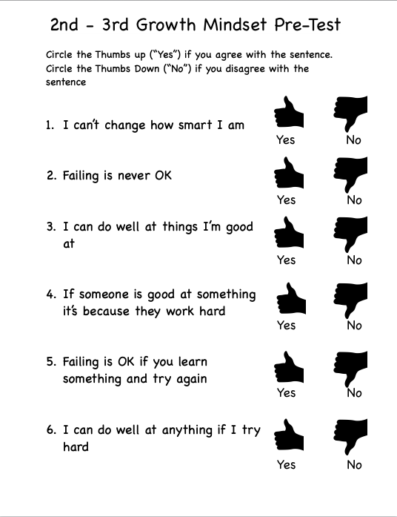

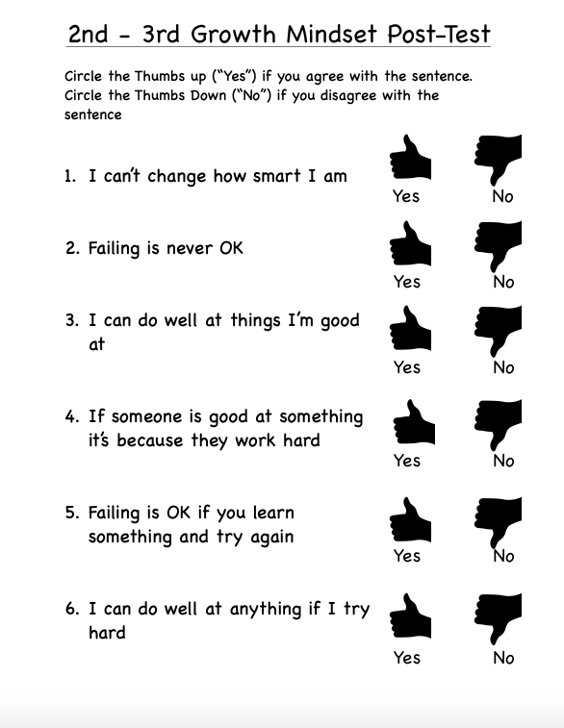

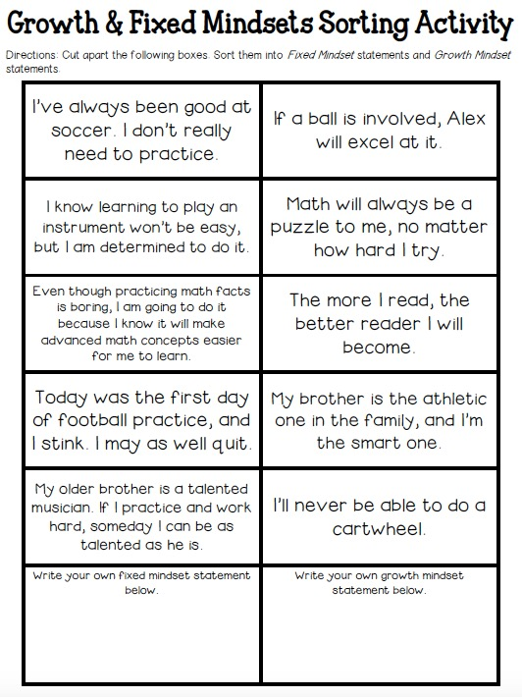



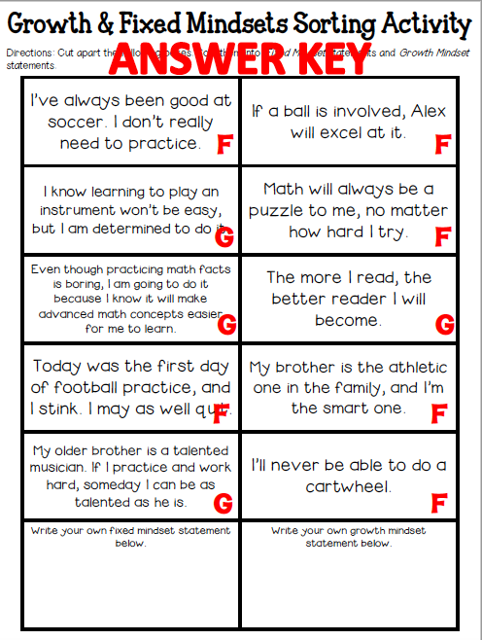

Perseverance Lesson Plan

School Counselor: Ms. Thompson Date: December 2018

Activity: Zootopia Motivational Tweets

Grade(s): 4th and 5th grade

ASCA Mindsets & Behaviors (Domain/Standard):

M5

B-LS4

B-SMS6

Learning Objective(s) (aligns with competency):

1. Students will be able to identify examples of persistence and perseverance

2. Students will be able to develop persistence-based messages to keep them motivated

3. Students will believe in the importance of perseverance

Materials:

Pre-test/Post-test

Computer with Internet and Projector

Zootopia Tweets Handout

Procedure:

1. Distribute pre-tests to each student. Answer any questions associated with it.
2. Introduce the topic: Today we’re going to talk about perseverance. Perseverance means continuing to try and practice, even when something is challenging – *especially* when things are challenging. To give you an idea of what this looks like, we’re going to watch a clip from Zootopia. Zootopia is about a bunny named Judy who wants to become a police officer, but there has never been a bunny cop before. Let’s see what obstacles she faces.
3. Play the [YouTube clip](https://www.youtube.com/watch?v=_c-SpmS0JZs)
4. “Judy shows persistence because she continues to try, even when the challenges are difficult or people tell her she can’t do it. Can anyone think of some other characters or people who are persistent?” (Captain Marvel, Alexander Hamilton, Michael Jordan, J. K. Rowling, Lady Gaga, a friend or parent, etc.)
5. “Why is persistence important?” (Because if we give up on everything, we’ll never be able to reach our goals)
6. “What makes someone persistent?” (They keep trying. They don’t let other people discourage them)
7. “Now we’re going to think of chances we have to be more persistent. I am going to give everyone this worksheet. On one side, I want you to write down 1 – 2 challenges that you are facing right now. They could be a class that you’re struggling in and want to improve in, a sport that you want to get better at, a habit or skill you want to improve, anything like that.”
8. “After you write down your one or two challenges, on the back, you are going to make up two tweets that Judy would say or you could say to yourself to stay motivated with that challenge.”
9. If students finish early, provide them with the opportunity to share their tweets (they don’t have to share their challenges)
10. Distribute post-tests to each student. Answer any questions associated with it.

Plan for Evaluation: How will each of the following be collected?

Process Data: Count of how many students are present; Count of how many worksheets are collected

Perception Data: Pre- and Post tests

Outcome Data: Student persistence in difficult subjects will increase, as measured by grades and homework/classwork completion

Follow-Up: The school counselors, teacher, and other school staff will recognize and reinforce when students are persistent in the face of difficulties

Persistence Pre-Test, Grades 4 – 5

*Rate yourself on the following statements on a scale of 1 – 5.*

1. I stop doing something (schoolwork, a sport, etc.) when it gets too difficult for me.

1 2 3 4 5

1. If I’m bad at something on the first try, I try again until I get better

1 2 3 4 5

1. I stop doing my work before it’s finished if it takes too long

1 2 3 4 5

1. When something matters to me, I keep working to get better until I’m an expert

1 2 3 4 5

1. It doesn’t matter how long it takes for me to get better, as long as I don’t stop trying

1 2 3 4 5

Persistence Pre-Test, Grades 4 – 5

*Rate yourself on the following statements on a scale of 1 – 5.*

1. I stop doing something (schoolwork, a sport, etc.) when it gets too difficult for me.

1 2 3 4 5

1. If I’m bad at something on the first try, I try again until I get better

1 2 3 4 5

1. I stop doing my work before it’s finished if it takes too long

1 2 3 4 5

1. When something matters to me, I keep working to get better until I’m an expert

1 2 3 4 5

1. It doesn’t matter how long it takes for me to get better, as long as I don’t stop trying

1 2 3 4 5

Persistence Post-Test, Grades 4 – 5

*Rate yourself on the following statements on a scale of 1 – 5.*

1. I will stop doing something if it gets too difficult for me.

1 2 3 4 5

1. If I’m bad at something on the first try, I will try again until I get better

1 2 3 4 5

1. If my work takes too long, I will stop doing it before it’s finished

1 2 3 4 5

1. When something matters to me, I will keep working to get better until I’m an expert

1 2 3 4 5

1. It doesn’t matter how long it takes for me to get better, as long as I don’t stop trying

1 2 3 4 5

Persistence Post-Test, Grades 4 – 5

*Rate yourself on the following statements on a scale of 1 – 5.*

1. I will stop doing something if it gets too difficult for me.

1 2 3 4 5

1. If I’m bad at something on the first try, I will try again until I get better

1 2 3 4 5

1. If my work takes too long, I will stop doing it before it’s finished

1 2 3 4 5

1. When something matters to me, I will keep working to get better until I’m an expert

1 2 3 4 5

1. It doesn’t matter how long it takes for me to get better, as long as I don’t stop trying

1 2 3 4 5

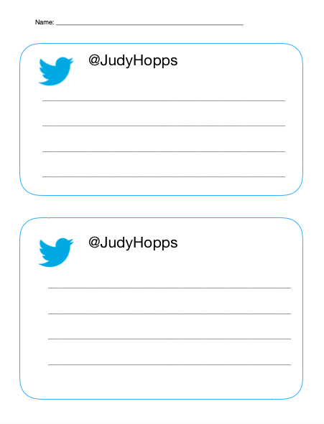

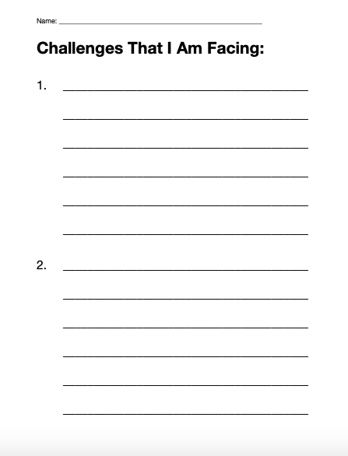

## Core Curriculum Narrative

Stars Hollow Elementary School has two full time professional school counselors, Ms. Thompson and Ms. Gilmore, who serve the 587 students in the school. Both counselors share the full school caseload and alternate teaching the upper and lower elementary school grades every other month. Lessons were scheduled based on a system where counselors send out a monthly Google Doc for teachers to sign up for days and time slots.

The Stars Hollow Elementary School Counseling Department evaluates every core curriculum lesson using a variety of data methods, including a combination of process, perception, and outcome data. Process data was collected via student headcount and reported attendance data for the day. Perception data included pre-tests/post-tests, student surveys, teacher surveys, worksheets, and teacher reports. Outcome data was collected for every applicable lesson (except for Introduction to the School Counselor, Career, College, and Future Goals). Outcome data included behavior referrals, grades, bullying referrals, and counselor referrals.

The counselors placed an emphasis on teaching lessons concerning including others, accepting differences, growth mindset, and perseverance. These themes were chosen to connect to the program’s yearly goals and selected Mindsets and Behaviors. To address the program’s first and third goals of increasing the achievement of Hispanic and African American students in 4th and 3rd grades, the counselors designed lessons on perseverance, growth mindset, embracing challenges, self-confidence, and lifelong learning. The lessons on Individual Differences, Discrimination, Inclusion, Friendship, and Bullying were designed to address the program’s second goal concerning bullying referrals and building a more accepting school environment to connect with the counseling program’s vision of an empathetic and inclusive school community. Remaining lessons on introduction to the school counselor, careers, and college were required for the year, and the counselors determined that a lesson on coping skills and emotions were necessary to support all three program goals. The core curriculum sets up a foundation for students to develop the mindsets and skills to become inclusive, resilient lifelong learners.

The three lessons included are for Individual Differences (Grades K – 2), Growth Mindset (Grades 2 – 3), and Perseverance (Grades 4 – 5). They were selected because each connects to the program’s yearly goals, mindsets, and behaviors. The first lesson, Individual Differences (Grades K – 2) was included to provide representation of lessons for all grade levels and to demonstrate the preventative actions that the counseling department is taking to promote acceptance and stop the bullying problem from growing in the younger grades. The lesson was assessed both via teacher survey and behavioral referrals. Following the lesson, teachers reported a slight increase in the number of students who invite students who are different from them (from 5 – 10 to 10 – 15) and a decrease in students who make fun of others (from 5 – 10 to 0 – 5). Behavior referrals concerning bullying and exclusion also decreased for grades K – 2 between October and November by an average of 3.

The other two lessons (perseverance and growth mindset) demonstrate the actions we are taking at the upper grades to promote persistence, particularly in the realm of academics. By teaching perseverance in 4th and 5th grade, the counseling department aims to teach students how to respond in the face of setbacks. The effectiveness of this lesson was measured by both pre-test/post-test and grades. When rating similar statements, students were more resolved to endorse persistent behaviors moving forward when compared with their responses before the lesson. Teachers also reported that some students made additional attempts to improve on assignments, which led to some slight grade performance. Similarly, the growth mindset lesson for 2nd and 3rd grade was designed to improve students enjoyment of learning as a process requiring persistence. Following the lesson, there was some improvement in students’ responses, particularly for the question ‘failing is OK if you learn something and try again.’ These lessons were designed to bolster students when they face academic setbacks.

The Stars Hollow Elementary School core curriculum provided students the opportunity to develop their perseverance and growth mindset skills as well as their inclusion and interpersonal skills, as aligned with the program’s yearly goals and overarching vision and mission.

|  |  |  |  |  |  |  |  |  |  |
| --- | --- | --- | --- | --- | --- | --- | --- | --- | --- |
|  | **ACTION PLAN**  **SMALL GROUP** | | | | | | | | |
|  | |
| Grade Level | | Group Topic | ASCA Domain and Mindsets & Behaviors Standard(s) | Curriculum and Materials | Projected Start/End | Process Data (Projected number of students affected) | Perception Data  (Type of surveys/ assessments to be used) | Outcome Data (Achievement, attendance and/or behavior data to be collected) | Contact Person |
| 4 | | Academic Achievement (emph: Hispanic students) | M5  B-LS3 | - Test Anxiety  - Overview of Study Skills  - Note-Taking  - Organization | Sept – Oct. 2018 | 4 | Pre-test/Post-test | Grades will increase  PARCC Scores will increase | Thompson |
| 3 | | Friendship | M3  B-SS2 | [CounselorUp friendship group](https://www.counselorup.com/blog/small-fry-friendship-groups)  -Friendship Puzzles  -Connecting with others  -Friendship blockers  -Handling rejection | Oct. 2018 | 4 | Pre-test/Post-test | Behavior referrals will decrease (Bullying) | Gilmore |
| 2 | | Social Skills | B-SS9  B-SMS 2  B-SMS 4 | **Second Step:** *Skills for Learning*  - Being Respectful  - Focusing Attention  - Using Self-Talk  - Being Assertive | Oct. – Nov. 2018 | 3 | Teacher survey | Behavior referrals will decrease (Number of teacher redirections back to task) | Thompson |
| 1 | | Anger Management | B-SMS2  B-SMS 7  B-SS4 | - Defining Anger (When Sophie Gets Angry…Really Really Angry)  - How Angry Am I (Anger Thermometer)  - Recognizing Signs of Anger  - Coping Strategies | Oct. 2018 | 3 | Teacher survey | Behavior referrals will decrease (Classroom outburst count) | Gilmore |
| 3 | | Loving to read (emph. Black students) | M2  B-LS4 | -Engaging interest – comic books  - Imagination – [painting mental images](http://www.teachhub.com/model-reading-strategies-improve-comprehension-all-students)  -Group Reading  -Pair Reading  -Mentored Reading  -Mentoring Reading (1st grade)  -Independent Reading | Jan. – Feb. 2019 | 3 | Pre-test/Post-test | Reading levels will increase  Language Arts grades will increase | Gilmore |
| 5 | | Bullying | B-SS4  B-SS2 | Wonder book club  -Part 1: August  -Part 2: Via  -Part 3: Summer  -Part 4: Jack  -Part 5: Justin  -Part 6: August  -Part 7: Miranda  -Part 8: August | Feb. – March 2019 | 5 | Pre-test/Post-test | Behavior referrals will decrease (Bullying) | Thompson |
| 4 | | Friendship | M3  B-LS7  B-SMS1 | [Friendship Support Group](https://caseymalarney.weebly.com/uploads/1/3/3/0/13301870/intermediate_friendship_support_group.pdf)  -Friendship Road  -Friendship Qualities  -Making Connections  -Communication Skills  -Leading and Following  -Reputations  -Handling Rejection  -Friendship Stars | March 2019 | 5 | Pre-test/Post-test teacher and student | Behavior referrals will decrease (Bullying) | Gilmore |

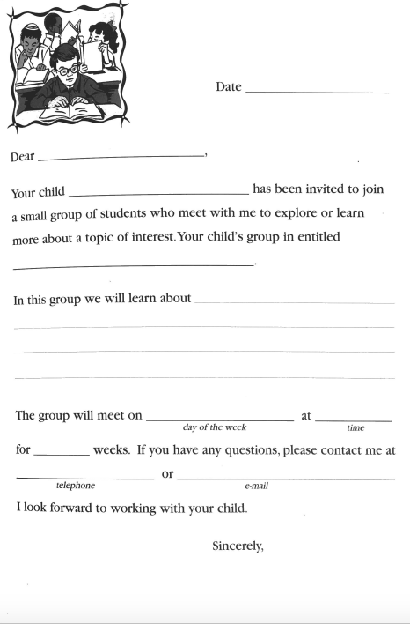

# Small Group Plan: 4th Grade Academic Achievement Group

# Positive Self-Talk and Test Anxiety

School Counselor: Ms. Thompson Date: 9/25/18

Activity: Caterpillars to Butterflies (Original)

Grade(s): 4th (Study Skills Group)

ASCA Mindsets & Behaviors (Domain/Standard):

M5. Belief in using abilities to their fullest to achieve high-quality results and outcomes

B-SMS6. Demonstrate ability to overcome barriers to learning

B-SMS7. Demonstrate effective coping skills when faced with a problem

Learning Objective(s) (aligns with competency):

1. Students will be able to identify the negative self-talk they partake in before tests.

2. Students will be able to combat negative self-talk by transforming it into positive self-talk.

3. Students will develop skills to address their test anxiety

Materials:

Test Anxiety Tips handout

Caterpillars to Butterflies worksheet

Writing utensils

Clipboards

Procedure:

1. Review norms from Week 1. Ask students to name them
2. Introduce topic: “I wanted to start our group with a discussion about mindset. School can be very challenging, but the way we look at things can make it easier or harder. By the end of our session today, I hope that we can decide together how we choose to look at challenges in school and in group moving forward.”
3. “This lesson also tie into test anxiety. Test anxiety is when you get very nervous for a test or quiz, and it throws off your performance. Test anxiety has a lot of different symptoms. Which ones do you experience?” Discuss.
4. “First, we are going to watch a video”: <https://www.youtube.com/watch?v=kO1kgl0p-Hw> (The Power of Positivity | Brain Games | National Geographic)

*The video compares two people trying to throw free throws. One initially missed ten baskets and one made 9/10. They had both try to shoot baskets while blindfolded. The first person, the crowd cheered for and convinced her that she made the baskets, the second person they were discouraging. When they tried again without blindfolds, the first person made 4 shots while the second missed three out of four shown.*

1. Discuss: “What were the differences between the two people? What happened when the people watching said good things and were encouraging? What about when they were discouraging and negative?”
2. “During tests, there aren’t people around us saying things, but what you do hear is the voice inside your head. Sometimes your thoughts might go unnoticed, but you have control over them and they make a difference.”
3. “We are going to focus on the thoughts that run through your head while taking a test. Sometimes when we’re anxious about the test, we can have trouble focusing or negative thoughts can run through our head. Would anyone like to share some negative thoughts that might come to mind during a test? You don’t have to use personal examples, just use general ones that might pop into someone’s head.”
4. “Those negative thoughts do the same thing that the crowd did in the second example in the video. Even if you know everything on the test, the negative thoughts can throw you off your game.”
5. “So now that we know what the negative thoughts are, we can catch them the next time those or similar thoughts pop into our heads. Because the thing with negative thoughts is, they aren’t true. They exaggerate and oversimplify things. When we catch these negative thoughts, we want to confront them and speak the truth to them.”
6. Pass out the Caterpillars to Butterflies worksheet, writing utensils, and clipboards to each group member.
7. “Take a look at the Caterpillars to Butterflies worksheet. We can think about negative thoughts kind of like a caterpillar – you don’t think much of them, they’re just there. But when you look at them a little closer, you might notice they’re not so nice looking. They’re kinda hairy and slimy. But caterpillars can transform into butterflies, and we can transform our negative thoughts the same way!”
8. “The worksheet lists examples of possible negative thoughts that might pop up while taking a test. Like I said, these are our caterpillars. It’s our jobs to help transform them into butterflies, or more true, positive thoughts.” Go through the examples with the group members. “Does anyone have any questions about the examples?”
9. “Now it’s your turn. Take the other negative examples and make up your own positive responses that you can say back to that negative thought. For the last two questions, think of the negative thoughts that you might have to face and come up with positive responses to those.”
10. After everyone has finished the worksheet, discuss with the group: “What were some of the positive responses you wrote down? What did you think of this activity? How might you apply it the next time you have a test?”
11. Have students use their blank sheet of paper to write down a goal for the week that applies one of the study skills discussed. Have them share out with the group.
12. “Finally, before we leave, I have also given you a worksheet with other tips for addressing test anxiety. Look it over and see which tips are most helpful for you. Which jump out?”
13. Wrap up question: What did you learn today? How do you plan to apply it?

Plan for Evaluation: How will each of the following be collected?

Process Data: Number of students present

Perception Data: How many students meet their goal during the week

Outcome Data: First Quarter Grades; PARCC performance in May

Follow-Up: Group members will be asked about the lesson and what they recall during the next session a week later.

# Study Skills Superheroes

School Counselor: Ms. Thompson Date: 10/2/18

Activity: How To Be A Study Skills Superhero (Original)

Grade(s): 4th (Study Skills Group)

ASCA Mindsets & Behaviors (Domain/Standard):

M-2: Self-confidence in ability to succeed,

M-6: Positive attitude toward work and learning,

B-LS 2: Demonstrate creativity,

Learning Objective(s) (aligns with competency):

1. Students will be able to name at least 4 new study strategies

2. Students will be able to identify which study approaches will work best for them

3. Students will develop and discuss a plan for applying new study skills to their routine.

Materials:

Laptop with PowerPoint slides of characters

Worksheets for each student

Writing utensils for each student

Clipboards for each student

(Optional:) Blank sheet of paper for each students

Procedure:

1. Ask members what they recall from last week. Did anyone get the chance to talk back to their test anxiety? How did it go?
2. Introduce the topic to the group (approaches to studying). Ask students: what is your current approach to studying?
3. “Today we are going to discuss some new approaches to studying. I have 12 tips that I wanted to share with you and afterwards, we can discuss if I missed any. Before I start, I was wondering, how do we feel about superheroes? Personally, I like superheroes and thought that we could learn something about study skills from some of them.”
4. Hand out one worksheet, one blank piece of paper, one clipboard, and one writing utensil to each group member.
5. Explain the activity: “I just handed you a worksheet that has 12 images on it. I am going to show you on my computer a picture of each superhero. When I show the picture, we are going to talk about possible study skills we could learn from that hero. Find the icon on your worksheet that goes with that hero (I will help you) and write down the skill and anything that jumps out at you from our conversation. Afterwards, we will have a discussion.”
6. Start PowerPoint presentation with images of each superhero. Facilitate a discussion and tell the group members the study skills listed for each hero.
7. Discussion questions: Which skills looked most interesting to you? Which do you plan to start using? How will you start using them? Do you anticipate any obstacles?
8. Have students use their blank sheet of paper to write down a goal for the week that applies one of the study skills discussed. Have them share out with the group.
9. Wrap up question: What did you learn today? How do you plan to apply it?

Plan for Evaluation: How will each of the following be collected?

Process Data: Number of students present

Perception Data: How many students meet their goal during the week

Outcome Data: First Quarter Grades; PARCC performance in May

Follow-Up: Group members will be asked about the lesson and what they recall during the next session a week later.

# Note-Taking

School Counselor: Ms. Thompson Date: 10/9/18

Activity: Taking Clear Notes (Passages from [Mrs. Thomas’s OWLstanding Class Blog](http://owlstandingclass.blogspot.com/2015/03/32315.html))

Grade(s): 4th (Study Skills Group)

ASCA Mindsets & Behaviors (Domain/Standard):

M-5: Belief in using abilities to their fullest to achieve high-quality results and outcomes

B-LS 3: Use of time-management, organizational and study skills,

B-SS 1: Use effective oral and written communication skills and listening skills

Learning Objective(s) (aligns with competency):

1. Students will be able to identify at least 2 note-taking strategies

2. Students will be able to determine which note-taking strategies will work best for them

3. Students will test their note taking skills and evaluate where they could improve.

Materials:

2 – 4 Passages (Passages from [Mrs. Thomas’s OWLstanding Class Blog](http://owlstandingclass.blogspot.com/2015/03/32315.html))

Writing Utensils

Clipboards

Example pages of note taking styles

Blank sheets of paper

Procedure:

1. Ask members what they recall from last week. Did they apply what they learned? Did it work?
2. One key part of study skills is taking good notes. You use notes to study what you discussed in class, understand what the teacher is saying, and remembering details. What is your current note taking strategy? How well is it working for you?
3. Today, I’m going to introduce you to a few note taking methods. You are welcome to use them in class, or stick to your old method, but we’re also going to try out at least one of them during group today.
4. Explain each of the four types: Mapping, Outline, Charting, and Cornell
5. Cornell: “For the Cornell method, you divide your page into three parts like this. The biggest section is the notes section. Use the notes section to write what the teacher is covering in class. After class, read over the notes (like we spoke about last week) and write in the margin column the main ideas about what you wrote. At the bottom, you write a summary of the lesson or page.” Review the benefits listed below and ask if anyone has questions about this type.
   * Helpful later for quick study (can scan the margin for the topic you want to go over/use it to quiz yourself)

* Neat
* Lets you study a little each day/review the lesson after class
* Allows you to pull out major themes, ideas, and concepts

1. Mapping: For mapping, the page is organized by topic, like this. The main topic branches out into a subtopic and detailed information about each. See if anyone has any thoughts or questions
   * Great for visual learners
   * Shows the connection between topics
2. Charting: For charting, you divide the page into columns, which are labeled by category. Then, you put the details that go with each category in its column. See if anyone has any thoughts or questions
   * Separates topics for quick review
   * Highlights key information for each topic
   * Organizes facts
3. Outlining: For outlining, each section starts with a main topic and the subtopics go underneath and are indented. This is a bullet point method and easy for in-class note taking
   * Easy to organize (don’t need to prepare before class)
   * Usually lines up with teacher’s PowerPoint presentations
   * Neat
   * Shows how topics are related
4. Have students look over each type of note taking style and consider which they like best.
5. Split the group in half or let members work individually. Give each group/member a passage to take notes on. Each person is allowed to use any of the note taking styles.
6. Set a timer for 5 minutes as they take notes
7. After 5 minutes have passed, have the groups/individuals trade notes. Read the notes.
8. Have each group or individual explain what the other group read about.
9. Discussion: What was clear in this activity? What was harder to understand? Do you see yourselves using any of these note-taking styles? Encourage students to try one for the week if they’d like
10. Wrap up question: What did you learn today? How do you plan to apply it?

Plan for Evaluation: How will each of the following be collected?

Process Data: Number of students present

Perception Data: How many students meet their goal during the week

Outcome Data: First Quarter Grades; PARCC performance in May

Follow-Up: Group members will be asked about the lesson and what they recall during the next session a week later

# Organization

School Counselor: Ms. Thompson Date: 10/16/18

Activity: Backpack Organization Game (Found at [School Counselor Blog](http://www.schcounselor.com/2013/11/backpack-organization-game-school.html), Adapted from *Creative Approaches for Counseling Individual Children in the School Setting* by Diane S. Senn)

Grade(s): 4th (Study Skills Group)

ASCA Mindsets & Behaviors (Domain/Standard):

M-5: Belief in using abilities to their fullest to achieve high-quality results and outcomes

B-LS 3: Use of time-management, organizational and study skills,

B-SMS 1: Demonstrate ability to assume responsibility

Learning Objective(s) (aligns with competency):

1. Students will be able to identify the key components to being organized

2. Students will be able to explain the steps it takes to organize a messy backpack.

3. Students will develop a plan for applying organizational skills to their routine

Materials:

Two backpacks filled with supplies (one neat, one messy)

Two pieces of paper with X’s on them

Organization tips handout

Procedure:

1. Before: Prepare two backpacks, one organized, one disorganized. Put a piece of paper with a big “X” marked on it in each backpack. Zip the backpacks so no one can tell they are different inside
2. Ask members what they recall from last week. Did they apply what they learned? Did it work?
3. Introduce today’s topic: While note taking is incredibly important, they can’t help you much if you don’t know where they are. So today, we’re going to talk about staying organized.
4. Choose two volunteers to play the game. Choose a third person to time the activity. Ask the remaining member(s) to take note of what is going on, how each person is reacting or feeling, what strategies each person used, etc.
5. Ask the two volunteers to each choose a backpack. Explain that the students will be racing to look through their backpack to find a piece of paper with an “X” marked on it. Students will not know before opening the backpacks that one is organized and the other not. Have students predict who will find the paper first.
6. Start the timer and watch the students search for the papers. The messy backpack will have it shoved at the bottom, while the neat backpack will have it in a binder or folder.
7. Discuss with the group their impressions of the game. What did you notice? Who had the easier time? How did each person seem to feel – relaxed? Anxious? Why is it important to be organized? How does it affect study skills? **Which backpack looks more like yours?**
8. Discuss how we can start to organize the messy backpack. Have the last group member(s) begin to organize the messy bag as the group directs.
9. Distribute a handout with organization tips: “I am handing out some organization tips so you can remember what we talked about today. For next week, I’d like you to take time to organize your backpacks like we did in group. If you can, bring in a picture of your neat backpack.
10. Discuss: What is one organization habit you are going to start this week?
11. Wrap up question: What did you learn today? How do you plan to apply it?

Plan for Evaluation: How will each of the following be collected?

Process Data: Number of students present

Perception Data: How many students meet their goal during the week

Outcome Data: First Quarter Grades; PARCC performance in May

Follow-Up: Group members will be asked about the lesson and what they recall during the termination session a week later.

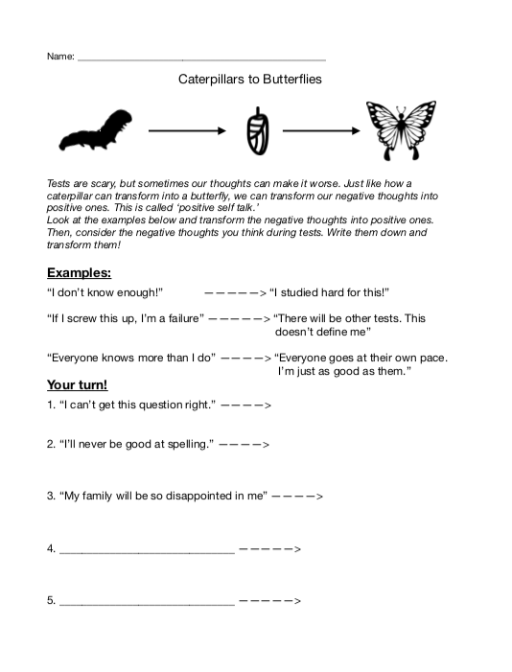

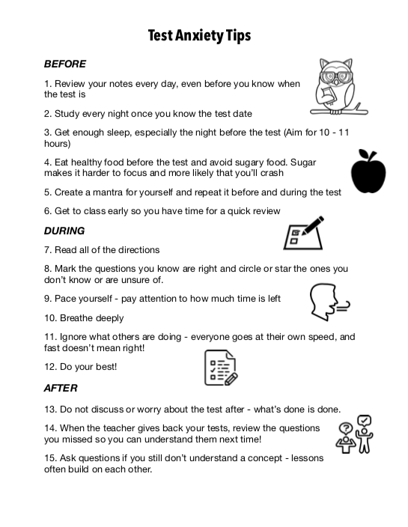

**Superhero Study Skills Slide Descriptions**

Slide 1 (Title) - Each superhero (except Batman) has a YouTube video linked when you click the hero. Connections to study skills are listed in each slide. Allow students to make their own connections as well.

Slide 2 (Hulk) - Focus during class – self-restraint, making good decisions. Just like how Bruce Banner stops himself from turning into the Hulk

Video: <https://www.youtube.com/watch?v=msRaooooyds>

Slide 3 (Ant-Man) - Use abbreviations (shortened versions of words) to write notes faster

Video: <https://youtu.be/Nfcn9Um8sk8?t=27>

Slide 4 (Captain America) - Practice makes perfect! Study a little every day and always do your homework. Just like how Steve Rogers practiced every day to get strong enough to join the military

Video: <https://www.youtube.com/watch?v=Rhn3woLBLXE>

Slide 5 (Black Panther) - Set aside a time and a place to study – make it remote like Wakanda, no distractions. How else do you think they got so smart?

Video: <https://www.youtube.com/watch?v=h3S9koeQzr8>

Slide 6 (Nick Fury) - Ask for help! If you don’t understand something while studying, circle it and ask the teacher about it the next day. Just like when Nick Fury assembles the Avengers when he needs help (or like he did at the end of Infinity Wars)

Video: <https://www.youtube.com/watch?v=Nyjwkav3h_0>

Slide 7 (Superman) - Encourage others, but don’t let them distract you! Know yourself – if group studying helps, try it, but make sure you’re all focused on making each other the best they can be.

Video: <https://youtu.be/_zL92MiSJb8?t=55>

Slide 8 (Thor) - Make a schedule so you can balance your time between studying and relaxing. (like how Thor balanced his time between Earth and Asgard in the first two Thor movies)

Video: <https://www.youtube.com/watch?v=aKDAKPuuBGM>

Slide 9 (Flash) - Use FLASHcards! If you have a computer, look them up online – it saves time.

Video: <https://www.youtube.com/watch?v=vR64m_pWdqc>

Slide 10 (Spider-Man) - Go ‘on the web’ for practice quizzes, worksheets, and flashcards (like we mentioned)

Video: <https://www.youtube.com/watch?v=0LQImbwYjbk>

Slide 11 (Iron Man) - After you’ve done your studying, teach someone else what you know! Just like how Iron Man teaches Spider-Man how to be an Avenger.

Video: <https://www.youtube.com/watch?v=YqyQjjLGzU8>

Slide 12 (Batman) - Review your notes the night before but get a good night’s sleep the night before the test (that’s what Alfred would want for Batman)

(No Video)

Slide 13 (Doctor Strange) - While taking the test, conquer test anxiety by visualizing a happy place (just like Dr. Strange does with the sling ring to open portals to other places)

Video: <https://youtu.be/-gm8tvwl4bI?t=197>

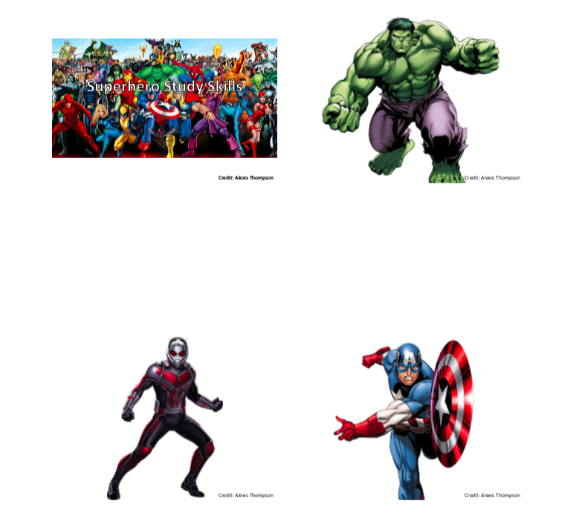



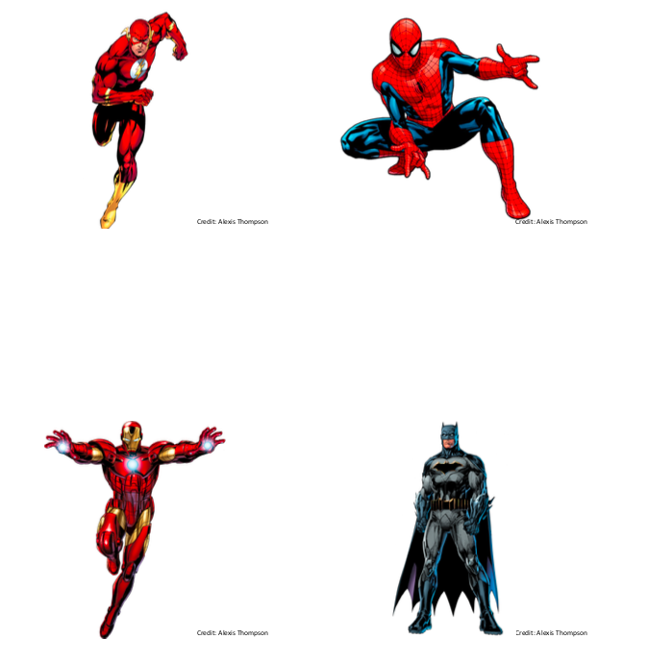



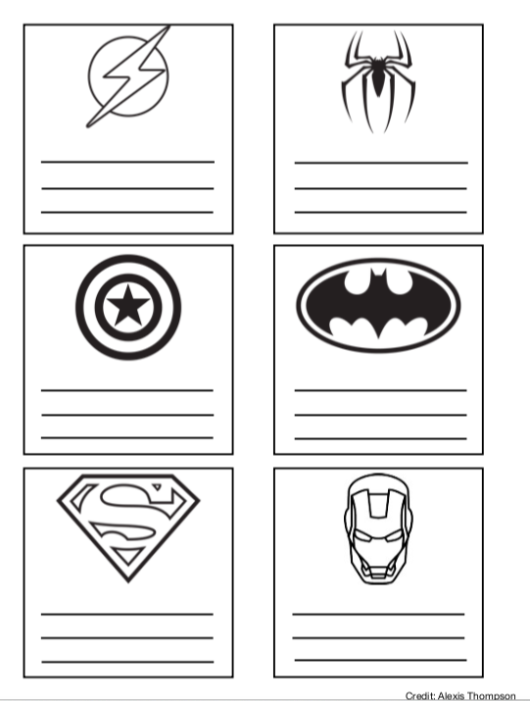

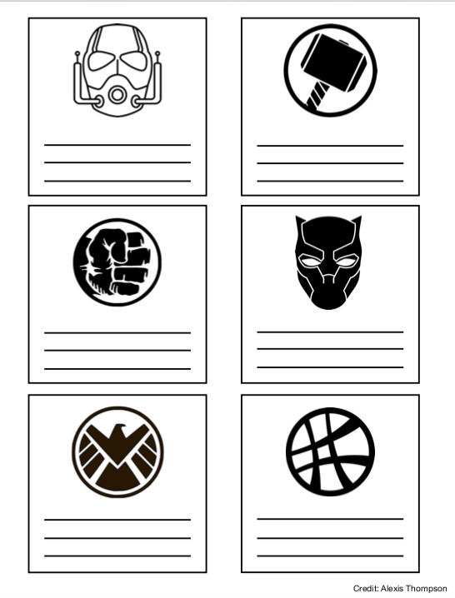

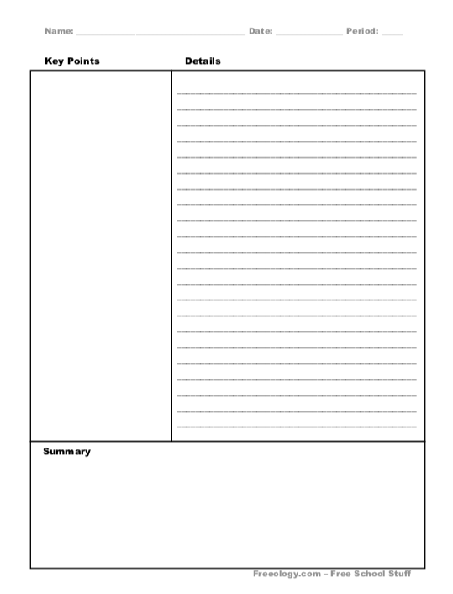

**Outlining Technique Example:**

* Main idea
  + Subtopic
    - Supporting Fact
  + Subtopic
  + Subtopic
    - Supporting fact
      * Detail
    - Supporting fact
      * Detail
  + Subtopic
    - Supporting fact
      * Detail
        + Example
    - Supporting fact
* New Topic

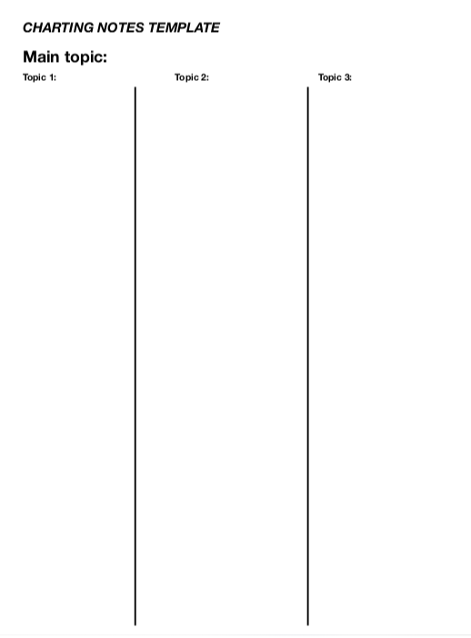

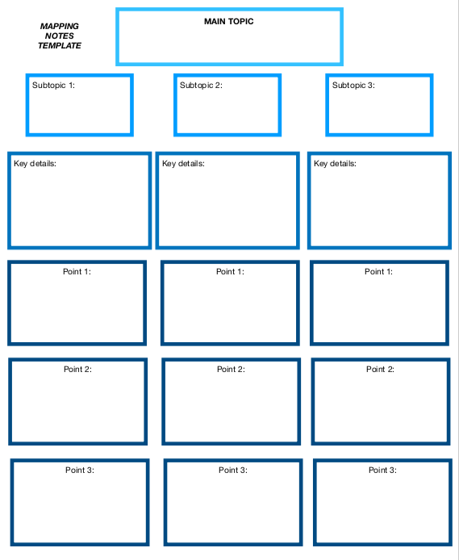

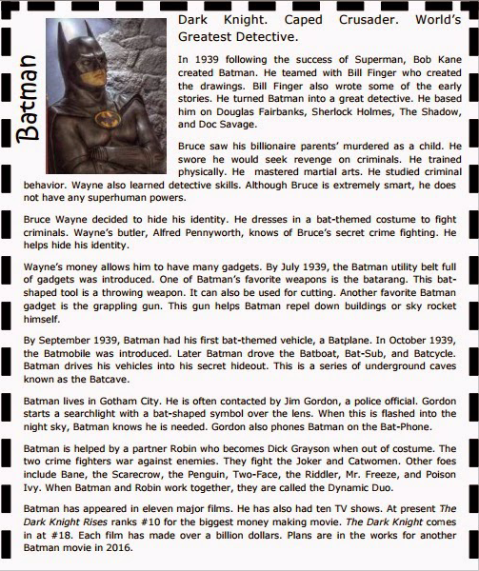

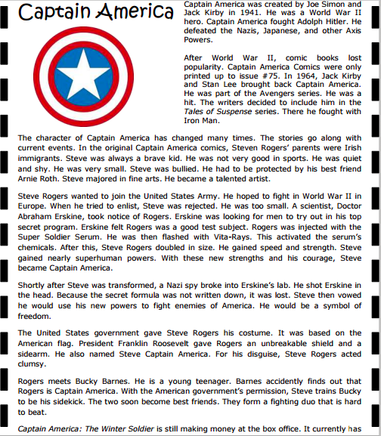

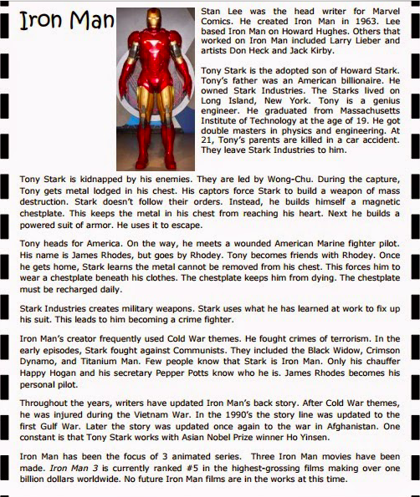

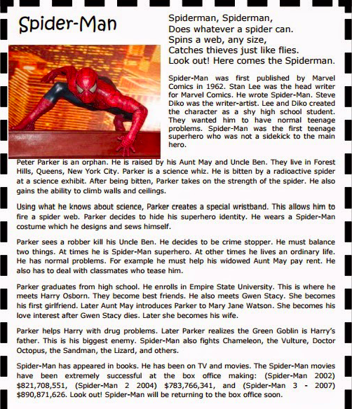

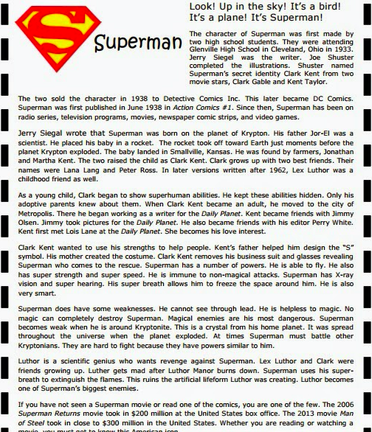

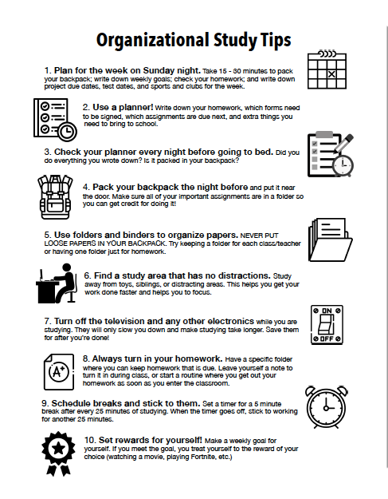

Name: _____________________________________________________

**Study Skills Group Pre-Survey:**

Please circle the answers that best apply to you.

**1. I like school:**

Strongly Disagree Disagree Neutral Agree Strongly Agree

**2. I do well in school:**

Strongly Disagree Disagree Neutral Agree Strongly Agree

**3. I have the potential to do well in school:**

Strongly Disagree Disagree Neutral Agree Strongly Agree

**4. I know how to do well in school:**

Strongly Disagree Disagree Neutral Agree Strongly Agree

**5. On a scale from 1 – 10, how would you rate your current study skills? (Circle):**

1 2 3 4 5 6 7 8 9 10

**6. I need help with the following things (check off as many that apply)**

____ Note Taking ____ Organization ____ Time management

____ Ways to study ____ Setting goals ____ Paying attention in class

____ Motivating myself ____ Test-taking skills/Test Anxiety

____ Working with teachers/asking for help

____ Other (Please write): ___________________________________________________________________________

**7. List any other things that are important for me to know:** ________________________________

__________________________________________________________________________________________________________________________________________________________________________________________________________________

_________________________________________________________________________________________________________

Name: _____________________________________________________

**Study Skills Group Post-Survey:**

Please circle the answers that best apply to you.

**1. I like school:**

Strongly Disagree Disagree Neutral Agree Strongly Agree

**2. I do well in school:**

Strongly Disagree Disagree Neutral Agree Strongly Agree

**3. I have the potential to do well in school:**

Strongly Disagree Disagree Neutral Agree Strongly Agree

**4. I know how to do well in school:**

Strongly Disagree Disagree Neutral Agree Strongly Agree

**5. On a scale from 1 – 10, how would you rate your overall study skills? (Circle):**

1 2 3 4 5 6 7 8 9 10

**6. List 2 things you learned from this group and 2 things you are going to work on:** ___________________________________________________________________________________________________________________________________________________________________________________________________________________________________________________________________________________________________________________________

_________________________________________________________________________________________________________

**7. Which topic was the most helpful for you? Which was the least helpful?** __________________________________________________________________________________________________________________________________________________________________________________________________________________

**8. What is one thing you would change about this group for future members?:** __________________________________________________________________________________________________________________________________________________________________________________________________________________

**9. List any other additional comments or concerns here:** __________________________________________________________________________________________________________________________________________________________________________________________________________________

_________________________________________________________________________________________________________

_________________________________________________________________________________________________________

# Academic Achievement Group Results Graphs

|  |  |  |  |  |  |  |  |  |  |
| --- | --- | --- | --- | --- | --- | --- | --- | --- | --- |
|  | **RESULTS REPORT**  **SMALL GROUP** | | | | | | | | |
|  | |
| Grade Level | | Group Topic | ASCA Domain and Mindsets & Behaviors Standard(s) | Projected Start/End | Process Data (Number of students affected) | Perception Data  (Data from surveys/ assessments) | Outcome Data (Achievement, attendance and/or behavior data) | Implications |
| 4 | | Academic Achievement (emph: Hispanic students) | M5  B-LS3 | Sept – Oct. 2018 | 4 | Average 22.5% increase in study skills self efficacy (measured on scale 1 – 10)  (6 🡪 8, 7 🡪 7, 5 🡪 10, 5 🡪 7) | 50% of students (2 group members) increased grades by one letter grade  Students increased in their lowest class by an average of 8.25 percentage points. | Group strongly benefited two students academically. Other two students may need additional intervention/observation  Two students’ interest in school decreased due to increased difficulty |
| 3 | | Friendship | M3  B-SS2 | Oct. 2018 | 4 | Students’ self-ratings of friendship skills increased by an average 60% (2 🡪 8, 3 🡪 9, 1 🡪 7, 2🡪 8) | Bullying referrals decreased for group students by 62.5% from 8 🡪 3 | Group was beneficial to students and decreasing bullying referrals |
| 2 | | Social Skills | B-SS9  B-SMS 2  B-SMS 4 | Oct. – Nov. 2018 | 3 | Teacher reported mild improvement (scale 1 – 10 measuring behavior 3 🡪 4) | Off-task behavior decreased by 13.3%, from 15 🡪 13 | Students could use additional support for decreasing off-task or disruptive behavior |
| 1 | | Anger Management | B-SMS2  B-SMS 7  B-SS4 | Oct. 2018 | 3 | Teacher ratings of students’ coping abilities increased by 100% on a scale of 1 – 10, from 2 🡪 4 | Daily classroom angry outbursts decreased by an average of 20% for each member (10 daily outbursts 🡪 8/8/7 per student; 30 🡪 23 or 23.33% decrease altogether) | Students could use additional support to further decrease angry outbursts and implement coping skills |
| 3 | | Loving to read (emph. Black students) | M2  B-LS4 | Jan. – Feb. 2019 | 3 | Student ratings of interest in reading increased by 200%. On a scale of 1 – 10, from average rating of 2 🡪 6 | Students grew by an average of 2 reading levels.  All students were seen reading for pleasure following the group  1 student earned a B in reading and 1 earned a C. | Group intervention benefited student reading levels and curiosity concerning learning.  Further intervention may benefit one student to translate interest in reading to grade performance |
| 5 | | Bullying | B-SS4  B-SS2 | Feb. – March 2019 | 5 | Students’ perspective-taking self-ratings increased by an average 20% | Conflict and bullying referrals for members decreased by 33.33% (from 30 to 20) | Group was effective in moderately decreasing bullying behaviors and increasing perspective-taking. |
| 4 | | Friendship | M3  B-LS7  B-SMS1 | March 2019 | 5 | Student self ratings of friendship skills increased by an average of 30% (2 🡪 4, 2 🡪 4, 3 🡪 4, 3 🡪 4, 4 🡪 4)  Teacher ratings of friendship skills increased by an average of 35.29% (1 🡪 3, 1🡪3, 2 🡪 3, 2 🡪 4, 3 🡪 4) | Bullying referrals for group members decreased by 36.36% from 11 🡪 7 | Group was effective in moderately decreasing bullying behaviors. |

## Small Group Narrative:

The counselors of Stars Hollow Elementary School looked to grade data, test scores, reading levels, and behavioral referral data to determine which students would best benefit from small group interventions. Specifically, for the 4th grade academic achievement group (included above), the counselors looked at student PARCC scores and selected the Hispanic students with the four lowest scores to participate in the group. The group was designed to address the department’s first goal of promoting equity in PARCC scores for Hispanic students. The first session was built around growth mindset in order to have students enter the group and the new quarter with a positive mindset that they are in control of their performance. Growth mindset and encouraging positive self-talk became a theme in the group, often tying back to the initial lesson. Additional topics included a study skills overview, note-taking, and organizational skills because they give group members direction concerning the positive academic steps they can take to improve during the quarter. Following the group, all but one student reported increases in their study skills self-efficacy, as measured by a scale from 1 – 10. The remaining student reported a constant, with the score going neither up nor down. All students saw increases in their grades for their lowest class. Two students went up by one letter grade (D’s to C’s), and the other two students saw a 2% increase and a 5% increase in each of their lowest classes, indicating that additional intervention would be beneficial.

A similar group was used to address the department’s third goal of increasing African American reading grades and performance. Members were selected by looking at the three students with the lowest reading grades. The group combined some additional reading strategies (engaging interest, painting mental images) with practice opportunities (as a group, in pairs) and mentored reading (both with an older mentor from the University of Maryland America Reads program and with a younger first grade student who is struggling to learn how to read). These opportunities provided members multiple ways to see reading in a more positive and social light as well as the chance to share a newfound love for reading with a younger student. After the group, students grew by an average of two reading levels. One student earned a B in reading the following quarter and another earned a C. Teachers reported that all group members were seen reading for pleasure following the group. Finally, student ratings of interest in reading increased by 200%, from rating it as 2/10 to 6/10.

Social groups ran throughout the year included two friendship groups, a social skills group, an anger management group, and a bullying group. Group members for the bullying group were selected based on the 5th grade students with the highest number of bullying referrals. This group took a book club format and read and discussed parts of the book Wonder by R. J. Palacio. The book takes many different characters’ perspectives, which gave students the opportunity to consider perspectives outside of their own. McCormac (2014) endorses literature-based bullying curriculum for students because it allows them to contemplate and discuss issues rather than being told what to think or how to behave. The group discussed individual differences and how to be respectful and appreciative of those differences. Following the group, conflict and bullying referrals for members decreased by 33.33% (from 30 referrals to 20 referrals). Students’ self-ratings of perspective-taking abilities also increased.

Friendship groups were implemented at the 3rd and 4th grade levels as a preventative measure, selecting the students with the most conflict/bullying referrals. The 3rd grade group saw a vast improvement in bullying referrals and friendship skills self-ratings. The 4th grade section saw more moderate improvements, but improvements nonetheless. Smaller improvements were noted for the 2nd grade social skills and 1st grade anger management groups, indicating that additional intervention may be beneficial in the future.

**Accountability**

|  |  |  |  |  |  |  |  |  |  |  |  |
| --- | --- | --- | --- | --- | --- | --- | --- | --- | --- | --- | --- |
|  | | **ACTION PLAN**  **CLOSING THE GAP** | | | | | | | | | |
| Goal: | | | | By May 2019, 4th grade Hispanic students who pass (Meet or Exceed Expectations) the 2019 Math PARCC test will increase by 50% from 5 students (or 38.5%) to 10 students (or 76.92%) | | | | | | |
| Target Group: | | | | 4th grade Hispanic students who are not passing the Math PARCC test | | | | | | |
| Data to Identify Students | | | | PARCC Math scores | | | | | | |
|  | | |
| Activities | | | | ASCA Domain and Mindsets & Behaviors Standard(s) | | Curriculum and Materials | Projected Start/End | Process Data (Projected number of students affected) | Perception Data  (Type of surveys/ assessments to be used) | Outcome Data (Achievement, attendance and/or behavior data to be collected) | Contact Person | |
| Parent workshops, Class-Wide Peer Tutoring, Perseverance Classroom Lesson, Academic Skills Group, Embracing Challenges Classroom Lesson, | | | | M5  B-LS6  B-SS3 | | Parent workshops based on YMCA family involvement program, Class-Wide Peer Tutoring program, Zootopia lesson, What Do You Do With A Problem? Lesson, Transition and Future Goals Lesson | September 2018 – May 2019 | 13 students | Pre-test/Post-test | 4th grade PARCC Math Scores | Ms. Gilmore  Ms. Thompson | |

|  |  |  |  |  |  |  |  |  |  |  |
| --- | --- | --- | --- | --- | --- | --- | --- | --- | --- | --- |
|  | | **RESULTS REPORT**  **CLOSING THE GAP** | | | | | | | | |
| Goal: | | | | | By May 2019, 4th grade Hispanic students who pass (Meet or Exceed Expectations) the 2019 Math PARCC test will increase by 50% from 5 students (or 38.5%) to 10 students (or 76.92%) | | | | |
| Target Group: | | | | | 4th grade Hispanic students who are not passing the Math PARCC test | | | | |
| Data to Identify Students | | | | | PARCC Math scores | | | | |
|  | | |
| Activities | | | | ASCA Domain and Mindsets & Behaviors Standard(s) | Projected Start/End | | Process Data (Number of students affected) | Perception Data  (Data from surveys/ assessments) | Outcome Data (Achievement, attendance and/or behavior data) | Implications | |
| Parent workshops, Class-Wide Peer Tutoring, Perseverance Classroom Lesson, Academic Skills Group, Embracing Challenges Classroom Lesson, | | | | M5  B-LS6  B-SS3 | September 2018 – May 2019 | | 13 students | Average student self-report of work-quality improved from an average of 2.62 to 3.77 out of 5.  Student reports of having at least one supportive adult also improved, rising from an average of 2.23 to 4.15 out of 5. | 8 Hispanic 4th grade students Met or Exceeded Expectations in Math PARCC test | We did not meet our goal, as only 8 students passed Math PARCC. However, interventions did benefit 3 students, indicating that more direct, individualized attention might be beneficial. Two of the three students who newly passed had participated in the academic skills group, so we will hold another group next year for four students who almost met expectations.  Families for 10 of the 13 target students were able to attend at least one event, indicating that future parent workshops may be beneficial for this population.  Workshops will be videoed and posted on the counseling department website in the future to increase access for parents unable to attend.  Students enjoyed the CWPT program and reported increased engagement and interest as well as grades, lending support to expanding it to additional classes in the upcoming years. | |

# Perception Data

# Outcome Data

# Narrative

While reviewing school data from the 2017 – 2018 school year, the counseling department found academic disparities that were imperative to address the following school year. Specifically, 3rd grade (now 4th grade) Hispanic students had distinctly lower PARCC scores and held a lower proportion of passing scores when compared with classmates, particularly their white classmates, who make up the same proportion of the class. 85% of white students met or exceeded expectations for PARCC (while the remaining 15% approached expectations). Only 38.5% of Hispanic students met or exceeded expectations, less than half of the performance for white students. We found this to be an important gap to close because this can be an easily-overlooked, but growing, group within the county and if not addressed now, the gap may not be acknowledged or addressed in the future.

The counseling department researched many ways to best address this gap when brainstorming interventions for the upcoming year, leading to the following research-based interventions: growth-mindset approaches, an academic skills group, three classroom lessons, a series of four parent workshops, and a class-wide peer tutoring intervention.

We chose to take a growth-mindset approach when addressing this disparity in Hispanic 4th grade PARCC scores. Research by Carol Dweck has found its effectiveness in improving student performance, persistence, and interest in learning. Specifically, in a study by Blackwell, Trzesniewski, and Dweck (2007), 7th graders who began the year with a growth mindset (i.e. placing more importance on hard work and determination than innate talent or intelligence) were more likely to improve their grades, while peers with a fixed mindset (i.e. placing more importance on innate talent or intelligence than hard work and determination) did worse over time. By instilling this mindset in students early on, we are investing in our students’ long-term success.

Growth mindset was a major theme during the academic small group, being specifically addressed during the first session via discussions and activities and continually referenced throughout the duration of the group. The group also covered more skills-based topics like note-taking, organizational skills, and general study skills. Overall, the group was a successful intervention, with 75% of students improving in their study skill self-efficacy and all members increasing their grades in their lowest class.

In the classroom, we placed an emphasis on persistence and growth mindset through multiple lessons throughout the year. We taught these lessons in December (perseverance), May (embracing challenges), and June (lifelong learning). These lessons were chosen to reinforce the growth mindset concepts discussed during the academic skills group in September and the parent workshop in December. These lessons were also scheduled to take place during times in the year where persistence tends to fall among students due to the proximity of breaks and the amount of effort that had been put in during the previous months. These lessons were effective in giving students the final push that they needed before the end of two particularly challenging grading periods.

Research also led us to believe that teaching parents about growth mindset would be important so that our interventions would be consistent across school and homes. Research by Dweck and Mueller (1998) was among some of the earliest research on growth mindset and found that the way adults praise children impacts the mindsets they develop, their persistence, and their interest in learning. In their study, they had 5th graders complete math problems, and after 4 minutes, they told the students that they did well and got 80% of the questions right. They told a third of the students “you must be very smart,” another third “you must have worked very hard,” and the last third no additional comments. They then gave all of the students a harder set of problems. Regardless of actual performance, they told each student they got less than half of them right. When the researchers gave the students a third set of problems that were the same level of difficulty as the first set, students who were initially told “you must be very smart” did substantially worse and reported not enjoying the task. To contrast, students who were praised for their persistence did better and reported enjoying the task. By sharing this information with parents, we had the opportunity to cultivate growth mindsets outside of the classroom and help families grow in awareness of the messages they communicate to their student.

A study by O’Donnell and Kirkner (2014) highlighted common needs of Latino families and ways they could be addressed via a workshop format. Specifically, we found their theme of increasing educational supports at home highlighted in their first workshop to be most relevant to our determined population. The study found that parental involvement in workshops was associated with more involvement at home and within the school. Additionally, two years after their families’ workshop participation, students were found to have higher effort, social skills, academic habits, and standardized test performance. This combined with the importance of family involvement in Hispanic cultures supported our decision to hold parent workshops to increase Hispanic student performance.

School-wide, we also offered teachers the opportunity to participate in a Class-Wide Peer Tutoring program. CWPT is a promising practice developed at the Juniper Gardens Children’s Project at the University of Kansas focused on improving academic outcomes for low-income students (Class Wide Peer Tutoring Program, 2003). It has been found effective across grade levels, and at Stars Hollow Elementary, we implemented it in 3rd and 4th grade classes. The original program was used in conjunction with 2nd grade classroom teachers and consists of four parts – teacher instruction, student pairs, immediate feedback, and reinforcement (Delquadri, Greenwood, Whorton, Carta, & Hall, 1986). The teacher explains the content for the day and then has the students assigned to two teams. In pairs, students take turns tutoring each other, with one person acting as the tutee for the first 10 minutes and then becoming the tutor for the next ten minutes. The tutor corrects any errors that the tutee makes, and the pair earns a point for their team each time the error is corrected. The program has been found to lead to an average increase of 12 percentage points on tests (Delquadri et al., 1986). In a meta-analysis of 26 studies (Bowman-Perrott et al., 2013), peer tutoring was found to have an average effect size of .75, indicating that using this method makes a moderate to large difference when compared to not using it, particularly when rewards are involved. The program’s emphasis on repeated attempts after mistakes reinforces the ideas of growth mindset. Through these interventions, students were able to begin developing a passion for learning and sharing that with younger students.

Ultimately, we did not meet our goal, but there was an increase in student performance. At the end of the 2018 – 2019 school year, 8 Hispanic students met or exceeded expectations. While short of our 10-student goal, our results taught us the effectiveness of the study skills small group in conjunction with parent workshop attendance. We also hope to research and consider applying these interventions with students from other cultural backgrounds who are facing similar gaps.

# References

Atkins, R. (2015, January 16). Small Fry Friendship Groups. Retrieved April 2, 2019, from <https://www.counselorup.com/blog/small-fry-friendship-groups>

Backpack Organization Game: School Counselor Spotlight. (2013, November 23). Retrieved October 8, 2018, from http://www.schcounselor.com/2013/11/backpack-organization-game-school.html

Bazaldua, B. (2007, February 20). Meet the Robinsons: The Movie Storybook. Retrieved March 27, 2019, from <https://www.amazon.com/Meet-Robinsons-Storybook-Barbara-Bazaldua/dp/0061124761>

Blackwell, L. S., Trzesniewski, K. H., & Dweck, C. S. (2007). Implicit Theories of Intelligence Predict Achievement Across an Adolescent Transition: A Longitudinal Study and an Intervention. *Child Development,* *78*(1), 246-263. doi:10.1111/j.1467-8624.2007.00995.x

Bounce Patrol Kids. (2017, August 05). "Alphabet Occupations" - ABC Jobs Song for Kids | Learn the alphabet phonics with Jobs & Occupations. Retrieved March 27, 2019, from <https://www.youtube.com/watch?v=r6Oxqyd5qUw>

Bowman-Perrott, L., Davis, H., Vannest, K., Williams, L., Greenwood, C., & Parker, R. (2013). Academic Benefits of Peer Tutoring: A Meta-Analytic Review of Single-Case Research. *School Psychology Review,* 42(1), 39-55.

Brennan, D., & Shuttlesworth, L. (2015, February 9). Light the Spark for Success: College and Career Guidance Lessons. Retrieved March 28, 2019, from <https://www.txca.org/images/Conference/SCC15/Handouts/8.pdf>

“Bullying: Guidelines for Teachers.” *Teaching Tolerance*, [www.tolerance.org/professional-development/bullying-guidelines-for-teachers](http://www.tolerance.org/professional-development/bullying-guidelines-for-teachers)

Children, B. R. (2017, October 20). WHAT DO YOU DO WITH A PROBLEM? by Kobo Yamata Read Aloud by Books Read Aloud For Children. Retrieved March 27, 2019, from <https://www.youtube.com/watch?v=HG25YyKJ4qs>

Class Wide Peer Tutoring Program. (2003, January). Retrieved from <http://www.promisingpractices.net/program.asp?programid=99>

College Prep. (n.d.). Retrieved March 31, 2019, from <https://jeopardylabs.com/play/college-prep2>

Community Helpers and Careers Coloring Pages and Printable Activities 1. (n.d.). Retrieved March 27, 2019, from <http://www.first-school.ws/theme/cp_comhelpers.htm>

Coping Skills for Kids. (n.d.). Feelings Thermometer. Retrieved November 8, 2018, from <https://store.copingskillsforkids.com/collections/free-printables/products/feelings-thermometer>

Counselor Keri. (2017, July 27). Meet the Counselor: Learn S’more About the School Counselor. Retrieved March 26, 2019, from <https://www.counselorkeri.com/2017/07/27/meet-the-counselor-activity/>

Counselor Keri. (2017). Meet the Counselor Activity Classroom Guidance Lesson for School Counseling. Retrieved March 26, 2019, from <https://www.teacherspayteachers.com/Product/Meet-the-Counselor-Activity-Classroom-Guidance-Lesson-for-School-Counseling-3261104>

CRazy. (2016, December 29). Zootopia - Judy's Best Inspirational scene| Don't Know When To Quit|. Retrieved March 26, 2019, from <https://www.youtube.com/watch?v=_c-SpmS0JZs>

Delquadri, J., C. R. Greenwood, D. Whorton, J. J., Carta, and R. V. Hall “Classwide Peer Tutoring” Exceptional Children, Vol. 52, pp. 535-542, 1986.

Eisenhuth, S. (n.d.). Growth Mindset Read Aloud Lesson Plans. Retrieved March 28, 2019, from <https://www.teacherspayteachers.com/Product/Growth-Mindset-Read-Aloud-Lesson-Plans-3271705>

Elementary School Counseling. (n.d.). Identifying and Expressing Feelings. Retrieved March 26, 2019, from <http://www.elementaryschoolcounseling.org/identifying-and-expressing-feelings.html>

Growth Mindset In Action. (n.d.). Long Term Goals - A Growth Mindset Lesson using the book; When I Grow Up. Retrieved March 28, 2019, from <https://www.teacherspayteachers.com/Product/Long-Term-Goals-A-Growth-Mindset-Lesson-using-the-book-When-I-Grow-Up-2554942>

Hanson, D. (2016, July 27). Growth vs. Fixed Mindsets... A FREE Sorting Activity! Retrieved March 27, 2019, from <https://www.crafting-connections.com/2016/07/growth-vs-fixed-mindsets-free-sorting.html>

The Helpful Counselor. (n.d.). Coping Skills Bingo Game. Retrieved March 26, 2019, from <https://www.teacherspayteachers.com/Product/Coping-Skills-Bingo-Game-1277724>

It's Okay to Feel Different. (n.d.). Retrieved March 26, 2019, from <https://www.tolerance.org/classroom-resources/tolerance-lessons/its-okay-to-feel-different-0>

J, S. (1970, January 01). I Like Myself {Another Back to School Book}. Retrieved March 27, 2019, from <http://www.sarajcreations.com/2014/08/i-like-myself-another-back-to-school.html>

Liggett, K. (n.d.). Mrs. Potato Head Counselor Introduction Lesson K - 5. Retrieved March 26, 2019, from <http://forestheightscounselor.weebly.com/uploads/1/3/2/1/13218952/mrs_potato_head_intro_lesson_for_sharing.pdf>

Lithgow, J. (2030). *Mahalia mouse goes to college*. Place of publication not identified: Simon & Schuster Books.

Lobron, A. A. (2017, March 04). An Inclusive Lesson: Can I Play Too? Retrieved March 29, 2019, from <https://www.thinkinclusive.us/inclusive-lesson/>

Malarney, C. (n.d.). Friendship Support Group Grades Third – Fifth. Retrieved March 29, 2019, from <https://caseymalarney.weebly.com/uploads/1/3/3/0/13301870/intermediate_friendship_support_group.pdf>

McCormac, M. E. (2014). Preventing and Responding to Bullying: An Elementary School’s 4-Year Journey. Professional School Counseling. <https://doi.org/10.1177/2156759X0001800112>

Midgett, A., & Doumas, D. M. (2016). Training Elementary School Students to Intervene as Peer-Advocates to Stop Bullying at School: A Pilot Study. Journal of Creativity in Mental Health, 11(3–4), 353–365. https://doi.org/10.1080/15401383.2016.1164645

Monroe, A. (2012, May 7). HULK SMASH. Retrieved November 8, 2018, from <http://pencilsglueandtyingshoes.blogspot.com/2012/05/hulk-smash.html>

Mueller, C. M., & Dweck, C. S. (1998). Praise for intelligence can undermine children’s motivation and performance. *Journal of Personality and Social Psychology,75*(1), 33-52. doi:10.1037/0022-3514.75.1.33

National Geographic (2015, June 22). Retrieved October 15, 2018, from <https://www.youtube.com/watch?v=kO1kgl0p-Hw>

The NED Show. (n.d.). You Can Be An Upstander. Retrieved March 26, 2019, from <http://www.thenedshow.com/assets/preventing-bullying-video-lesson-plan-you-can-be-an-upstander.pdf>

O'Donnell, J., & Kirkner, S. L. (2014). The Impact of a Collaborative Family Involvement Program on Latino Families and Children's Educational Performance. *School Community Journal*, *24*(1), 211-234.

O'Neill, A., & Huliska-Beith, L. (2006). *The Recess Queen*. Gosford, N.S.W.: Scholastic.

Readers, L. (2017, October 30). The Legend of Spookley the Square Pumpkin Read Along. Retrieved March 28, 2019, from <https://www.youtube.com/watch?v=K-acOrQ3aSo>

Rivera, M. (2015, May 21). Retrieved November 8, 2018, from <https://www.youtube.com/watch?v=YFvZOjGUTYk>

Palacio, R. J. (2017). *Wonder*. London: Puffin.

Paws-itive School Counselor. (n.d.). Friendshape: A Lesson on Friendship. Retrieved March 30, 2019, from <https://www.teacherspayteachers.com/Product/Friendshape-A-Lesson-on-Friendship-3859379>

Plasticfantastic777. (2010, March 01). Keep Moving Forward! Retrieved March 27, 2019, from <https://www.youtube.com/watch?v=7p_eKV3SzwE&feature=youtu.be>

Robb, L. (2007, April). Model Strategies To Improve Reading Comprehension For All Students. Retrieved March 29, 2019, from <http://www.teachhub.com/model-reading-strategies-improve-comprehension-all-students>

Rosenthal, A. K. (2017). *Friendship*. Weston Woods.

Schuette, T., & Mertens, C. (2014, October 22). Get Into A Growth Mindset Presentation. Retrieved March 29, 2019, from [https://www.nhsd.k12.wi.us/faculty/toeftger/Fixed vs. Growth Mindset.pptx](https://www.nhsd.k12.wi.us/faculty/toeftger/Fixed%20vs.%20Growth%20Mindset.pptx)

Second Step: Scope and Sequence. (2011). Retrieved September 13, 2018, from <https://assets.ctfassets.net/98bcvzcrxclo/1YOB00MJZSui8G6AyAwIGm/abca49c2a67a326193d2ecbf762b1dcf/k-5-scope-sequence-ss-short.pdf>

Sesame Street. (2014, September 10). Sesame Street: Janelle Monae - Power of Yet. Retrieved March 27, 2019, from <https://www.youtube.com/watch?v=XLeUvZvuvAs>

SoulPancake. (2015, January 19). The Story of Martin Luther King Jr. by Kid President. Retrieved March 28, 2019, from <https://www.youtube.com/watch?v=4xXZhXTFWnE>

Stangline, M. (n.d.). A Warm & Fuzzy School Counselor Guidance Lesson on Goal Setting. Retrieved March 29, 2019, from <https://www.creativecounseling101.com/school-counselor-guidance-lesson-goal-setting.html>

Stopbullying.gov (2012, August 03). Retrieved April 15, 2019, from <https://www.youtube.com/watch?v=mJ4v7R3MbrU>

Thomas, A. (2015, March 23). 3.23.15. Retrieved September 24, 2018, from <http://owlstandingclass.blogspot.com/2015/03/32315.html>

Troiano, J., & Banta, S. (2016). *The legend of Spookley the square pumpkin*. New York: Holiday Hill Farm.

Willems, M. (2015). *Can I play, too?* New York: Scholastic.

WVDE. (n.d.). Transitioning to Middle School. Retrieved March 29, 2019, from <https://wvde.state.wv.us/counselors/documents/TransToMiddle2-2.doc>

Yamada, K., & Besom, M. (2016). *What do you do with a problem?* Seattle, WA: Compendium Kids.

Yankovic, A., & Hargis, W. (2012). *When I grow up*. New York: Scholastic.

# APPENDIX A: Perception Data Summary

## Intervention: Parent Workshops

## Intervention: Friendship Literature

## Intervention: Peer Advocates

## Intervention: Teacher Development

## Intervention: Reading Mentorship Program with University Students

## Intervention: Class-Wide Peer Tutoring

# APPENDIX B: Outcome Data Summary

## Goal 1: Math PARCC Scores, 4th Grade Hispanic Students

*By May 17, 2019, 4th grade Hispanic students who pass (Meet or Exceed Expectations) the 2019 Math PARCC test will increase by 100% from 5 students (or 38.5%) to 10 students (or 76.92%)*

## Goal 2: 5th Grade Bullying Referrals

*By June 2019, the number of 5th grade referrals for bullying will decrease by 25% from 75 to 56*

## Goal 3: 3rd Grade African American Reading Grades

*By June 2019, the number of 3rd grade African American students who are failing reading will decrease by 30% from 10 to 7*